WHOLE OF
GOVERNMENT ACCOUNTS
2009-10

WGA ‘L PACK’
FOR
LOCAL GOVERNMENT BODIES
IN
ENGLAND

GUIDANCE NOTES

Version: 1.0
CONTENTS

SECTION 1: INTRODUCTION 4
SECTION 2: TIMETABLE & AUDIT REQUIREMENTS 6
SECTION 3: CHANGES & UPDATES IN 2009-10 PACK 11
SECTION 4: COVERAGE OF THE FORM 20
SECTION 5: DEFINITIONS 21
SECTION 6: VALIDATION & DATA INTEGRITY CHECKS 23
SECTION 7: TREATMENT OF INTERNAL CHARGES 27
SECTION 8: TRANSACTIONS BETWEEN THE AUTHORITY AND OTHER 28

PUBLIC BODIES
SECTION 9: PAGE BY PAGE GUIDANCE 32
Overview (1) 32
Validations (2) 34
Prior Year Restatement Sheet (3) 38
Income And Expenditure Account: Net Cost Of
Services– Subjective Analysis (4) 40
Income And Expenditure Account (5) 47
Fixed Assets (6) 53
Intangible Assets (7) 56
Investments (8) 58
Current Assets (9) 60
Liabilities & Provisions (10) 63
Frs 17 (11) 71
Reserves (12) 73
Balance Sheet (13) 81
Cash Flow (14) 82
Financial Instruments Main (15) 83
Financial Instruments Risk (16) 86
Counter-party Data Sheet (17) 87
Additional Data Sheet (18) 98
Additional Info – Pooled Budgets (19) 100
Additional Info – Transferred Debt (20) 101
Additional Info – Highways Infrastructure Assets (21) 102
Sign Off (22) 103 Cpid Codes (23) 103
Upload Sheets (24) And (25) 103
Scoa Codes (26) 103
Post Audit Journal & Cpid Audit Journal Sheets 103
SECTION 10: OTHER SOURCES OF GUIDANCE & CONTACTS 105
SECTION 11: FREQUENTLY ASKED QUESTIONS 106
Annex A: Guidance on ONS staff statistics 108
Annex B: Sample survey for ONS 110
Annex C: Colour coded match relationships 112
Section 1

INTRODUCTION

Background to Whole of Government Accounts

1.0 Preparing the Whole of Government Accounts (WGA) is necessary to meet the undertaking in the Code for Fiscal Stability to produce consolidated accounts for the whole public sector on the basis of Generally Accepted Accounting Practice (GAAP). Publishing audited WGA will also improve the transparency of government’s finances.

1.1 WGA will increase the completeness of public sector financial data by showing information on items not currently in existing measures of public finance (such as provisions, contingent liabilities and future contract expenditure). In addition the WGA programme will progressively increase the amount of audited data included directly in the UK National Accounts, for example by replacing statistically modelled depreciation data with actual data.

1.2 The extension of the WGA from Central Government to full WGA is essential if it is to provide a complete picture. The inclusion of local government will have a particularly significant effect on WGA – local government controls over 50% of public sector fixed assets, accounts for about 25% of net public expenditure and represents 10% of UK GDP. The boundary for WGA is defined in the designation order available at www.opsi.gov.uk/si/si2010/uksi_20101051_en_1.

1.3 We believe that the completion of WGA can offer benefits to local government. WGA will develop into a source of robust audited financial data for central government. This supports a move towards a single data set, which may lead to a reduced burden on local government bodies (LGBs) as data can be collected once and used for several purposes, e.g. to support policy analysis and resource allocation within local government, as well as achieving the wider benefits set out above.

1.4 In the recent Budgets the commitment to prepare and publish the WGA has been confirmed. The Statutory Instrument has been made http://www.opsi.gov.uk/si/si2010/em/uksiem_20101051_en.pdf
Therefore the 2009-10 WGA exercise will be the first to be published. This presents a major milestone.

1.5 WGA will be produced on an International Financial Reporting Standards (IFRS) basis for 2009-10. Treasury, CLG and CIPFA have worked closely on the implications for LGBs of this decision.

1.6 This (2009-10) L Pack is designed to follow the current SORP and the supporting practitioners’ guidance notes. This is the primary reason that PFI has been brought in the 2009 SORP (one year in advance of the move to full IFRS implementation for local government). Any issues regarding the alignment of the last SORP based accounts and the IFRS basis central government accounts are resolved centrally.

1.7 We remain committed to introducing WGA in a way that minimises the burden on all concerned, but still achieves WGA consistent with GAAP.

1.8 Most of the data we require continues to be the same as that required for authorities’ published accounts, with the additional requirement to collect information on major transaction streams and balances within the public sector to allow these to eliminate upon consolidation.
Section 2

TIMETABLE & AUDIT REQUIREMENTS

Deadline for Completion

2.0 The process has changed for 2009-10. There are two deadlines:
- The unaudited WGA L Pack is due by 30 July 2010.
- The audited return is required by 1 October 2010.

2.1 This deadline has been set to allow CLG, HMT and local government greater time to address the sub consolidation issues. Previous years’ timetables for CLG and HMT to complete the sub consolidation of 482 local government bodies have been challenging and significant counter-party mismatches remain unresolved. This is the biggest single issue identified by the NAO in their review of the sub-consolidation.

2.2 Hence the decision to require local government bodies to provide an unaudited return. This is coupled with major changes to the form on the government grant streams to help address these issues.

2.3 Please note that the deadline for the audited return remains the same as for the previous year’s dry run exercise.

2.4 Completion of the WGA return by the deadlines is a requirement under the Government and Resources Accounts Act 2000. Failure to submit a completed unaudited and audited form by this date will result in authorities being in breach of this legislation.

2.5 Authorities are required by the Accounts and Audit Regulations to prepare accounts and have these accounts approved by members by 30 June 2010. We strongly recommend that authorities complete the WGA return at the same time as preparing their statement of accounts for presentation to members. Experience of central government shows that integrating the accounts preparation and WGA processes makes completion of WGA returns significantly easier. This will also allow the unaudited WGA return to be submitted for the 30 July deadline.

2.6 Recognising that the deadline for submission to CLG of audited packs is 1 October 2010, we strongly suggest that the unaudited pack sent to CLG should be sent to the auditors at the same time. This should ensure that the timetable for the audited return is met.

2.7 Local government bodies will be sent an email reminder by CLG periodically.

Completion of the audited/final return

2.8 To avoid duplication of effort the Pack has functionality built in so that only those areas impacted by the audit need to be changed. There are various cells in the Validation Sheet (2) to facilitate this. More information is provided in the relevant section of the guidance.

Audit Requirements

2.9 As set out in Government Resources and Accounts Act 2000, the legislation that makes provision for the WGA, there is a requirement that the WGA form prepared by local government bodies must be audited.

2.10 The audited return should be submitted to CLG (copying in the local government body) by the deadline of 1 October 2010.

2.11 To submit the audited L Pack, the auditors should send the L Pack by email to CLG, copying in the respective local government body. The L Pack should be emailed to wga.returns@communities.gsi.gov.uk, with the following subject field:

E Code_ Local Government body name_Audit status_ WGA 2009-10

Where: E code: is available on the L Pack
Local Government Body Name: please refrain from abbreviating too much. (LB for London Borough or DC for District Council is acceptable, whereas full abbreviations such as ABDC can be difficult to recognise.)
Audit Status: Either Audited or Unaudited

Please also save the L Pack using the above convention. This will assist us enormously to process all 448 returns promptly and efficiently.

2.12 When the auditors send in the return to CLG then, unlike previous years, the audit certificate is required to be sent to the National Audit office (NAO), not to CLG. The NAO are collating the audit certificates in their overall assessment of the Whole of Government Account. NAO require the audit certificates to be sent to them (PDF format is acceptable). We will advise the email account nearer the deadline.

2.13 Please note that CLG do not usually liaise with the auditors. It is essential that the respective local government body works with their auditors to ensure that the audit of the L Pack is completed as planned and delivered by the deadline.

2.14 CLG experienced some difficulties with our IT system. Emails were rejected without a warning email, leading to duplication of emails and a number of authorities and auditors being asked to resend completed forms. We would like to thank you for your patience and perseverance throughout that period, and reassure you that our IT provider is working to remedy the issue in time for this year’s exercise.

2.15 We will update the position in due course (via the reminder system).

2.16 We no longer require a hard copy of the Chief Financial Officer sign off sheet to be submitted. As the auditor sign off is required to be sent directly to the NAO, We agreed to dispense with the requirement to send a hard copy of the sign off form.

2.17 Those authorities whose audit is not complete by 1 October 2010 must forward their final L Pack to CLG (as this will have the most up to date information) unaudited to meet the submission deadline. For these bodies, once the audit of the L Pack is completed, the auditor must submit the audited L Pack, with a covering email stating that that the Pack is a resubmission; that the L Pack has now been audited and that it incorporates all audit adjustments. The authority should advise CLG and the auditor whether any changes have been made to the previously submitted L Pack and provide a summary of any changes over £1M. An example schedule for changes will be available on the CLG website. http://www.communities.gov.uk/localgovernment/localgovernmentfinance/governmentaccounts/
Submission of the Unaudited Return

Complete the “Lock Draft Pack function
Have all the primary validations passed?
No
Is the L Pack complete? Has the “Lock Draft pack” function been completed?
No
Yes
Yes
The pack cannot be sent to CLG if the primary validations failed. Please review and resolve issues.
Yes
Once these are resolved then send in the Pack to wga.returns@communities.gsi.gov.uk
The pack is ready for submission to CLG – follow instructions in 2.11 re naming convention

Deadline: 1st October 2010

Is the L Pack complete and has the audit been finalised?

Yes
Yes
No

(Ref 2.11, 2.15) Send in the form to CLG
wga.returns@communities.gsi.gov.uk
Is the L Pack finalised?

Yes
No

Indicate a date for delivery of the audited return to CLG. Send the latest version (unaudited) L Pack to CLG by 1 October 2010 to wga.returns@communities.gsi.gov.uk.
Provide details of the delay to CLG and copy in the auditors. Indicate a date for the delivery of the audited return to CLG at wga.returns@communities.gsi.gov.uk.

Notify CLG of the reason for the delay in audit opinion. Consider:

Is there another issue? Please advise CLG of the details.
Is there a problem on the main account audit? When is it expected to be resolved?
Section 3

CHANGES & UPDATES IN 2009-10 L PACK

2009 SORP

3.0 The only major changes to the SORP for this year are: firstly the introduction of accounting for PFI (application of IFRIC 12) and secondly changes to accounting for Council Tax and National Non Domestic Rates (NNDR). The introduction of PFI in advance of full implementation of IFRS in local government in 2010-11 is largely to align the data from local government and central government for WGA purposes. Central government is implementing IFRS for 2009-10.

3.1 The WGA L Pack is based on the 2009 SORP. Please note that no additional IFRS information is requested – suffice that which is required in the SORP.

3.2 Other changes to the SORP include the change to require council tax and National Non Domestic Rates (NNDR) to be accounted for on an agency basis. The L Pack has been changed to reflect these changes.

Functionality and Presentation

3.3 New functionality and presentational changes have been made to the form.

Firstly, new mandatory fields have been introduced on the Overview Sheet (1): if these cells are not completed then further input to the form will not be allowed. Also there is a new section “essential checklist” – these questions need to be answered so that the relevant sections in the form are available for input. For instance, if an authority has pooled budgets then a new additional information sheet becomes available for input.

Further detail is provided on the sheet by sheet analysis.

Group Accounts & Local Authority Accounts

3.4 If an authority completes group accounts, they must also submit their WGA Return on a group basis. Entries that are required to complete group accounts complete cells marked in a blue font and can only be used if the “Group” status has been selected from the drop down menu on the Overview sheet. This is now a mandatory field and so if the group or single entity status is not input in the Overview Sheet further input to the form will not be allowed.

Transferred Debt

3.5 Transferred debt (also referred to as deferred liabilities or inherited debt) arising from local government reorganisation receives a wide range of accounting treatments by different authorities. The issue for WGA is that this causes large sums not to eliminate, and also presents several different scenarios for treatment of transferred debt which would each need separate guidance as to how they should be addressed.

3.6 Transferred debt is brought into the form on a separate line with a number of cells available in the counter-party data sheet, to promote inclusion of these balances. Please enter interest payments/receipts relating to these balances within the general interest / receipts cell of the counter-party data sheet

3.7 In order to reduce the number of queries sent to local authorities to reconcile the figures provided for transferred debt, we have introduced a second additional disclosures sheet. If your authority has inherited debt from the dissolution of a former metropolitan county, we require you to complete sheet 20.

3.8 If your authority is the debt administrator, please provide the total deferred liability held by your authority, and the total remaining debt to be paid by all of the authorities. Where your authority is not the administrator, you only need supply the amount of deferred liability held by your authority. We also ask you to indicate what information is included on the counter-party sheet to highlight to us the differences that exist between each authority’s return.

3.9 The Additional Data: Transferred Debt sheet is additional information only and so including information on transferred debt that is held outside of the authority’s accounts will not interfere with the “consistent with” opinion issued by the auditors. Since its introduction last year this enabled a significant reduction in the level of contact required with the local government bodies impacted and the CLG WGA team were able to raise journals to ensure transferred debt was eliminated.

Password Protection

3.10 The information contained within the L Pack is extracted and uploaded to COINS using a Macro. Password protection was introduced to the L Pack for 2007-08 to prevent amendments to the layout of the form which cause the macro to fail; such as inserting or deleting rows or columns, inserting additional sheets or entering data into incorrect cells. As we continued to receive forms which cause the macro to fail by including decimals, copied and pasted data and links to other spreadsheets, we have extended this password protection and added a mechanism which means it is no longer possible to input decimals or links, or cut or copy and paste on the form.

3.11 The introduction of this check has saved considerable time for CLG WGA team in uploading the information (as it is in the required format). However, following feedback from local government bodies, we have placed an un-password protected version on the website to facilitate easier reconciliation to the main statutory accounts working papers. Note that this is simply to assist in the completion of the exercise (as so local government bodies are able to use the various tools in excel to check the formulae etc).

Note that we still require the password protected version to be completed and submitted. Any other version will not be accepted.

3.12 If you identify an area that requires amendment to the form please send your form to CLG so that we can make the adjustments and return the form to you. WGA.Queries@communities.gsi.gov.uk.

3.13 It is now possible to add extra rows to the counter-party sheet without contacting CLG as a macro has been developed to allow insertion of new rows.

Counter-party Information

3.14 The 2008-09 WGA exercise showed improvements in the counter-party data provided. However there remain considerable variations between the amounts identified as counter-party information, both within the English local government sector and between central government and local government bodies.

3.15 One key reason noted for these differences is the inconsistent way in which transactions are recorded. For example, one authority may record levy income received, whilst the corresponding authority records the levy paid as payment of goods and services. This had caused a number of transactions not to eliminate as the online system used to consolidate the accounts will only recognise two sides of a transaction if they fall into the same match relationship.

3.16 Another problem linked to this, is that we require any transactions with one organisation, that have a total greater than £1 million within any match relationship, to be included in the counter-party sheet. Some authorities have interpreted previous guidance as requiring only single transactions greater than £1m to be recorded, causing differences and no matches to arise.

3.17 To tackle both of these problems, we have colour-coded each of the match relationships on the face of the counter-party sheet (17) as well as identifying the match relationship on the face of the counter-party sheet. The list of colour coded relationships is available in Annex C. We strongly advise you when completing this section to consider other categories highlighted in the same colour – are there additional transactions to be included? - Does the corresponding entry for your transaction fall into a line description of the same colour? A more detailed explanation of the counter-party section can be found on p.87 and section 8 together with some worked examples.

Cash Flow

3.18 The cash flow introduced in 2008-09 has been completely reworked following the considerable feedback received. This is a derived cash flow (indirect method). We appreciate that the SORP practitioners’ guidance notes allows a choice as to the direct and indirect method but we need the derived cash flow to be able successfully produce a consolidated cash flow as part of the overall Whole of Government Accounts. It is very difficult to produce a “one size fits all” cash flow especially where there is such a variety in the local government bodies that we are required to sub consolidate.

3.19 Additional information has been included throughout the L Pack to facilitate the creation of this cash flow, which is partially derived from elsewhere in the form. However we have not linked all of the cells as we do not have the opening balance information in sufficient detail to be able to auto-calculate the movement in cash for the cash flow. We decided that for the purposes of the completion of the cash flow we would not require local government bodies to provide this breakdown. The cells are available and the same information that has been used in the authority’s own cash flow.

3.20 The cash flow is subject to audit review for this year. We hope that as it is in a similar recognisable format that it should be relatively easy to confirm the balances.

Prior Year Restatement sheet

3.21 The prior year restatement sheet was introduced in 2007-08 to capture the reasons for any significant changes in the opening balances. For WGA 2009-10 this sheet has been amended to allow the completion of the SORP 2009 changes (i.e. PFI and council tax and NNDR income).

3.22. Note this sheet requires the information that was input into COINS for 2008-09 – this may not be the same as the audited version finally submitted. Input into COINS was completed by third week in October; any return received thereafter would have been assessed on a case by case basis to see if any revision to COINS data input was required. For example, if an audited return was received from a band 1 Authority after the deadline (following an unaudited return received by the deadline) CLG would assess the difference to the version previously received and then upload this.

3.23 As a separate check to ensure that the closing position does agree an additional data integrity check has been introduced. This checks two specific data cells from data held on the COINS system and compares these to the information included in the return. If there is a difference and this is not explained by a change in the accounting policies, boundary changes, introduction of IFRIC 12 or any other change then the data does not match the data already held in COINS. It is likely that a later version has been used (to that uploaded onto COINS). As a general rule of thumb, local government bodies that submitted an audited return within 2 weeks of the deadline will have audited data in COINS. Thereafter mainly band 1 bodies would have had their data replaced.

3.24 If there is any doubt as to which version was uploaded then please contact CLG on wga.queries@communities.gsi.gov.uk for further information.

3.25 The key changes to note are:
- the introduction of an additional column Early adoption of IFRS - IFRIC 12 (PFI) in the analysis of differences section (as required in the SORP)
An additional data validation has been added at the bottom of the sheet to ensure that the closing balances are the same as those submitted to CLG and input into the HMT COINS system. It is possible that an audited return was received after the deadline but where this was after the CLG internal cut-off to replace data (in particular where this was not for a band 1 authority) then unaudited data is on COINS. To avoid any confusion CLG will make a list available on the CLG WGA webpage to clarify which version was uploaded.

Additional Data Requirements

3.26 In order to produce the notes to the accounts some additional information is required, including summary details of commitments, contingent assets and liabilities. As per last year we have requested the average number of whole time equivalent staff working as both employees and as agency staff.

3.27 We believe that all this information will already be available to local authorities as it is provided to ONS on a quarterly basis through the Quarterly Public Sector Employees Survey. The information required should be equivalent to that provided as at 31 March 2009 and 31 March 2010 to the ONS, to allow automatic calculation of an average. The ONS return requiring this data and the relevant guidance notes are included in Annex A and Annex B for reference.

3.28 Other additional breakdown is required on the PFI commitments including a breakdown as to the number of PFI schemes for school building projects in particular – more information is included in the relevant section of this guidance.

Data Integrity Checks and Validations

3.29 The validation sheet that highlights key validation checks for authorities and auditors to observe has been further expanded. This is in two sections – the primary validations and the data integrity checks. The primary validations have been increased to 7 (from 3) to include:

- The Balance Sheet Balances
- The counter-party upload sheet total (sheet 25) agrees to the counter-party data input (sheet 17)
- The Upload accounts (i.e. the trial balance) is zero
- The prior year balance sheet must balance
- The Cash flow agrees
- WGA balances from Financial Liabilities CPID data must not exceed WGA balances in Financial Liabilities table
- WGA balances from Financial Assets CPID data must not exceed WGA balances in Financial Assets table

3.30 This is a key part of the CLG and the subsequent National Audit Office (NAO) review of the quality of the L Packs, is to review this sheet first.

3.31 Following on from the successes of the previous dry run exercises, additional validation checks have been added to the form and incorporated into the Validation Sheet (2).

3.32 In total there are 27 validations – split according to the following worksheets:

Tangible Fixed assets 1
FRS 17 liability 7
Reserves 6
NNDR tax creditor/debtor 1
I&E – Financial Instruments 1
Cash flow – Govt grants 1
Prior Year Restatement 2
Financial Instruments 8

Capital and Revenue Grants

3.33 As the volume and value of counter-party differences between central government and local government funding flows remains the single most challenging issue, considerable changes have been made to the government grant sections in the I&E (sheet 4 and 5) and the Liabilities and Provisions (sheet 10).

3.34 The changes introduced in previous years have gone a long way to assist our understanding as to why elimination differences exist. Further changes to the local government L Pack and the central government C pack for 2009-10 should enable us to identify and make any necessary adjustments centrally.

Capital Grants

3.35 On the Liabilities sheet we have followed the methodology in the SORP, which is to assume that in the first instance all capital government grant income received is recorded in the unapplied account.

3.36 We are interested in that element which is stated as received in year as this should match to what central government have stated as government grants to local government. However there could be a brought forward and a carried forward element which may distort this picture - this is highly likely given the very nature of this grant. The brought forward values would relate to previous years’ capital grant paid by central government – we are not interested in these (as these would form part of previous years’ eliminations). It is worth remembering that we are only interested in the amounts relating to 2009-10 being identified on both local government and central government sides. Also there will be a carry forward element.

3.37 The movements to deferred (i.e. where an asset has been created and brought into use) are shown as line items from unapplied. As the items should agree these balances are auto populated. This will save time for the person inputting the data and this should serve as an additional data integrity check.

3.38 In capital accounting there is a third scenario – where capital grant income is received and is expended immediately but this does not result in the creation of a fixed asset. In this scenario the amount is taken to the I&E otherwise it would never be recognised. This is input into the liabilities sheet and the information is automatically updated in the Income and expenditure Account (sheet 5).

Revenue Grants

3.39 The Income and Expenditure Account (sheets 4 and 5) have been amended to require more analysis on revenue grant income received. There are similar complications to the capital grant income i.e. there could be a brought forward and a carried forward element which we believe are causing the significant elimination differences.

3.40 There are different types of revenue grant – some of which have a deferred element such as the Dedicated Schools grant – The grant covers 1st April 2009 to 31st August 2010 – therefore there is a brought forward element for 2008-09 that is received in 2009-10. This is required to be disclosed separately so that we are able to match this and eliminate with central government grant stream – carrying on this analogy – this is from DCSF. There is the 2009-10 element and again there will be a carry forward element.

Worked examples are included in the relevant section.

Financial Instruments Disclosure Notes

3.41 Accounting for Financial Instruments was introduced in 2007 SORP. However the disclosures were not required for WGA as central government did not require this information.

3.42 In 2008 only band 1 bodies were required to submit this information. This is a standard disclosure and so the Pack has been expanded to require the disclosures. The level of disclosure is determined by the “Essential checklist” on the Overview sheet – so if there are no derivatives then these fields will be hidden. It is hoped to make the L Pack look a little less daunting and only relevant to the local government body completing the return.

Pooled budgets – Additional Information

3.43 Pooled budgets are arrangements where there are local funding arrangements with other bodies within the Whole of Government Accounts boundary to collectively provide local government services. This makes economic sense to do this. However, there were major differences in the counter-party information included on the WGA returns. It is believed that this contributed to £3bn difference in 2008-09.

3.44 Unfortunately there is little guidance in the SORP guidance notes [SORP Guidance Module 3, para N23 to N26, page 163].

3.45 Hence this sheet has been introduced to assist us to identify and complete the counter-party information. It is based on the various scenarios as to how the shared funding is recorded in the I&E – some authorities only record their share as host, other host authorities record all the income and expenditure in the I&E and so this is required to be netted-off in the L Pack. However given the different scenarios there are differences as to the amounts recorded. Refer to the guidance within the Pooled Budget sheet (19).

Possible extension to the band 1 criteria

3.46 Negotiations with NAO and the Audit Commission are on going (at the time of drafting this guidance) as to the number of band 1 bodies. Provisionally the number of band 1s will increase from 59 (there were 60 in previous years but due to the changes in local government boundaries one has now been split) to 128. The criteria is where the assets, liabilities, income or expenditure is over £1 billion these bodies are brought into the definition as these balances are material in WGA terms. The possible band 1s have been identified using the following convention:
Yes: Band 1 last year AND is in the NAO draft list (for anticipated new Band 1 thresholds).
Yes (TBC): in the NAO draft list as a Band 1, but was not previously a Band 1.
TBA: for all new Unitary Authorities that are not already a Yes based on the NAO draft list.
No: Was not a Band 1 last year, was not in the NAO draft list, and is not a new unitary authority.
No (TBC): Band 1 last year that is not a Band 1 in the NAO draft list. A comment has been added on the Overview sheet to reiterate this.

Additional Information – Highways Infrastructure Assets

3.47 Note this sheet is not subject to audit for 2009-10. This information is required as part of the move towards valuing the highways infrastructure assets on a Depreciated Replacement Cost basis in the future. Preliminary work has highlighted that such a transition is not going to be easy and this marks the beginning of the journey.

3.48 It is important to note that highways infrastructure assets should be recorded at historic cost in the fixed asset note in the 2009-10 Accounts.

3.49 Refer to the L Pack guidance and the WGA timetable paper "Accounting for Highways Infrastructure Assets in the Local Authority Sector on a Depreciated Replacement Costs Basis: Interim Accounting Arrangements for the Period up to 2012-13". This paper is available on the WGA page of the HM Treasury and CLG websites, and is based on the decisions made by the CIPFA Project Implementation Sub-Group (PISG).

http://www.communities.gov.uk/localgovernment/localgovernmentfinance/governmentaccounts

3.50 All estimates should be calculated on the basis set out in the new CIPFA Code of Practice on Transport Infrastructure Assets - Guidance to Support Asset Management, Financial Management and Reporting (published March 2010). Refer to http://www.cipfa.org.uk/pt/infrastructure/index.cfm for information on the development of this Code.

3.51 The highways infrastructure data requested in the L Pack is for information purposes only, and is to capture the progress being made by local authorities on revaluing their highways infrastructure assets for Gross Replacement Cost (GRC) and Depreciated Replacement Cost (DRC). Please be aware that in many cases local authority staff outside of the central finance team, such as asset management and engineering staff, are undertaking this work.

Completion of the Pack

3.52 As there is considerably more pre-population of the cells (acting as an additional data integrity check as well as reducing the need to input the same data more than once) it may be easier to complete the Pack in the following order:

- Start with the Overview sheet (the mandatory cells must be completed otherwise the rest of the Pack will not be available for data input).
- Following sections in the bottom half of the Liabilities & Provs (10) sheet:
  - Capital Grants Unapplied followed by Capital Grants Deferred.
  - Landfill Allowance Trading Scheme (LATS) Government Grants Deferred section.
  - Financial Liabilities table at base of sheet (if you have Financial Guarantees or Derivative Liabilities)
- First table in the Financial Instruments Main (15) sheet (Net gains/losses in I&E and STRGL table). Note, for this table to be complete, fill out the three Interest Paid cells in the I&E (5) sheet (C23, C24 & C25).
- Complete the Pooled Budgets (19) sheet (if applicable).
- At this point go back to the I&E NCS (4) sheet and work through the sheets sequentially.
- Complete the Prior Year Restatement sheet (3).
- Review the Validations (2) sheet, and amend/provide explanations as needed.
Section 4

COVERAGE OF THE L PACK

4.0 This section highlights some key areas of local government finance which either require special treatment, or must be included or excluded.

Housing Revenue Account
4.1 The HRA should be included in the WGA return. Transactions within
HRA Net Cost of Services should be included on the Net Cost of Services sheet.

Collection Fund
4.2 SORP 2009 changes in the accounting for Council Tax and Business Rates, i.e. these will be included on an agency basis, are incorporated into the L Pack and so will be picked up from the relevant worksheets.

4.3 Therefore issues around excluding precepts have been removed. All local government bodies will record their share of the collection fund. There will be a balance at year end between the billing and precepting authorities. This should be accounted for in the Balance Sheet section of the return, (as the relevant year end debtor/creditor will need to be disclosed), hence this information should be disclosed in the counter-party data.

Pensions Fund and Other External Funds
4.4 These should not be included in the WGA return except where consolidated into the Authority’s group accounts. Transactions between the authority and these funds do not constitute transactions with another public sector body for WGA purposes unless, exceptionally, an external fund has been specifically designated for WGA purposes. However FRS 17 liabilities and expenses should be included as recognised in the authorities own accounts.

Trading Accounts & Trading Operations
4.5 Trading organisations included in the authority’s own accounts should be included in the WGA return.

4.6 Where a trading operation within the authority’s own accounts provides services to third parties (trading operation types a, b and possibly c in accordance with the classification in Section 4 Chapter 9 of BVACOP) the full income and expenditure of the operation should be reported. Where the operation trades with other public bodies the transaction streams and any year end balances should be reported as usual. See section 7 and section 9, p. 20 for further guidance.

4.7 Trading organisations of BVACOP types c – f trade internally. Where the surplus or deficit of the trading operation would lead to material misstatement of
Total Cost, paragraph 2.34 of BVACOP requires that the surplus is reapportioned to client Divisions of Service. See section 7 for further guidance.

Section 5

DEFINITIONS

General Guidance
5.0 Other than as set out in this Guidance the accounting concepts and practices used in the local government WGA return are as set out in the CIPFA/LASAAC Code of Practice on Local Authority Accounting in the UK 2009 (the SORP) and the Best Value Accounting Code of Practice (BVACOP). Note the 2008 BVACOP covers both the 2008-09 reporting year as well as 2009-10.

Materiality & Input Conventions
5.1 For data input into all sheets, except as noted below, you should use the materiality that applies in the authority’s statement of accounts.

5.2 Note that all input are in £’000s and must be whole numbers. It is not possible to input decimals onto the form. We have introduced an additional protection in previous dry run exercises. Inputting decimals causes referencing errors (REF!) preventing the form being uploaded – a primary validation failure. The only exception to this rule is the percentage disclosures section on FRS17 (sheet 10). These should be input as numbers without percentage signs, for example as 3.55. Do not enter pound signs or percentage signs. The same restrictions apply to copying and pasting, and to linking to other spreadsheets.

5.3 Following numerous requests from local government colleagues, a separate un-password protected version has been introduced so that if it helps expedite the completion of the form to link this to the other working papers, it is now possible to do this. However, the password protected version is required to be completed and submitted to CLG.

5.4 Numbers representing debit amounts should be input as positives and all numbers representing credit amounts should be input as negatives. That is, asset and expense data will normally be positive, while income, reserves and liabilities will normally be negative. Data validations have been included in the cells as reminders.

5.5 All cells are formatted with commas added so the numbers are shown as £X,000. Therefore £5 million will be shown as £5,000.

  - On the Additional Data sheet apply the following conventions:
- Cells for Contingent Liabilities and Post Balance Sheet Events should be completed only for total amounts over £1 million and to the nearest £1,000 (e.g. a Contingent Liability estimated at £1.5 million should be input as 1,500).
- Cells for capital debtors and creditors need only be completed for total amounts over £500,000 and to the nearest £1,000 (e.g. a capital creditor of £500,000 would be included as 500, a capital debtor of £300,000 need not be included).

5.7 Provide data on counter-party transaction streams or balances over £1 million by match relationship category; e.g. the total for income (or expenditure or debtors or creditors); should be included in the relevant section of the Counter-Party Data sheet to the nearest £1,000. Counter-party transaction streams should be reported on an accruals basis. Further extensive guidance is provided in section 8 and from p.87.

VAT
5.8 Irrecoverable VAT should be included in the relevant item of expenditure. In line with normal practice, payments from HM Revenue and Customs in relation to recoverable VAT should not be recognised as income. Any VAT debtor (or creditor) should be reported as a balance with HM Revenue and Customs as normal (see section 8 for further guidance).
Section 6

VALIDATION & DATA INTEGRITY CHECKS

6.0 The L Pack includes three types of data integrity/validation test:
1. Line signage checks (in-built within cells)
2. Data integrity checks
3. Primary validation tests

6.1 These checks are designed as an aid to authorities when completing the L Pack, and an aid to CLG when preparing the local government sub-consolidation. They will also be of use in auditing the L Pack.

6.2 The number of checks have increased considerably in this, the first live, L Pack. The main reason for this is to ensure the accuracy and quality in the completion of the form.

6.3 The Validations sheet has been brought forward and is now sheet 2, following the Overview sheet. This will help the CLG review of the validations and assist the auditors in their review too.

Line Signage Checks
6.4 The L Pack convention is that numbers representing debit amounts should be input as positives and numbers representing credit amounts should be input as negatives. For many lines it is possible to anticipate the ‘natural’ balance for the account – for example all expense accounts should be debits and thus positive.

6.5 Where we consider that an input cell has a natural signage the cell includes a validation that prevents inputting a number with the incorrect sign.

6.6 We recognise that there may be local circumstances where the ‘natural’ signage is not correct. For cells where this is appropriate a signage validation restriction has not been applied.

Data Integrity Checks
6.7 As stated in the changes section, additional data integrity checks have been added as well as auto populating the cells where a number in one cell is the same as that required in another cell somewhere else on the L Pack. This has the additional benefit of reducing data input for colleagues and is an additional data integrity check.

6.8 Any set of accounts contains many items where the amount shown in one statement or note should agree to an equivalent amount on another statement or note. For example, the expected return of assets reported on the face of the Income and Expenditure Account should equal the expected return on assets as reported in the FRS 17 note. For key figures these relationships are a good test of the integrity of the underlying accounting data. However, rounding or other factors can lead to the items not agreeing exactly.

6.9 We have therefore included a number of data integrity check boxes for key accounting relationships. Where amounts that are expected to agree differ, these boxes will provide a warning. For example where the amortisation of intangible fixed assets figure differs between the SMGFB in Reserves and the I&E account, the relevant box warns:

Should these two lines total zero?

6.10 Other validation wordings are similar or may be more specific. Authorities are requested to insert a brief explanation in the explanation box provided.

6.13 In addition, a further reasonableness check exists on the FRS 17 note to ensure that the figures quoted are realistic. The warning message is:

Amount greater than 10% is this correct?

6.14 Authorities may submit returns with data integrity warnings. However authorities should thoroughly check all data integrity warnings and correct all “inappropriate failures” before submitting the return. CLG or HM Treasury may approach authorities with significant data integrity warnings for confirmation that the figures affected are correct.

Primary Validations

6.15 The number of primary validations has been increased from 3 to 7. Also it is no longer possible to submit the Pack until all of these have been resolved.

6.16 The 7 primary validations are as follows:

- The Balance Sheet Balances
- The counter-party upload sheet total (sheet 25) agrees to the counter-party data input (sheet 17)
- The Upload accounts (i.e. the trial balance) is zero
- The prior year balance sheet must balance
- The Cash flow agrees
- WGA balances from Financial Liabilities CPID data must not exceed WGA balances in Financial Liabilities table
- WGA balances from Financial Assets CPID data must not exceed WGA balances in Financial Assets table

Balance Sheet Validation

6.17 The L Pack must be based on the authority’s audited accounts; there should be no differences that effect the balancing of the accounts. The Balance Sheet is wholly derived from previous input sheets, and will balance if all items have been input correctly.

6.18 The Balance Sheet page includes the key validation check: “does the balance sheet balance?” If the Balance Sheet is out of balance the following warning appears:

Balance Sheet does not Balance; do NOT submit to CLG

6.19 If the authority considers it has completed the return and the Balance Sheet is out of balance, the return should be checked carefully against the audited accounts and corrected as required. In previous years’ despite the request not to send returns where the balance sheet did not balance several local government bodies did so. Hence we have added a validation check box and if there are any primary validation failures then it will not be possible to send the form to CLG.

6.20 If the balance sheet does balance, a message reading “Balance sheet Balances” is displayed. This does not confirm that the form has been correctly completed in other respects.

The Counter-party upload sheet total (sheet 25) agrees to the counter-party data input (sheet 17)

6.21 This is an important check for CLG to ensure that the data input into the counter-party sheet is the same as that being uploaded into COINS. In essence the whole form is required to be completed so that two data input sheets are extracted – the Accounts information and the intra government transactions (to facilitate the eliminations).

6.22 The main reason why there could be a difference in this case is where a referencing error has been caused when someone inputting data has realised that they have input an amount in the wrong cell and have cut and paste this to put it in the right cell. This causes a REF! error as the formula picking up the counter-party information to upload onto the COINS system has been corrupted. A warning has been placed on the Overview sheet to advise the completer that this can happen so please do not use the cut and paste in the L Pack.

The Upload accounts (i.e. the trial balance) is zero

6.23 This is a standard data integrity check to see that the Trial balance is zero.

The prior year balance sheet must balance

6.24 This is a new primary validation check for 2009-10. This has always been present since the introduction of this data sheet in 2007-08 and so completers of the form should continue to complete this as they have always done.

Cash Flow Validations

6.25 The Cash Flow sheet has been considerably modified following the “dry run” version included in the L Pack in 2008-09 for the first time. This year the new cash flow is designed strictly adhering to the SORP guidance notes. More information is provided in the relevant chapter.

6.26 The cash flow is subject to full audit review. Hence this is now a primary validation check. If the cash flow does not agree to the cash at bank balance then this will need to be resolved before the Pack can be submitted to CLG.

6.27 As with the balance sheet, this includes the question, “Does the cash flow balance?” If the cash flow does not balance a warning will show:

Error Cash flow does not Balance

6.28 If the cash flow balances, the validation will state “Cash flow balances,” and can be sent to CLG. Where the cash flow does not balance, please review the information provided against the audited accounts and resolve issues where possible.

WGA balances deducted from Financial Assets/Liabilities CPID data must not exceed the WGA balances in the respective Financial Assets/Liabilities table.

6.29 This is a logical data integrity check. We must ensure that the breakdown provided in the counter-party data sheet does not exceed the amount entered as ‘balances with other WGA bodies’ in the Financial Instruments tables (sheet 15). This has been included as a primary validation check to save significant additional disclosures being required on the investments worksheet.
Section 7

TREATMENT OF INTERNAL CHARGES

Background
7.0 A key aim of local authority accounting statements is to highlight the Total Cost of individual services. As such it is normal for overheads to be recharged to services and for these charges to be recorded by those services according to the origin of the recharge (e.g. finance department recharge). Recharges typically come from support departments and trading operations, but may be between two ‘front-line’ services.

7.1 It is the basic principle of consolidation that charges within the group should be eliminated leaving only the income and expenditure with the “outside world” in the consolidated statements. GAAP also requires certain disclosures (e.g. of staff costs) that require the ‘true’ total of an item to be shown not including recharges (i.e. disclosure of staff costs including finance staff as a staff cost not as a recharge). WGA aims to produce useful data for policy and National Accounts purposes, which require data in this format.

7.2 For all of these reasons it is necessary that internal recharges are disregarded in preparing WGA, with all income and expenditure being accounted for according to its nature (i.e. a “subjective classification”). Naturally materiality and cost-benefit considerations under FRS 18 apply.

Overall Approach
7.3 The process will remain the same as for previous years, in that all items above Net Cost of Services should be analysed by the nature of the expenditure according to the BVACOP Recommended Subjective Analysis (RSA).

7.4 Conceptually this is straightforward. It is not necessary to “reverse out” recharges between services. A ‘cross-tab’ of all cost centres above NCS would show income and expenditure for both front-line and support services. Direct costs to support service cost centres would be recorded by their nature, as this is the information support service managers require. A total for each BVACOP RSA Group should then provide the necessary data on external transactions, after recharge expenses have been off-set against income. No analysis between services is required.

7.5 One difficulty is that there is ‘leakage’ into and out of NCS because of re-charges from and to trading operations. As noted in section 4 this does not materially affect the Total Cost of NCS. We will continue to accept that the income and expenditure of trading operations will not be stated according to its nature. Accordingly there is no requirement on authorities to remove recharges from/to trading operations. However if an authority can easily remove recharges from/to trading operations we would encourage it to do so. A comment box on the face of the L Pack has been added to clarify this requirement.
Section 8

TRANSACTIONS BETWEEN AN AUTHORITY AND OTHER PUBLIC BODIES
(COUNTER-PARTY ANALYSIS)

8.0 Advice on how to complete the counter-party information can be found on p.87

Overview of Counter-party Identification Codes (CPID)

8.1 Consolidated Accounts require transaction streams and balances between the bodies comprising the consolidation to be cancelled out (or eliminated) in order to present the overall financial position as if it were a single entity.

8.2 There is often confusion as to what is included in the WGA consolidation Boundary. As a general rule of thumb this includes approx 1300 bodies as defined in the Statutory Instrument www.opsi.gov.uk/si/si2010/uksi_20101051_en_1

8.2 Accordingly, WGA requires transaction streams and balances between the bodies comprising the public sector to be identified and eliminated. The information needed to complete this is collected on the Counter-party Sheet (17) of the L Pack. WGA eliminations are facilitated by the identification of transaction streams and balances and the subsequent attachment of a Counter-party Identification (CPID) code to those transaction streams or balances. Transaction streams are defined as a stream of income or expense transactions conducted with a particular body over the year, recognised on an accruals basis. Balances are defined as those amounts outstanding as a debtor or creditor with a body at year end.

8.3 For example: Local Authority A received grant income from Department X in four instalments over the year, to a total of £18,000k. At year end, Local Authority A was owed £1,500k from Department X for grant income which is unpaid at the balance date. That is, Local Authority A would have a debtor on the balance sheet owing from Department X for £1,500k.

8.4 In this instance, Local Authority A would record the CPID code of Department X against the grant income line for £19,500k and also against the Short Term Debtors line for £1,500k.

8.5 At the WGA level, the consolidation system will search for a matching transaction and balance, and once found, these will be eliminated. For the above example, the consolidation system will search for a grant expense recorded by Department X for £19,500k with the CPID of Local Authority A and a creditor for £1,500k with the CPID of Local Authority A.

8.6 The elimination process works on a number of match relationships and in the example above the debtors should match to the creditors. This process is automated in the HM Treasury Combined On line System (COINS).

8.7 However there were many instances in the completion of the previous WGA L Packs where there was not proper consideration to the actual relationship. This resulted in mismatches at the consolidation level necessitating correspondence with local government bodies to identify what the correct relationship should have been.

Identifying counterparties

8.8 The best way for an authority to identify balances and transaction streams will depend on factors such as the way the authority’s systems are structured. Useful starting points include:
- The SORP requires that the Related Parties note include transactions with the rest of the public sector. The working papers for this note may be of use.
- Authorities adopting the full BVACOP Recommended Subjective Analysis should find the Third Party Payments group useful as it is structured by sector.
- CLGs RO form includes a list of specific and special grants by government department.
- Certain items, such as PWLB debt or NI payments have fixed counterparties; these are built into the return.
- Authorities will of course also find searching their debtors and creditors ledgers a robust method of identifying counterparties although the transactions shown on these ledgers as occurring in the year will need adjusting to an accruals basis for WGA purposes.

8.9 We strongly advise that you complete the counter-party sheet at the same time as the production of your Statement of Accounts and the supporting audit track information. The workings for the Related Parties note and similar audit papers will highlight key transactions that should be included on the counter-party sheet and reduce the work required to complete this page.

8.10 Following many queries raised as to what is included in the “group” HMT have made a list of the organisations that are part of the “family” for a body included in the consolidation. For example the Cabinet Office will have many entities included in the overall statutory Resource Accounts. This information is clearly identified in CPID List of Bodies available for download from the following link: http://www.hm-treasury.gov.uk/wga_guidance_index.htm

Thresholds

8.11 No formal agreement is necessary between Local Government, Central Government, Health Trusts or Public Corporations. Amounts greater than £1 million (per transaction stream) with other public sector bodies must be reported, although no prior agreement is required. As part of your normal accounts preparation work we expect that authorities will agree material balances (including Grants) with key suppliers/customers. This is in accordance with best practice and should assure authorities of the integrity of their material balances. For WGA purposes, we will rely on the authority's own assurance and if a significant difference in balances appears between two Authorities, we may contact both Authorities to enquire as to the nature of the discrepancy.

8.12 If a body has a number of flows or balances with a particular counter-party, the £1m threshold will apply to the total if they all fall under the one description line in the form, or under one match relationship. Match relationships are colour coded on the counter-party sheet to highlight where consideration to other lines must be given. In all other instances, counterparties for transactions below £1 million may be ignored.

New developments in the 2009-10 L Pack:

8.13 The addition of the breakdown of the major Government grants has been extremely helpful in identifying the areas where considerable differences were arising between local authorities and central departments. However this has not eradicated the differences.

8.13 In 2008-09 a separate breakdown for capital grant information was introduced. Authorities were required to identify the balances brought forward on capital grants where applicable. However, the review of the Pack, feedback from local government and our (CLG/HMT) observations as to the level of differences has necessitated a different approach to 2009-10.

8.14 As stated in chapter 3 (paras 3.33 -3.40 inclusive) additional information as to the opening and closing accruals has been requested from local government and central government. It is hoped that by requesting this earlier will enable CLG and HMT to assess the level of differences and identify common reasons for these. We hope to make central adjustments (and so reduce the level of information we have to request subsequently).

8.15 It is considered that this information should be readily available to local government bodies. Indeed as these grants by their nature are likely to be material, as part of the audit on the Statement of Accounts, we would reasonably expect these to be reviewed. The relevant section in the counter-party sheet has been amended to “hard code” these departments and the values should be automatically transferred to the relevant section in the counter-party sheet.

8.16 Other feedback to CLG has questioned our premise to obtaining the counter-party information i.e. that it must be derived from transactions in the main statutory accounts. This is sound assumption for central government. However, there are instances due to the unique way in which local government operates that this assumption may not hold true. This is the case where we have pooled budgets.

8.17 An additional information sheet has been added to request pooled budget information. S75 of the NHS Act 2006 allows an arrangement for local government bodies to pool their budgets (with either a strategic health authority or group together with other local government bodies to work collaboratively to procure and deliver services more efficiently. In this case one authority will act as a host. There are various permutations as to how, if at all, these amounts are recorded in the authority’s accounts. This determines whether there is an adjustment needed to balances in the L Pack, or if a counter-party balance needs to be identified.

8.18 As these are material transactions for some local government bodies, this is a huge issue in completing the eliminations of the various transactions streams. The new additional information – pooled budgets sheet has been introduced to help identify these and how the local government body has recorded these in their accounts and so determine whether any adjustment to ‘net-off’ the balances in the L Pack or counter-party disclosure is required.

Section 9

PAGE BY PAGE GUIDANCE

OVERVIEW (sheet 1)

9.1.0 The Overview sheet has been changed considerably for the 2009-10 L Pack. There are several mandatory fields. These must be completed before further data input to the rest of the form is allowed. These include:

- Name of local authority – local government body’s have an option to pick from the drop down list or can start to type in their authority name and the name should appear. Select your details.
The next two cells will auto populate:
1. The Authority’s E code and
2. If it is a band 1 authority or not.
Note, at the time of drafting this guidance the NAO were discussing (with the Audit Commission) the option to increase the number of band 1 bodies so that all bodies with either, income, expenditure, assets and liabilities of greater than £1billion are included as band 1 bodies. This would result in the number of band 1 bodies increasing from 60 in 2008-09 (59 following the changes to local government boundaries) to 128 in 2009-10. The bodies that may be included as band 1 authorities (under the new definition) are stated as being in the cell.

- Whether it is a Group or Single Entity (if it is group then additional data cells become available for input)

- Local Authority contact details (including name, telephone number, fax and email address) to facilitate swift resolution of any queries. We request that the person completing the form inputs their details– this is particularly important if we have any further queries on the L Pack as it will allow us to contact the most relevant person from your organisation first.

9.1.1. There is a new Essential Checklist section that is mandatory too. This has been introduced to help filter the Pack to ensure only that information pertinent to the local government body is requested. For example, we do not envisage many local government bodies having hedge accounting. If you do not then the cells/sheets requesting any hedge accounting information is automatically hidden. It is hoped that this will avoid confusion and make the Pack look less overwhelming.

9.1.2. Please fill in white cells only as the grey cells are auto-populated cells and are locked preventing data input.

9.1.3. Once the audit of the Pack is completed then this section should be completed on the Overview sheet.

9.1.4. In previous years we have only requested whether the Pack has been audited or not but have not asked the audit opinion on the main statutory accounts. This implies we do not have complete information. This year we have inserted a new drop down menu to request the audit opinion on the Statement of Accounts. The NAO will consider this in their assessment of the overall Whole of Government Accounts.
VALIDATIONS (Sheet 2)

9.2.1. As stated in Section 3 the Validations sheet has undergone significant change. There are 3 key changes to note:

- There are new boxes denoting the “status” of the Pack.
- The primary validations have increased from 3 to 7 and these must be PASSED before the Pack can be submitted to CLG.
- The number of data integrity checks has increased significantly. There are now 27 data integrity checks.

9.2.2. The Status boxes (as shown below) are designed to help reduce the workload for both local government colleagues and central government managing the data flow onto the HM Treasury COINS system.

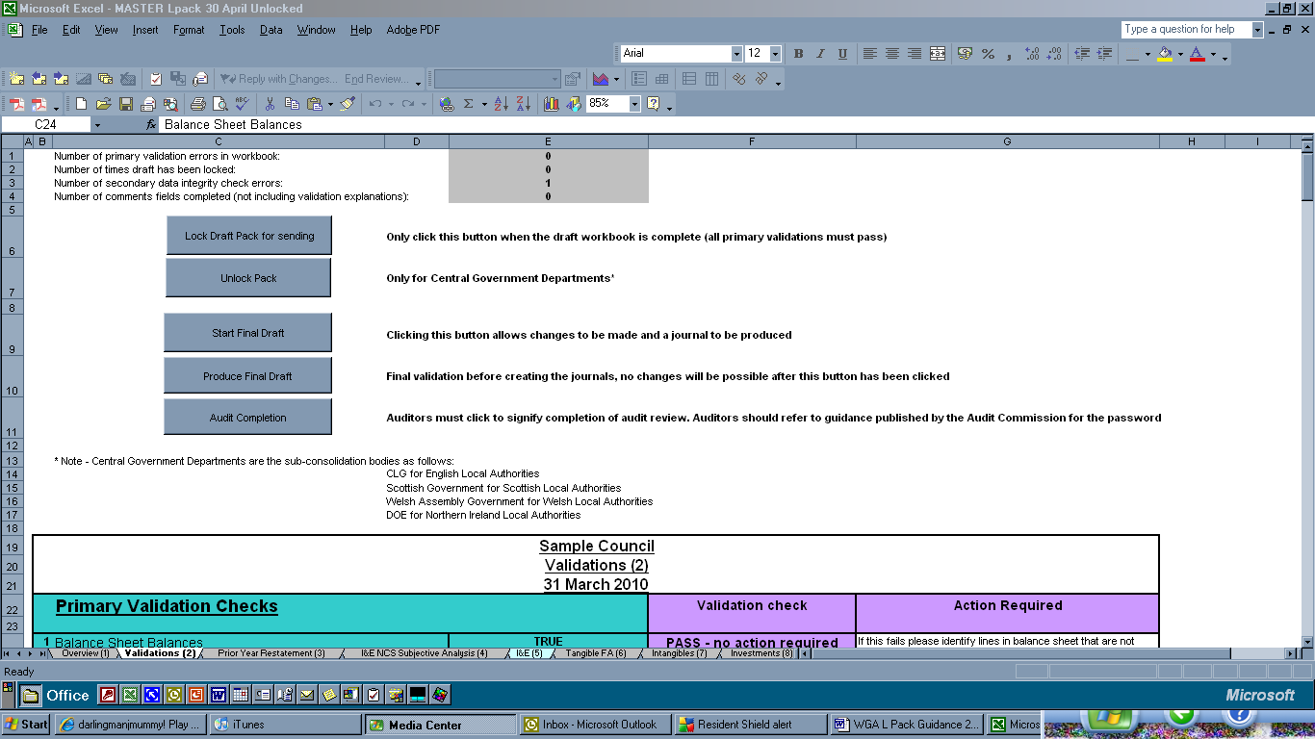
A
B
C
D

9.2.3. The pack is required to be completed and submitted to CLG by the deadline of 30th July 2010. (We strongly recommend that the Pack is submitted for audit review at the same time.) When the Pack has been completed then click on the button to “Lock Draft Pack for sending [A]. This will highlight any validation failures; the number of primary errors and the number of times the Pack has been validated [B]. This effectively locks the data. It is important that the data is locked. This is key when managing the upload of data post audit review.

9.2.4. CLG WGA team will review the validations and if there are material issues, we could unlock the data requiring the local government body to carry out some remedial work on the Pack. To do so we would click on [C].

9.2.5. The idea is to avoid too much duplication of effort, only the audit changes are required to be input into the L Pack. Therefore once the Pack that was locked is submitted by the 30th July deadline, the intention is that local government bodies will update the same pack with audit changes.

9.2.6. Local government bodies will click on the box stating “start final draft” [box D] and update as necessary. Then once all adjustments have been reflected in the Pack then the completers must click on the box titled “Produce final draft”. The reason for this is to generate a journal to be uploaded by CLG only of the changes between the draft and final accounts. This will save our workload too (negating the need to remove all 448 data sets and then re-inputting the same). This methodology has been successfully applied in the central government C pack in 2008-09.

9.2.7. Finally the auditors are required to click on the final button signalling completion of the audit (“Audit Completion” box – password protected).

9.2.8. This may appear rather confusing at first sight but we hope that the time saved in just updating for the audit adjustments will outweigh the need to re-perform the whole of the L Pack. This has the additional benefit of saving time for us at the centre in loading, removing and re uploading the data. However, to balance this we need to carefully manage the locking of the data so that only the changes are uploaded via a journal. Hence the need to have this strict sequencing of various checks.

9.2.9. The primary validations have increased from 3 to 7 and now it is no longer possible to submit the return if these primary checks fail.

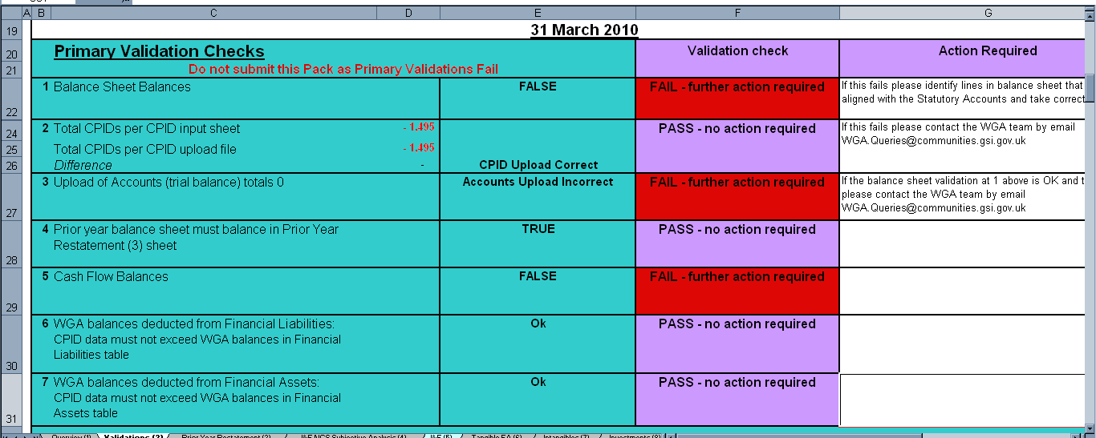
A

9.2.10. As discussed in Section 3 (changes to the 2009-10 L Pack) and Section 6 (Validations & Data Integrity Checks) the number of primary validations have increased significantly. This marks a general trend in the Pack to make these more robust and test the completeness, accuracy and the quality of the Packs received and included in the WGA. This is key as we are now producing the first live WGA. More information on each of the primary validations and the reasons for their determination as primary checks are included in Chapter 6 and not repeated here.

9.2.11. In keeping with the increased number of primary validations, the number of data integrity checks has grown significantly. There are now 27 data integrity checks:

Tangible Fixed assets 1
FRS 17 liability 7
Reserves 6
NNDR tax creditor/debtor 1
I&E – Financial Instruments 1
Cash flow – Govt grants 1
Prior Year Restatement 2
Financial Instruments 8
9.2.12. The data integrity checks are as follows:

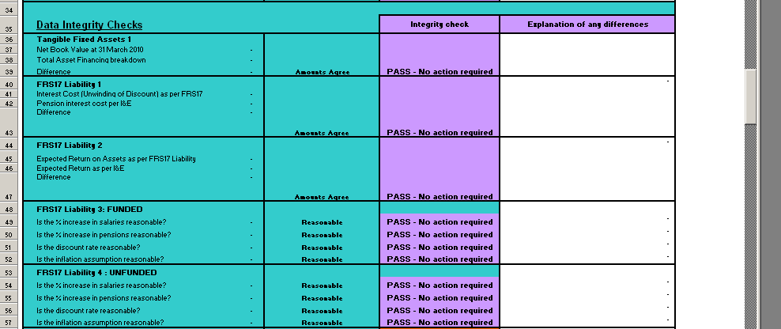
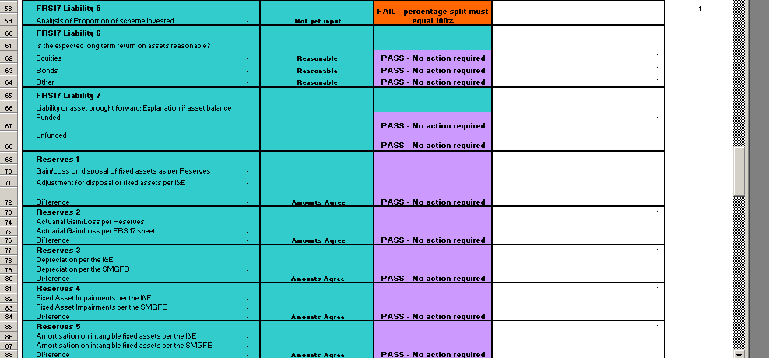
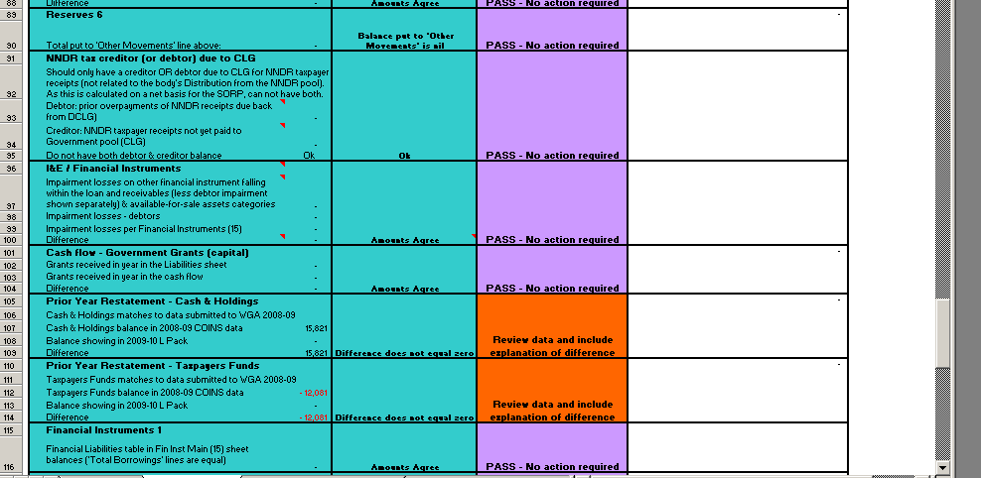
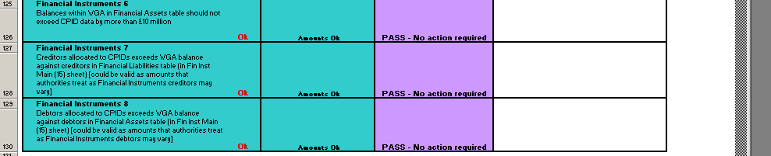

9.2.13. Many of these will be familiar but there are a number of additions. In particular the new reserves depreciation, amortisation and impairment data integrity checks (having split out the depreciation and impairments from the Statement of Movement of General Fund Balance we can do this check).

9.2.14. There are a number of additional checks associated with the Financial Instruments disclosures.

9.2.15. The only other notable additions are associated with the prior year sheet where the data held in COINS is being checked to the data submitted by local government bodies. Therefore both the taxpayer’s equity and the cash at bank are being compared.

9.2.16. As we have done previously there are comment boxes to provide explanations for differences. It is fully acknowledged that whilst we take considerable care in the development of the form to ensure that the tests are logical and sound (and based on the SORP Guidance Notes), there could be instances where local agreement between the body and their respective auditors could result in a seeming validation failure. All we request is that an explanation is provided.
PRIOR YEAR RESTATEMENT (Sheet 3)

9.3.1. This sheet was introduced in 2007-08 to identify the differences between the opening and closing balances, in order to explain major movements in the overall General Fund. Last year, additional lines were added to the prior year sheet in order to provide the information needed for the new Cash Flow sheet (14). These breakdowns are also reflected on other relevant sheets throughout the L Pack, for example, on the Liabilities and Provisions sheet. Also, as stated previously, we have made the prior year balance sheet balance a primary check and well as introducing two further data integrity checks to ensure the data input is the same as that included in COINS for the previous year.

9.3.2. The key changes to note are:
- The two new PFI disclosures (as a result of the SORP 2009 changes.
Change in the analysis for the reason for the differences to include the differences as a result of the adoption of IFRIC 12 (note this is wider than PFI).

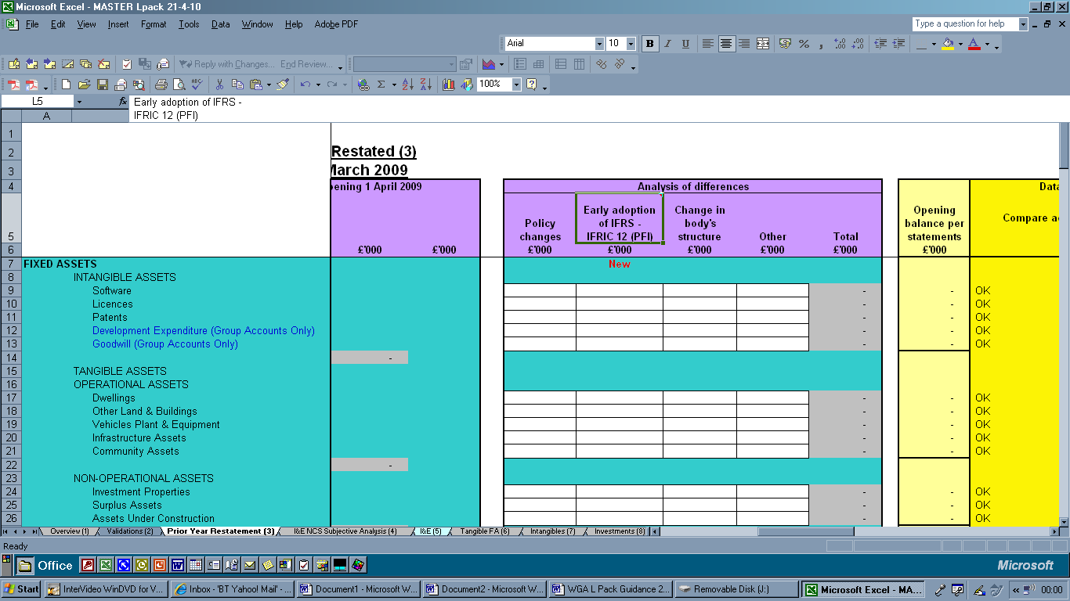
9.3.3. Another item to note is that we have tried to minimise repetition in data being input by linking cells where possible. In the Prior year restatement sheet we have linked the Taxpayers Funds section to the Reserves sheet.

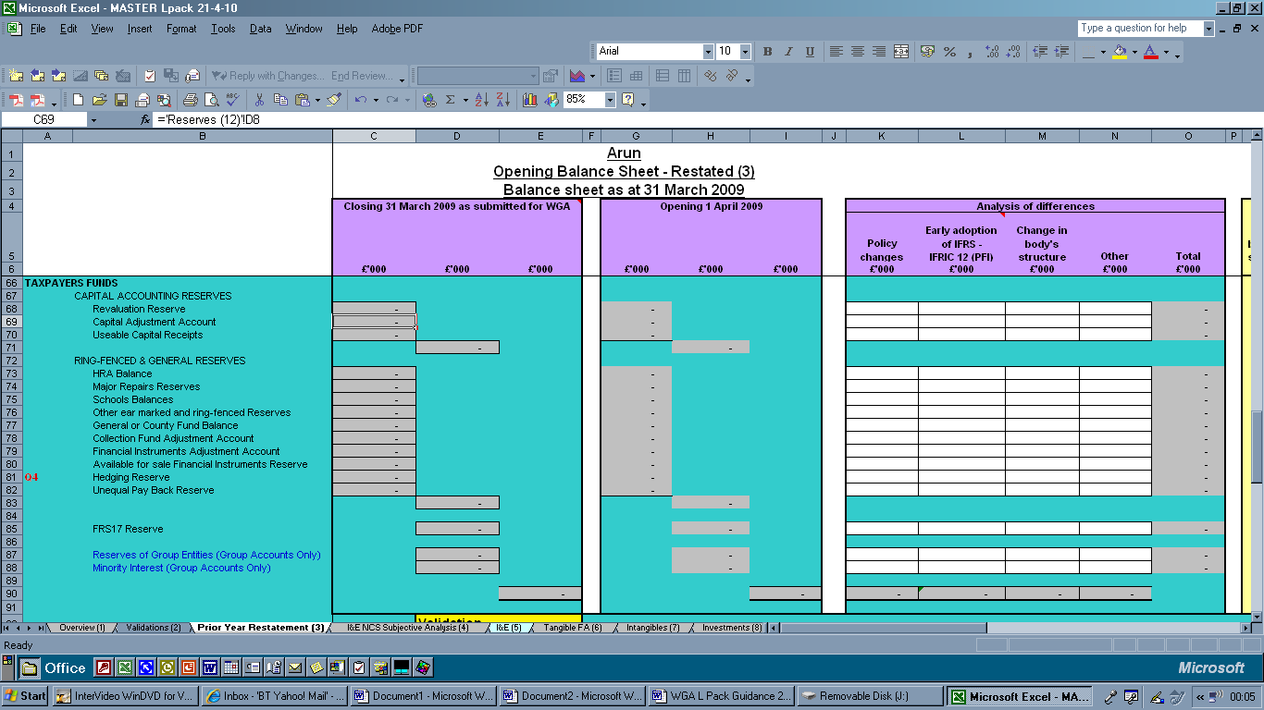

The cells which are auto populated are greyed out and not available for input. Therefore it may be easier to complete the L Pack in a different order rather than systematically working through the Pack from sheet 1 to the end as appropriate. See ‘Completion of the Pack’ within Section 3 of this guidance for the recommended order of completion.
INCOME AND EXPENDITURE ACCOUNT: NET COST OF SERVICES –
SUBJECTIVE ANALYSIS (sheet 4)

9.4.1. The categories included on this sheet generally follow the structure of “Groups” in the BVACOP Recommended Subjective Analysis. Where necessary we have included additional detail, as explained below. The sheet has been updated with comment boxes which cross reference to the relevant section, Section 4.9, in the BVACOP for clarity.

9.4.2. All income and expenditure within Net Cost of Services (NCS) in the authority’s Income and Expenditure Account should be included; including both the General Fund and Housing Revenue Account. The input for each line should include income and expenditure for all front-line and support services according to its nature. Key points to consider when completing this section are included below.

Employee Costs (BVACOP Group 1)

9.4.3. Include all employee costs charged to Net Cost of Services.

9.4.4. Details of Employers National Insurance Costs are required to allow the transaction with HM Revenue and Customs to be identified. NB – Employee National Insurance Contributions are a transaction between the employee and HM Revenue and Customs, i.e. they are ‘external’ to WGA. They should not be included in the intra-group transaction with HM Revenue and Customs.

9.4.5. Separate identification of transactions with unfunded centrally administered pension schemes (such as the Teachers’ scheme) will allow Employer’s Contributions to the relevant pension’s agency to be separately identified.

9.4.6. Note where there have been any payments as a result of the unequal pay back ruling these amounts should be included in the “employee expenses” section under direct employee costs.

Premises Costs (Group 2)

9.4.7. Business Rates should be disclosed separately in order that an appropriate adjustment can be made, – please note there is no need for the counter-party to be disclosed.

Supplies and Services (Group 4)

9.4.8. Audit Fees and PFI Service Charges are required to be disclosed separately in the WGA and so we need this information separately here. Include all other expenses charged under these Groups in the other box.

Third Party Payments (Group 5)

9.4.9. A third party payment is a payment to an outside provider (or an internal delivery service unit of the authority defined as a trading operation in accordance with Section 2 Annex D of BVACOP) in return for the provision of a service.

9.4.10. Recharges from internal trading operations should be included within ‘Internal Units Within the Council’. Recharges from support services that are not defined as internal trading operations should be included in Support Services (Group 7) in accordance with BVACOP.

9.4.11. Payments to NHS Trusts and NHS Foundation Trusts should be recorded in the relevant cell, and counter-party data entered in the counter-party data sheet for payments greater than £1 million. Payments to Primary Care Trusts and Strategic Health Authorities should be entered in the ‘Government Departments’ cell and counter-party data entered as relevant (typically, the Department of Health).

9.4.12. Levies have been separately analysed within this group to assist in the automatic eliminations process. The SORP is not prescriptive, and levies can be shown above or below the net cost of services line. Therefore there are cells to accommodate levies both above and below the NCS line. WGA packs should be completed in line with authorities’ own accounts, with the relevant counter-party data for amounts over £1 million entered in the counter-party data sheet. Income from levies or net expenses funding arrangements should be included in LA Levy Income.

9.4.13 Analysing this Group into the BVACOP Sub-Groups representing the various parts of the public sector should help local authorities identify those transactions that are “internal” to WGA. Authorities may be able to use this analysis in identifying counter-party transactions for elimination purposes. Details of transactions with internal units are required for the reasons set out in Section 7.

Transfer Payments (Group 6)

9.4.14. Transfer payments are payments to individuals for which no goods or services are received by the authority. Include all transfer payments made by the authority whether chargeable to the General fund or HRA.

Support Services (Group 7)

9.4.15 Recharges from support services should be allocated or apportioned to front line services in accordance with the SORP and BVACOP. It is not necessary for authorities to analyse which support service ‘originated’ the debit.

9.4.16. Include all recharged expenses from support services here. Recharges from internal trading operations should be included in line 46 in accordance with BVACOP. Some authorities may operate a policy of coding the ‘recharge credit’ to the support service cost centre to this Group. This is acceptable for WGA purposes.

Depreciation and Impairment charges (Group 8)

9.4.17. The impacts of capital items on NCS should be included here. These have been sub-divided into the following categories:
- Depreciation
- Amortisation of intangible assets
- Loss on Impairments, including impairments due to a change in market value as well due to the consumption of economic benefits.
- Amortisation of Government Grants deferred – this is the income recognised in the I&E to offset the depreciation charge associated with bringing the asset into use. This is an auto populated cell and derived from the Liabilities and Provisions sheet.
- Amortisation of Other Capital Grants & Contributions (Non-Govt) – this is the other contributions being recognised in the I&E. This has been split out from government grants deferred (although no such split is required in BVACOP or the SORP). The reason to split this out is to ensure the government grants deferred can be matched to the Liabilities and Provisions sheet (and the counter-party). Again this value is auto populated from the information provided in the Liabilities and Provisions section (and acts as a further data integrity check).
- Revenue funded from Capital under statute – was introduced last year, although as stated in the comment box BVACOP do not envisage that this is required as this should be analysed according to the most appropriate revenue service.

Income (Group 9)

9.4.18. This section has undergone a significant change in an attempt to fully understand and correctly record the income received. This will help CLG and HMT prepare central adjustments as required.

9.4.19. All income credited to NCS should be included in this Group.

9.4.20. Over the last few years the WGA process has required more information on the government grants received so that we can better understand and match/eliminate with the data provided by central government departments. We have now split revenue income into the following:
- Revenue income for a specific purpose (therefore included in the NCS
- Revenue that has an inherent deferred element – Dedicated Schools grant

- Revenue income for general purpose (included in the Net Operating Expenditure. (This is discussed in section 9.5)

9.4.21. Revenue grant income received from central government for specific purposes (therefore included in the NCS) is required to be analysed into the following:
A

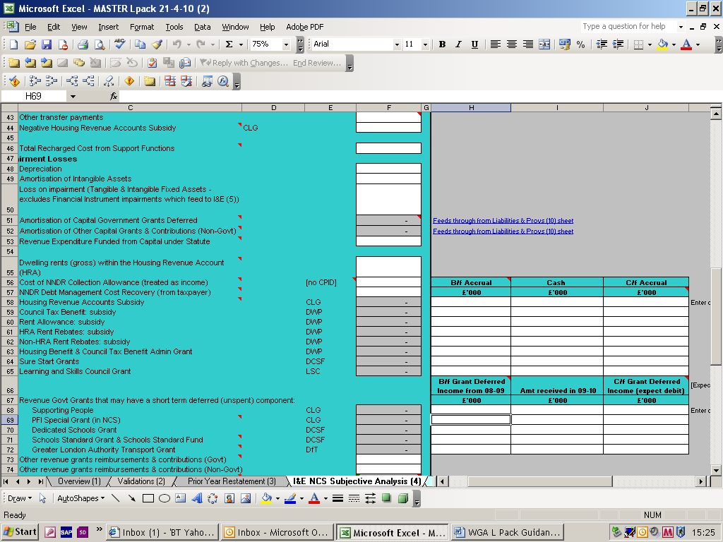

9.4.22. There may be a brought forward element to the grant: Please include this amount in the b/f accrual. Input any previous year brought forward balance as a debit (positive) e.g. £100 income recognised (accrued) in the previous year, but received as cash in the current year would be recorded as a £100dr. If there was a settling-up prior period adjustment that required a payment back to central government, then this should be recorded as a credit.
The cash received in the year is simply that – the cash grant received.
The carried forward accruals for income recognised but not yet received may be negative here (with a corresponding debtor/accrued income in current assets) due from central government, or positive (with a corresponding creditor/accrued expense in liabilities) due to overpayment of grant.

9.4.23. This analysis will auto populate the values to be included in the cells (ref A). Please complete the form so that the values in the NCS are as per your Statutory Accounts.

9.4.24. Revenue grants that have an inherent deferred element, for example the dedicated schools grant, are treated differently. The dedicated schools grant runs for a period of 17 months e.g. the 2009-10 grant determination covers the period from 1st April 2009 to 31st August 2010. Therefore to ensure that we are matching the amounts relating to 2009-10 in both the central government WGA information and the local government L Pack information we need this to be separately identified on the return.

9.4.25. Again the amounts that are recorded in the NCS are automatically populated from the breakdown required (i.e. the brought forward or deferred income element for the last year, amount received in the current year and the carry forward element (deferred income liability component)). Therefore these amounts should be input to ensure that the amounts recorded in the NCS are the same as per the Statement of Accounts. Note Enter data using appropriate signs so the figure in the I&E sheet (column F) results in the amount reflected in your I&E (Column F is the sum of H to J).

9.4.26. Therefore in the NCS there will be brought forward grant deferred income from 2008-09 (covering 1st April 2009 to 31st August 2009). This should be recorded at [A]. Note this is expected to represent the amount recognised as a current liability (deferred revenue grant income) in 2008-09, in which case negative amounts (credits) are appropriate in this column).
A
C

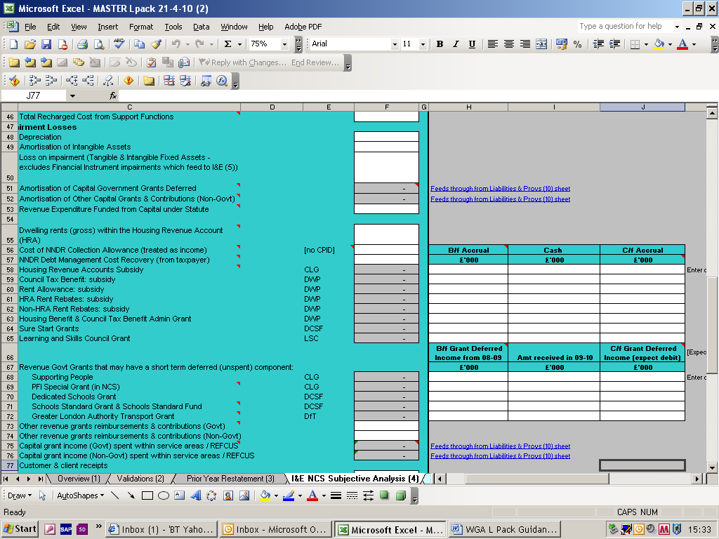
B

9.4.27. Please include the amount received in 2009-10 in the middle column (B). Include the carried forward deferred element in the final column (C). These will be a debit (positive) amount against income (in (C)), and flow through to the Liability and Provisions sheet as a credit.

9.4.28. Government grants recognised within NCS should be identified as counter-party transactions. To assist the counter-party identification process the Pack automatically populates the counter-party identifier (CPID) in the counter-party data sheet. More information regarding counter-party information and worked examples are included in section 9.16.

Grants include:

CLG: Housing Revenue Accounts Subsidy
Supporting People
PFI Special Grant
DWP: Council Tax Benefit
Rent Allowance
HRA Rent Rebates
Non-HRA Rent Rebates
Housing Benefit & Council Tax Benefit Admin Grant
DCSF: Dedicated Schools Grant
Schools Standard Grant & Schools Standard Fund
Sure Start Grants
DFT: Greater London Authority Transport grant

9.4.29. The extract below shows us the government grant information required within the NCS. It is hoped that the grant streams identified will cover the majority of the grant income received/receivable by local government. There is also a cell for other government grant information. Further information relating to which government department this is received from is required on the counter-party sheet.

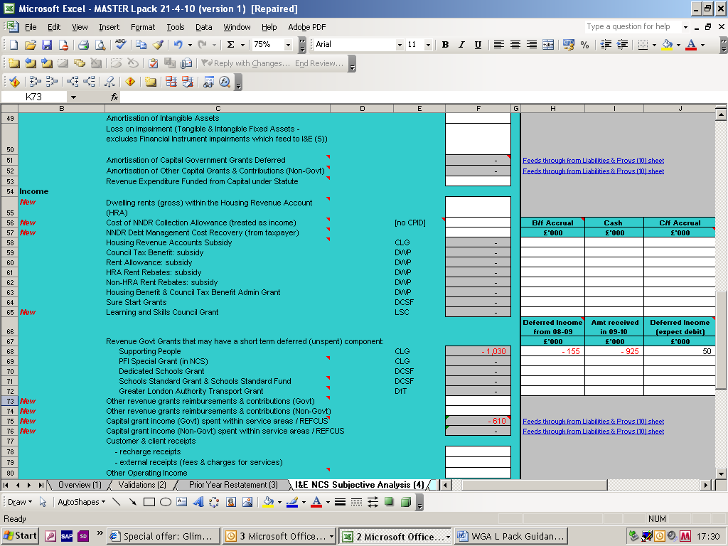

9.4.30. As we have done in previous years we are working with the central departments who issue major grant streams to try and make available to local government bodies the transaction balances held with them. These should be posted on our website when ready and should prove a useful tool to assist in the identification and completion of counter-party information.
http://www.communities.gov.uk/localgovernment/localgovernmentfinance/governmentaccounts/wga200910/

9.4.31. There is no expectation that there should be any agreement of balances, however local government bodies should assure themselves of the completeness and accuracy of the information included in the counter-party sheet. Whilst considerable improvement has been made by many authorities since 2006-07, the quality of data provided remains inconsistent and needs improvement. This is the biggest single issue in the completion of the sub consolidation. Hence the redesign of this section of the form.

9.4.32. Generally recharge income will be shown in this Group. It is important that this figure be separately identified for the reasons set out in Section 7.

Landfill Allowance Trading Scheme

9.4.33. The various accounts that are used in this scheme are separately categorised to enable elimination within the consolidated accounts. The breakdown also facilitates more consistent treatment as to where to disclose these amounts.

Other Items (Group Accounts only)

9.4.34. Include the total recorded in the Authority’s own Group Accounts for each of these items.

Net Cost of Services

9.4.35. This automatically generated total should be the same as the Net Cost of Services shown in the authority’s own accounts. It is understood that when Auditors review the L Pack they apply a “consistent with” (the statement of accounts) opinion. Therefore, the Net Cost of Services figure is one of the Auditor’s primary checks. However, as we are now in the first live year, this is being reviewed by the auditors (at the time of writing the guidance – any update on this position will be advised).

INCOME AND EXPENDITURE ACCOUNT: NET OPERATING EXPENDITURE
AND SURPLUS/DEFICIT FOR THE YEAR (sheet 5)

9.5.1. All items included in the Income and Expenditure account should be reported here, in accordance with the authority’s statutory accounts. This includes transactions on the Housing Revenue Account (HRA), if applicable, and General Fund Services.

9.5.2. The L Pack should follow the reporting convention outlined in the SORP. The net cost of services figure is automatically transferred across from the Income and Expenditure Account subjective analysis – sheet 4.

Levies

9.5.3. This should include levies made on the authority and net expenses funding for other public sector bodies charged to the authority, which are disclosed below the net cost of services line within the authority’s accounts. Most bodies whose funding is included in this line will be included in WGA and the authority should also report the details of amounts over £1million on the Counter-party Data sheet. Typically, this will include levy payments made to waste or transport authorities (now renamed the integrated transport authorities).

9.5.4. Income from levies or net expenses funding arrangements should be included in LA Levy Income.

Gains/Losses on Disposal of Fixed Assets

9.5.5. Include gains and losses as shown on the face of the authority’s I&E. Please see Module 5 of the SORP Guidance Notes for the detailed accounting treatment.

Local Precepts

9.5.6. Include precepts from all local precepting bodies such as Town, Parish and Community Councils (but excluding major precepting authorities, such and police, fire and county councils).

9.5.7 These bodies are excluded from WGA on materiality grounds and it is not necessary for authorities to identify transactions with these bodies on the Counter-party Data Sheet.

Trading Operation Expenditure

9.5.8. Include the results of all trading operations, after any internal reapportionment required by BVACOP.

9.5.9. The SORP requires that the net trading outcome is reported on the face of the I&E Account. The WGA team would be delighted if the income and expenditure from trading could be included in the respective subjective analysis. If this is not feasible we ask that you provide the gross income and expenditure. This will allow us to provide some detail of authorities trading performance and will also facilitate the adjustment of internal recharges from support services included within Net Cost of Services and avoid some double counting (e.g. of FRS 17 costs).

Dividends receivable – Other

9.5.10. Include dividends receivable from all local authority investments in shares (other than the return on pension scheme assets reported under FRS 17).

Interest Payable and similar charges

9.5.11. This section has been revised significantly following the introduction of the Financial Instruments disclosures (15) and NAO review of the completeness of the counter-party information.

9.5.12. The interest payable and similar charges is required to be further analysed into the following:

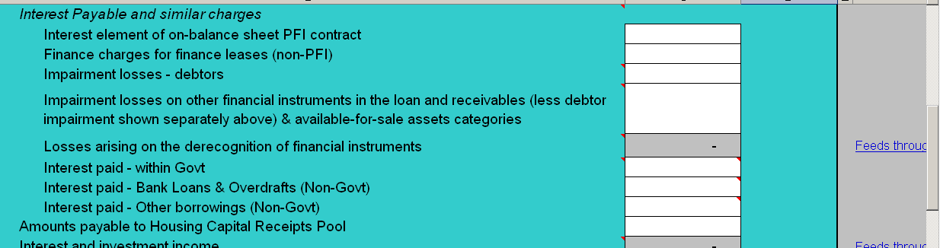

The key changes to note here is the new disclosure as PFI is introduced; Impairment losses separated for financial instruments and other debtors, Note SORP Module 6 paras A14 - A18 inclusive - this amount should also include the interest receivable at the higher rate in respect of soft loans.

9.5.13. Interest paid is required to be analysed into intra WGA boundary bodies i.e. interest paid to PWLB would be disclosed here and interest payments to other local authorities on transferred debt. Any relevant transactions streams and balances over £1million between the two bodies must be recorded on the Counter-party data sheet. Although the same has been requested in the past, this year we have split this out between government and non-government on the face of the I&E as a further reminder.

Amounts Payable to the Housing Capital Receipts Pool

9.5.14. Only Housing Authorities should enter any value in this cell. This payment should equal the payment debited to the I&E account and shown on the face of the account. Values entered in here automatically update the relevant cell in the counter-party data sheet, with CLG automatically entered as the relevant CPID code.

Interest and investment income

9.5.15. Include all interest and other investment income not received as dividends.
This includes financial assets as classified in the SORP. Include:
- Loans and receivables: any interest receivable, impairment losses and gain or loss on de-recognition.
- Available for sale assets: interest and dividend income, impairments and the gain or loss arising on de-recognition.
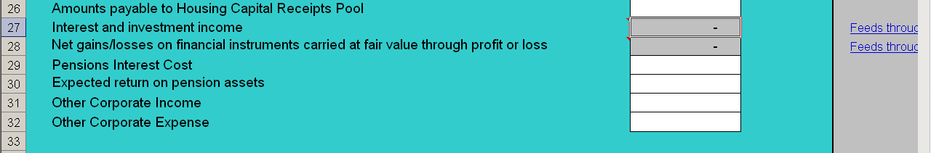
A
B

9.5.16. Interest and Investment income [A] is auto populated from the Financial Instruments Main (sheet 15). The detailed analysis required as per the SORP Module 6 Table E11 provides the summary for this. Again this acts as an additional data integrity check. To include financial asset income as classified in the SORP. Loans and receivables: any interest receivable, and gain on derecognition. Available for sale assets - interest income, and the gain arising on derecognition.

9.5.16. The net gains/losses on financial instruments carried at fair value through profit or loss [B] is also auto populated from the detailed analysis provided in the Financial Instruments Main sheet. SORP Guidance Module 6 Section E, para F14 pg 705. Includes revaluation movements and gain/loss on derecognition. ie. all amounts recognised through the I&E for financial instruments carried at fair value through profit and loss (held for trading & derivatives) are recognised here.

Expected Return on Pensions Assets

9.5.17 Include the total of each of these items charged to the I&E in accordance with the SORP. It is expected that the pensions interest cost would be a debit (i.e., a positive value) and the expected return on assets a credit.

Other Corporate Income

9.5.18. All other income included within Net Operating Expenditure in the authority’s accounts.

Other Corporate Expenditure

9.5.19 All other expenditure included within Net Operating Expenditure in the authority’s accounts.

Group Accounts Only

9.5.20 Include the total of each of the following items in accordance with the SORP:
- (Profit)/Loss on Disposal of Group Entity Assets
- Share of Interest Payable of Associates & Joint Ventures
- (Gains)/Loss on Repurchase or Early Settlement of Borrowing
- Share of Interest & Investment Income of Associates & Joint Ventures
- Share of Pension Interest Cost & Expected returns of Associates & Joint Ventures
- Taxation Payable of Group Entities
- Share of Taxation Cost of Associates & Joint Ventures
- Minority Interest Share of Profits or Losses of Subsidiaries

9.5.21. These items will feature above Net Expenditure but before Reserve Movements and should be input with any amounts recorded in the Authority’s own Group Accounts.

Net Operating Expenditure

9.5.22. This automatically generated total should be the same as the Net Operating Expenditure shown in the authority’s own accounts.

Income from Council Tax

9.5.23 This is a new requirement and is as a result of the changes in the SORP 2009, requiring Council Tax to be accounted for on an agency basis. Therefore billing and precepting authorities will include their respective income from Council Tax here (regardless of who actually collects this money).

LA Levy Income, Revenue Support Grant, Distributed Non-Domestic Rate Pool, Police Grant and Area Based Grant

9.5.24 These are general government grants which local government bodies are free to spend on locally determined priorities. Note the distributed domestic rate pool figure is that amount which local government receive from CLG. The actual collection of NNDR is recorded on an agency basis.

9.5.25. The amount of grant receivable for the year should be reported as a transaction stream on the Counter-party Data sheet. Any balance outstanding at the year end should be reported as a debtor (creditor if overpaid).

9.5.26 Note as we have done for previous years, government grant information will be made available on the CLG WGA website (when this is available from central government departments – due 30 June).

9.5.27. Also the following link will be helpful to you http://www.communities.gov.uk/localgovernment/localgovernmentfinance/areabasedgrant/

General Greater London Authority Grant

9.5.28. Greater London Authority and Functional Body use only. This grant has a deferred component – therefore we need this to be recorded separately (similar to that required in the NCS).

PFI Special Grant (not in the NCS)

9.5.29. Following feedback from the 2008-09 some local government colleagues stated that they had PFI special grants not in the NCS. Hence this line has been introduced here. Again this type of grant will have an inherent deferred component. Therefore we require the analysis similar to that in the I&E NCS sheet (4).

Other (Government) Grants (non capital)
9.5.30 Include any other general (un-hypothecated) grant receivable from central government not included in the above and recognised in the authority’s I&E below Net Operating Expenditure. Does not include REFCUS or capital grant income recognition. This includes all other grant income including LABGI - SORP technical query answer refers - this is a non-specific grant and therefore should be included with general government grants at the bottom of the I&E, below the figure for "Net Operating Expenditure"

Other Grant Income (Non government)

9.5.31. Include any grants received (other contributions) for general purposes that have not been included elsewhere in the I&E.

Amortisation of Grant Income

9.5.32. These cells are included here to recognise the grant income (government or other contributions) where an asset has been created and is brought into use and so will attract a depreciation charge – the income is recognised at this stage. Therefore if the asset is fully financed by the grant then it follows that the depreciation charge is fully offset by the amount recognised as income here. These cells are auto-populated from the information in the Liabilities and Provisions sheet and acts as a further data integrity check.

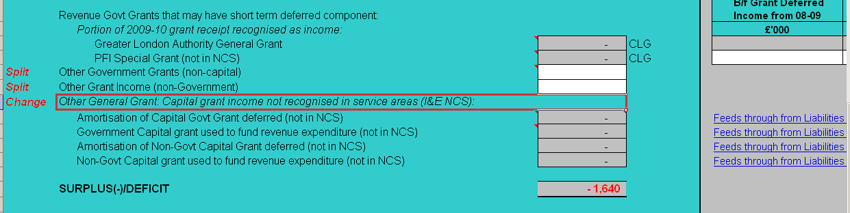

Surplus/Deficit for the Year
9.5.33 This automatically generated total should be the same as the surplus/deficit shown in the authority’s own accounts. Auditors will check this figure to ensure that the L Pack is consistent with the authority’s statutory accounts.
TANGIBLE FIXED ASSETS (sheet 6)

Classification of Tangible Fixed Assets

9.6.1. The asset classes available in the return follow the Balance Sheet format in the SORP. Authorities should include all tangible fixed assets in the relevant class in line with their accounts.

Valuation of Tangible Fixed Assets

9.6.2. Tangible fixed assets should be valued in accordance with the SORP, as included in the authority’s accounts. Movements in the value, other than depreciation, should be grouped as follows:
- Additions should include all purchases of tangible fixed assets and recognition of any internally constructed assets.
- Disposals represent the writing out of the gross book value on the sale of tangible fixed assets or their transfer to another party. It does not include the writing-off of assets which no longer have readily ascertainable market value. Disposals of assets under construction are not recognised within the SORP, so the relevant cell has been greyed out.
- Impairments include all diminutions of value below the previous carrying value of the asset, other than depreciation; this includes the writing-off of assets. Investment properties are not subject to impairment; as per SSAP 19 they are held at the balance sheet at market value, and downward movements in value should be classified within revaluations.
- Reclassifications should be between classes of tangible assets.
- Revaluations both upwards and downwards should be included here. Note that as per the SORP, infrastructure and community assets are held at depreciated historical cost and should not be revalued upwards.
- Other Movements may be used for any other movements in the un-depreciated value of the asset. If an authority is unable to distinguish movements the undifferentiated movement should be included here.
- Separate local agreement as to the accounting treatment applied may exist - e.g. some authorities do indeed revalue the community assets as agreed with their auditors. As the revaluations cell is locked, these non SORP amendments should be reflected in the ‘other movements’ column.
- Comment boxes have been added to clarify where the boxes have been locked to prevent input. This was the source of many of the queries raised with CLG and HMT. The comments highlight the relevant guidance in the SORP that for example requires the infrastructure and community assets to be held at depreciated historical cost and not subject to revaluations – hence there is no facility on the form to do so.

Depreciation of Tangible Fixed Assets

9.6.3. Authorities will adopt different policies about depreciation in the year of acquisition and disposal, depreciation methods or asset lives. It is neither practical nor desirable to specify the depreciation policy to be followed for specific assets. For WGA, authorities should use the policies that apply in their statutory accounts.

9.6.4. WGA draws a distinction between the amount of depreciation due to the historical cost and current value of the asset. This allows WGA to be prepared to include an Accumulated Income and Expenditure Reserve incorporating only realised gains and losses in accordance with GAAP.

9.6.5. We recognise that analysing depreciation between these elements is not usual practice within local government as all depreciation is transferred to the Capital Adjustment Account. Authorities that can easily produce an analysis between the current and historical cost elements of depreciation are encouraged to provide this information.

9.6.6. The total depreciation charge for the year should be analysed as follows:
- Charge for the Year: Ideally this is the charge for the year based on the un-revalued cost of the asset. Where it is not practicable to analyse between the historical cost depreciation and current value depreciation, both elements may be credited here.
- Disposals: The written-out balance of accumulated depreciation for all disposals should be debited here.
- Reclassifications: Debit here the reclassified balance of accumulated depreciation.
- Revaluations: Ideally this is the element of the charge for the year based on the revalued element of the book value of the asset. Where it is not practicable to analyse between the historic cost depreciation and current value depreciation, both elements may be credited here.
- Other Movements: may be used for any other movements in the amount of depreciation

Asset Financing

9.6.7. GAAP requires that WGA disclose, for each class of asset, the net book value of public sector assets financed by PFI and conventional finance leases. Only a relatively limited amount of information is required. This should be available from notes to the core financial statements. The totals of the asset financing section should equal the NBV of fixed assets as at 31 March 2010.

Additional Data Integrity Checks

9.6.8. A new data integrity checks has been introduced on the tangible fixed assets sheet to check that the analysis of the asset financing equals the net book value of the assets held [A] .

Comment Box

9.6.9. A new comment box (similar to that on every sheet) has been introduced to allow authorities to make comments – this may be to highlight where there has been a departure from the SORP (on which the L Pack is based) following agreement locally with the auditors.
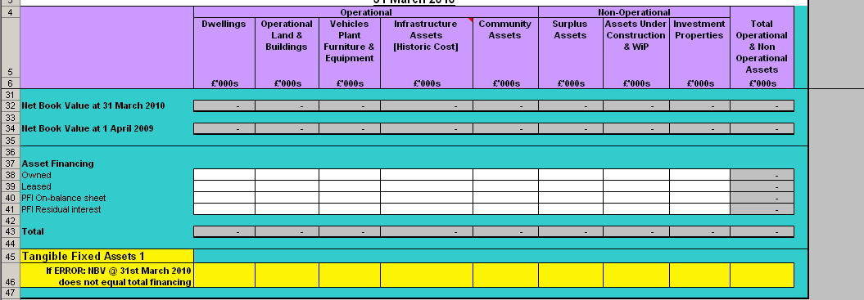
A
INTANGIBLE ASSETS (sheet 7)

Classification of Intangible Assets

9.7.1. The SORP states that local authorities will not have capitalised development expenditure, and goodwill will not apply in the single entity only statements. Hence we expect that for authorities reporting as single entities, intangible assets will consist mainly of purchased software licences (or internally developed software), other purchased franchises, licences and patents.

9.7.2. For those authorities producing Group accounts, companies may have additional categories of intangible asset within their accounts. For group accounts, two additional columns exist within the note:

- Development Expenditure
- Goodwill

Valuation of Intangible Assets

9.7.3. Intangible fixed assets should be valued in accordance with the SORP as included in the authority’s accounts.

9.7.4. Movements in value, other than amortisation, should be grouped as follows:
- Additions: should include all purchases of intangible fixed assets and recognition of any internally generated assets with readily ascertainable market value.
- Disposals: represent the writing out of the gross book value on the sale of intangible assets or their transfer to another party. It does not include the writing-off of assets which no longer have readily ascertainable market value.
- Impairments: include all diminutions of value below the previous carrying value of the asset, other than amortisation; this includes the writing-off of assets which no longer have readily ascertainable market value.
- Reclassifications: are likely to be between classes of intangible asset.
- Revaluations: of intangible assets are likely to be rare as these are only admissible in the SORP where there is a readily ascertainable market value. Where an authority does revalue an asset this should be included here.
- Other Movements: may be used for any other movements in the unamortised value of the asset. If an authority is unable to distinguish movements the undifferentiated movement should be included here.

Amortisation of Intangible Assets

9.7.5. It is likely that most intangible assets in local government will have finite lives and thus be subject to amortisation.

9.7.6. Authorities may adopt different policies about amortisation in the year of acquisition and disposal, amortisation methods or asset lives. It is neither practical nor desirable to specify the amortisation policy to be followed for specific assets. For WGA, authorities should use the policies that apply in their statutory accounts.

9.7.7. WGA draws a distinction between the amount of amortisation due to the historical cost and current value of the asset. This allows WGA to be prepared to include an Accumulated Income and Expenditure Reserve incorporating only realised gains and losses in accordance with GAAP.

9.7.8. We recognise that analysing amortisation between these elements is not usual practice within local government as all amortisation is transferred to the Capital Adjustment Account. Authorities that can easily produce an analysis between the current and historical cost elements of amortisation are encouraged to do so.

9.7.9. Where possible, authorities should include any existing amortisation of deferred charges as the opening balance. The total amortisation charge for the year should be analysed as follows:
- Charge for the Year: Ideally this is the charge for the year based on the asset’s un-revalued cost. Where it is not practical to analyse between the historic cost depreciation and current value depreciation both elements may be credited here.
- Disposals: The written-out balance of accumulated amortisation for all disposals should be debited here.
- Reclassifications: Debit here the reclassified balance of accumulated amortisation.
- Revaluations: Ideally this is the element of the charge for the year based on the revalued element of the book value of the asset. Where it is not feasible to analyse between the historic cost amortisation and current value amortisation, both elements may be credited here.
- Other Movements: can include any other movements in the amount of amortisation.

Comment Box

9.7.10. A new comment box (similar to that on every sheet) has been introduced to allow authorities to make comments – this may be to highlight where there has been a departure from the SORP (on which the L Pack is based) following agreement locally with the auditors, or there is other information that the completer of the Pack wants to bring to our attention.
INVESTMENTS (sheet 8)

9.8.1. This sheet requires the detail of local authority investments (other than investment properties which are on the fixed assets page).

9.8.2. The data requirements in this sheet has expanded considerably since the 2008-09 L Pack. The reason for this is that the presentation of the WGA requires this level of detail and it is important to have this breakdown for the counter-party sheet as well as the financial instruments disclosure sheets.

9.8.3. Greater detail on the accounting for financial instruments is included in
Module 6 of the SORP guidance notes.

9.8.4. The investments are required to be analysed into the short term and long term component. The long term component requires greater analysis (as can be seen below)

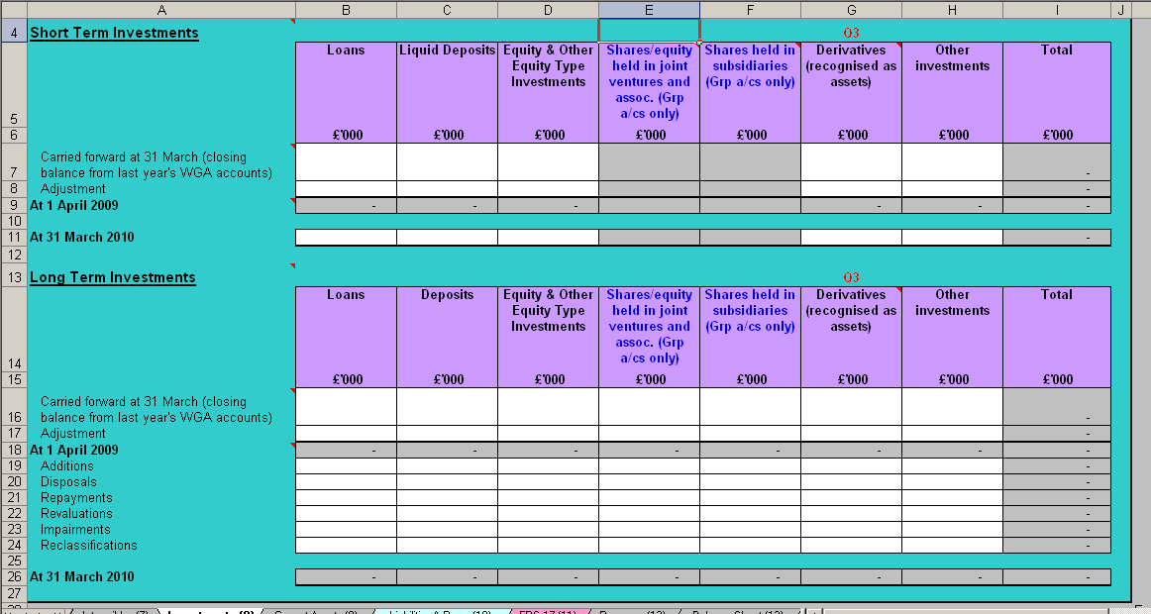

Short term Investments

9.8.5. Short term Investments should be analysed as follows:
- Loans
- Liquid deposits is the same as liquid resources as defined in the SORP Glossary. These are current asset investments held as readily disposable stores of value, i.e., disposable without curtailing or disrupting an authority’s activities, and either readily convertible into known amounts of cash at or close to its carrying amount, or traded in an active market. Included overnight and short-term deposits with brokers here. Careful consideration should be given as to whether counter-party data is necessary to accurately reflect the authority’s data as at 31 March 2010.
- Equity and other equity type deposits including investments listed on a recognised stock exchange.
- Derivatives (if the authority has stated that they have derivatives in the essential checklist)
- Note, Shares / equity held in Subsidiaries / Joint Ventures and associates is not available for data input as these are by definition not held on a short-term basis.
- Other Investments should include all other financial asset investments except investment properties, which are included in Tangible Fixed Assets.

Long term Investments

9.8.6 Long term investments are required to be analysed into the same categories. In addition the following is also required to be disclosed:
- Shares / equity held in Subsidiaries / Joint Ventures and associates This analysis is required for disclosure purposes. The information required should be available from the notes to the core financial statements.

9.8.7. The categories are required to be further analysed into opening balances, additions, disposals, repayments, revaluations, impairments, reclassifications to give the final closing balance. This is required as the presentation in the WGA for this information is on this basis. It is hoped that this break-down will be available to local government bodies.

9.8.8. Note some of these investments may be held with bodies within the WGA consolidation boundary and so will need to be disclosed onto the counter-party data sheet. For example some liquid deposits may be to other local government bodies.

CURRENT ASSETS (sheet 9)

Stocks and Work-in-Progress

9.9.1. The SORP does not require stocks and work-in-progress to be further sub-analysed, however we require these to be broken down into their sub groups. Hence the sheet has been changed to require this information. This also provides the necessary analysis to calculate the stock movement for the cash flow.

9.9.2. This is a standard disclosure under GAAP where the amounts are material.

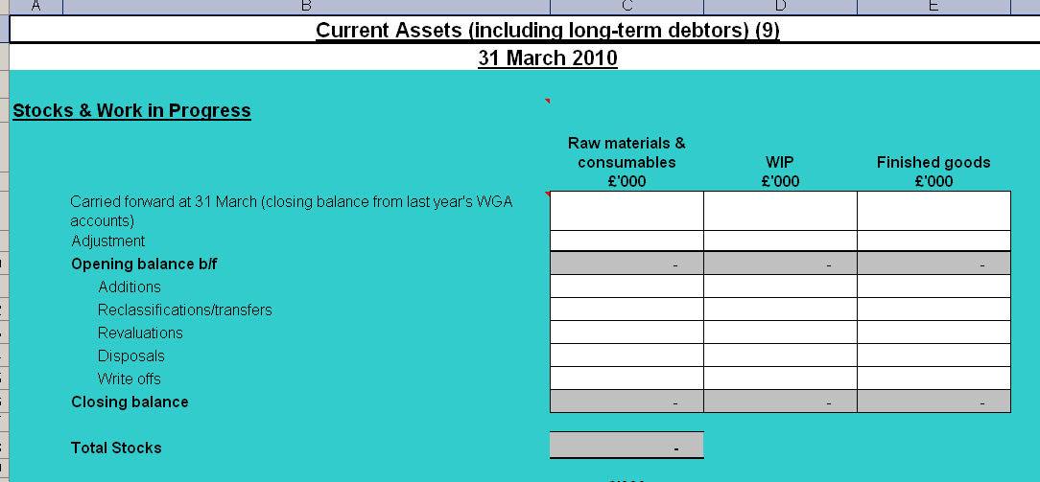

Landfill Allowance Asset

9.9.3 The value of the year end current asset relating to landfill usage allowance should be inserted here.

Debtors

9.9.4. This section has changed too to require a greater analysis of the of the debtor position, including the short and long term provisions for doubtful debts. Note it is important that all debtors relating to loans and deposit debtors are included in the investments sheet (to which they are proper).

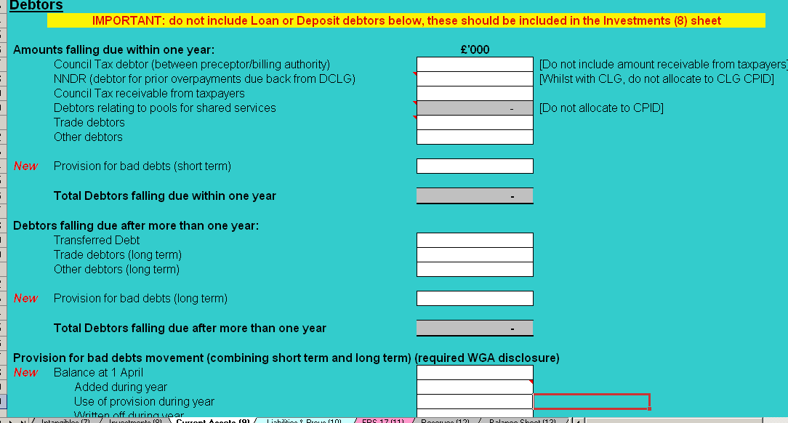
B
A

9.9.5. With the change to the accounting for Council Tax (to be required on an agency basis) there will either be a debtor or creditor at the year end – please record the debtor at [A].

9.9.6. The debtor should be the amount due from the billing or precepting authorities and does not include any amounts outstanding from local council tax payers (this is required to be disclosed separately at [B].

9.9.7. The NNDR debtor is included for any debtor that may be due back from CLG as a result of previous overpayments of NNDR.

9.9.8. Where local government bodies have identified any pooled budget arrangements there could be a debtor in the following circumstances:
- reimbursement due from pool for direct expenditure;
- refund due for the balance left in the pool at year end; or
- for hosts that include the pool within their accounts, the amounts due from other bodies to balance the pool at year end.
This amount is automatically populated from the Pooled Budgets sheet (19) as is indicated from the comment.

9.9.9. To complete the debtor analysis please include any trade debtors and other debtors.

9.9.10. Transferred debt arising from local government reorganisation has been separated out on to a separate line within long term debtors, because of the materiality of these balances, and so as to highlight the need for values to be entered into the counter-party data sheet.

Provision for bad debts movement (combining short term and long term)

9.9.11. A change to previous years where the debtors were requested to be net of the provision for bad debts, we need this to be disclosed separately – this is a requirement in the WGA. This has to be split between the provision for short term and long term bad debts. To ensure that the analysis of the provision for bad debts is complete a validation has been added [B].
A
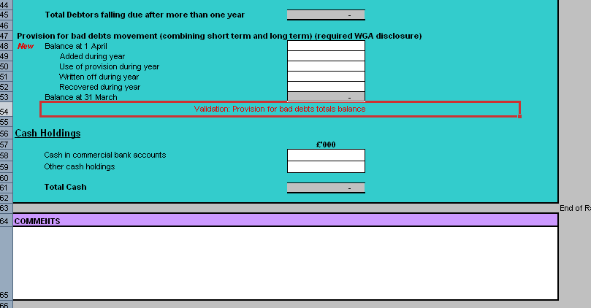
B

Cash Holdings
9.9.12. Include only positive cash balances with the authority’s bankers. Overdrafts should be included in Creditors within one year – bank overdraft.

Comment Box

9.9.13. A comment box has been added to the sheet if the local government body wish to add any further information.
LIABILITIES AND PROVISIONS (sheet 10)

9.10.1. This sheet should be used for all current liabilities and any deferred discounts.

9.10.2. Please note that we ask for borrowings to be split between those due after one year and those amounts falling due within one year. This includes separating out the amount of a long-term loan or borrowing due to paid within one year.

Creditors – Amounts falling due within one year

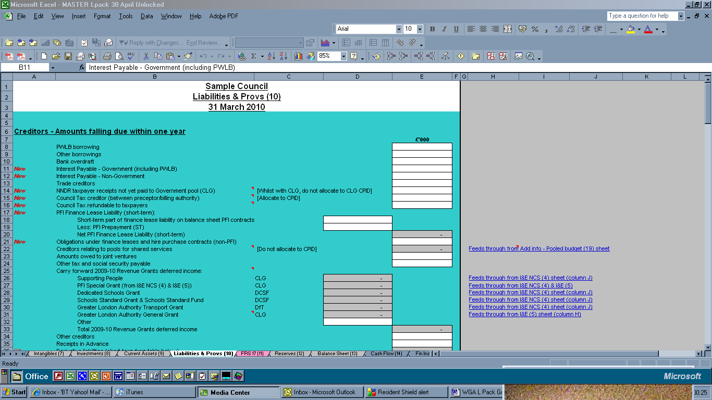

9.10.3. Current liabilities should be analysed as follows:
- PWLB Borrowing: Separate analysis of LA borrowing from the PWLB should facilitate authorities’ identification of balances and transactions within the public sector. Authorities will be able to identify this item from the Residual Maturity Letter provided by PWLB after the end of the year. The balance should be included here and disclosed on the Counter-party data sheet (this is completed automatically but may be overwritten if required). Repayments of debt and new borrowings are not recognised as income and expenditure and should not be reported as transactions on the Counter-party sheet.
- Other borrowings: Include borrowing from commercial lenders and other public sector bodies. Where borrowing is from another public sector body the balance should be included here and disclosed on the Counter-party data sheet. Where relevant, borrowing from the pension fund should be treated as borrowing from the private sector as the fund itself is outside the WGA boundary. Repayments of debt and new borrowings are not recognised as income and expenditure and should not be reported as transactions on the Counter-party sheet.
- Bank Overdraft: The bank overdraft was split out from bank and other borrowings in the 2008-09 L Pack to facilitate the working of the cash flow.
- Interest Payable – Government (including PWLB): This has been introduced separately to ensure that we capture intra government interest payable usually, but not exclusively, to the Public Works Loan Board (PWLB). The PWLB shows against this line in the Counter-party sheet, but an amount must be entered. This information was required in previous years but the interest paid to PWLB was often omitted. By adding this separately it should act as a reminder.
- Interest Payable – Non Government: to complete the total interest paid amount the non government interest paid is required to be disclosed separately.
- Trade creditors: This should include all balances arising from contractual commitments in respect of normal day to day acquisition of goods and services, other than those payable after one year. Where Trade and Other Creditors cannot be separately identified the unanalysed balance should be included here.
- NNDR taxpayer’s receipts not yet paid to CLG: SORP 2009 requires NNDR to be accounted for on an agency basis. The amount not yet paid to Government at the Balance Sheet date shall be included in the Billing Authority's Balance sheet as a creditor (net of cost of collection allowance for England & Wales).
SORP guidance ref Module 4 CC3 pg 471. No creditor is recognised for NNDR payable back to taxpayers (SORP guidance ref Module 4 Section CC, para 3.87(b) pg 469). This is not allocated to the CLG CPID as CLG do not recognise a corresponding debtor. The cost of collection allowance is to be included in the I&E (NCS) sheet (England & Wales).
- Council Tax creditor (between preceptor/billing authority): As stated on the current assets (sheet 9), there could be a debtor (to be recorded on sheet 9) or a creditor between the billing and precepting authority as a result of the change in accounting for council tax (so that this is on an agency basis). The counter-party must be identified on the counter-party sheet. A comment has been added to state that this creditor and the associated debtors should equal nil across all English local government bodies.
- Council Tax refundable to taxpayers: Please record any council tax refundable to council tax payers here. This could be where they have made an overpayment in the previous year.
- PFI Finance Lease Liability (short-term): This is a new requirement this year as a result of the introduction of PFI (IFRIC 12) accounting in local government. This is required to be analysed into the short term part of finance lease liability on balance sheet PFI contracts less the PFI prepayments (short term) to be identified separately.
- Obligations under finance leases and hire purchase contracts (non-PFI): To complete the short term liabilities please input any obligations under finance leases (non PFI).
- Creditors relating to pools for shared services: Where local government bodies have identified any pooled budget arrangements there could be a creditor in the following circumstances:
  - Amount due to pool at year end (top-up); or
  - For hosts that include the pool within their accounts, the balance left in the pool at year end to be paid back to the other contributing body(s).
This amount is automatically populated from the Pooled Budgets sheet (19) as is indicated from the comment.
- Amounts owed to joint ventures and associates: This analysis is required for disclosure purposes. Details of any balances should be available to authorities either from preparing their own group accounts or in the working papers to their related party transactions notes.
- Other tax and social security payable: This balance should include all amounts payable in respect of employers and employees contributions and taxation. The relevant amount should be included here and disclosed on the Counter-party data sheet (this is completed automatically but may be overwritten if required).
- Carry forward 2009-10 Revenue Grants deferred income: This relates to the government grant income and has been changed significantly following analysis of the counter-party differences (as stated previously). This information is auto populated from the information in the I&E sheet. (A hyperlink has been included in the form to highlight where this information is being picked up.) The relevant counter-party data for balances greater than £1 million is automatically entered in sheet 17. There is an additional “other” section for deferred grant income from other government departments not listed.
- Other creditors: This should include all balances arising from contractual commitments that are not related to normal day to day acquisition of goods and services, and are payable within one year. Examples include unpaid salaries and capital creditors, and unapplied developer’s contributions where appropriate. Where Trade and Other Creditors cannot be separately identified the unanalysed balance should be included in Trade Creditors.
- Receipts in Advance: should be included here where separately identifiable. Otherwise they may be included within Other Creditors (or Trade Creditors if necessary). Receipts in advance from other public sector bodies should be included here and disclosed on the Counter-party Data Sheet.
- Derivative Liabilities: Where an authority has indicated that they have derivates (in the Overview sheet) any short term liabilities as required in the analysis at the bottom of the sheet is auto-populated here.
- Financial Guarantees: Where an authority has indicated that they have financial guarantees (in the Overview sheet) any short term liabilities as required in the analysis at the bottom of the sheet is auto-populated here.

Creditors – Amounts falling due after one year

9.10.4. Long-term liabilities should be analysed as follows:
- PWLB Borrowing: Separate analysis of LA borrowing from the PWLB should facilitate authorities’ identification of balances and transactions within the public sector. Authorities will be able to identify this item from the annual listings supplied by PWLB. The balance should be included here and disclosed on the Counter-party sheet (this is completed automatically but may be overwritten if required). Repayments of debt and new borrowings are not recognised as income and expenditure and should not be reported on the Counter-party sheet.
- Bank and other borrowings: Bank and other borrowings should include borrowing from commercial lenders and other public sector bodies. Where borrowing is from the public sector the balance should be included here and disclosed on the counter-party sheet. Borrowing from the pension fund should be treated as borrowing from the private sector as the fund is outside the WGA boundary. Repayments of debt and new borrowings are not recognised as income and expenditure and should not be reported on the Counter-party sheet.
- Trade Creditors: This should include all balances arising from contractual commitments in respect of normal day to day acquisition of goods and services, other than those payable within one year. Where Trade and Other Creditors cannot be separately identified the unanalysed balance should be included here.
- PFI Finance lease liability (long-term): This is a new requirement this year as a result of the introduction of PFI (IFRIC 12) accounting in local government. This is required to be analysed into the long term part of finance lease liability on balance sheet PFI contracts less the PFI prepayments (long term) to be identified separately.
  - Finance lease liability of on-balance sheet PFI contracts (LT)
  - Less: PFI Prepayment (LT)
  - Net PFI Finance Lease Liability (long-term)
- Obligations under finance leases and hire purchase contracts (non-PFI) To complete the long term liabilities please input any obligations under finance leases (non PFI).
- Deferred Liability – Transferred Debt: Transferred debt arising from local government reorganisation has been separated out on to a separate line within long term debtors, because of the materiality of these balances, and so as to highlight the need for values to be entered into the counter-party data sheet.
- Other creditors: This should include all balances arising from contractual commitments that are not related to normal acquisition of goods and services that are not payable within one year. Where Trade and Other Creditors cannot be separately identified the balance should be included in Trade Creditors.

Provisions

9.10.5. Provisions should be considered as follows:
- BMW Landfill Usage Provision: The liability arising when an authority has used more than its allocation of landfill usage should be entered here.
- Other provisions: Movements in other provisions are required for disclosure and to calculate the cash flow. For these reasons it is important that the amount provided in year and the utilisation of provision is accurate. Authorities may have long-term provisions (other than for pensions), i.e. those for which the net present value is materially different from the undiscounted value of the provision. The increase in these provisions from the unwinding of discount should be separately disclosed

Deferred Income/Deferred credits (excludes Deferred Capital Receipts, Capital Grants deferred or unapplied)

9.10.6. Deferred income other than government grants may come from a number of sources, such as developer’s contributions. Some authorities may include these items in reserves, however it should be relatively simple to adjust by mapping the relevant accounts to these lines; the movements in will be unaffected. Amounts received in the year should be included as increases and amounts applied shown as released (similar to that for government grants).

Landfill Allowance Trading Scheme

9.10.7. The LATS scheme liability is required to be disclosed here. The amount released to the I&E is auto populated in the I&E from this sheet.

Capital Grants Unapplied/Deferred
A
C
B
D

9.10.8. This section has been developed following the changes introduced in 2008-09 to capture capital government grant information. Following feedback and considerable research the capital grant information has been refined:
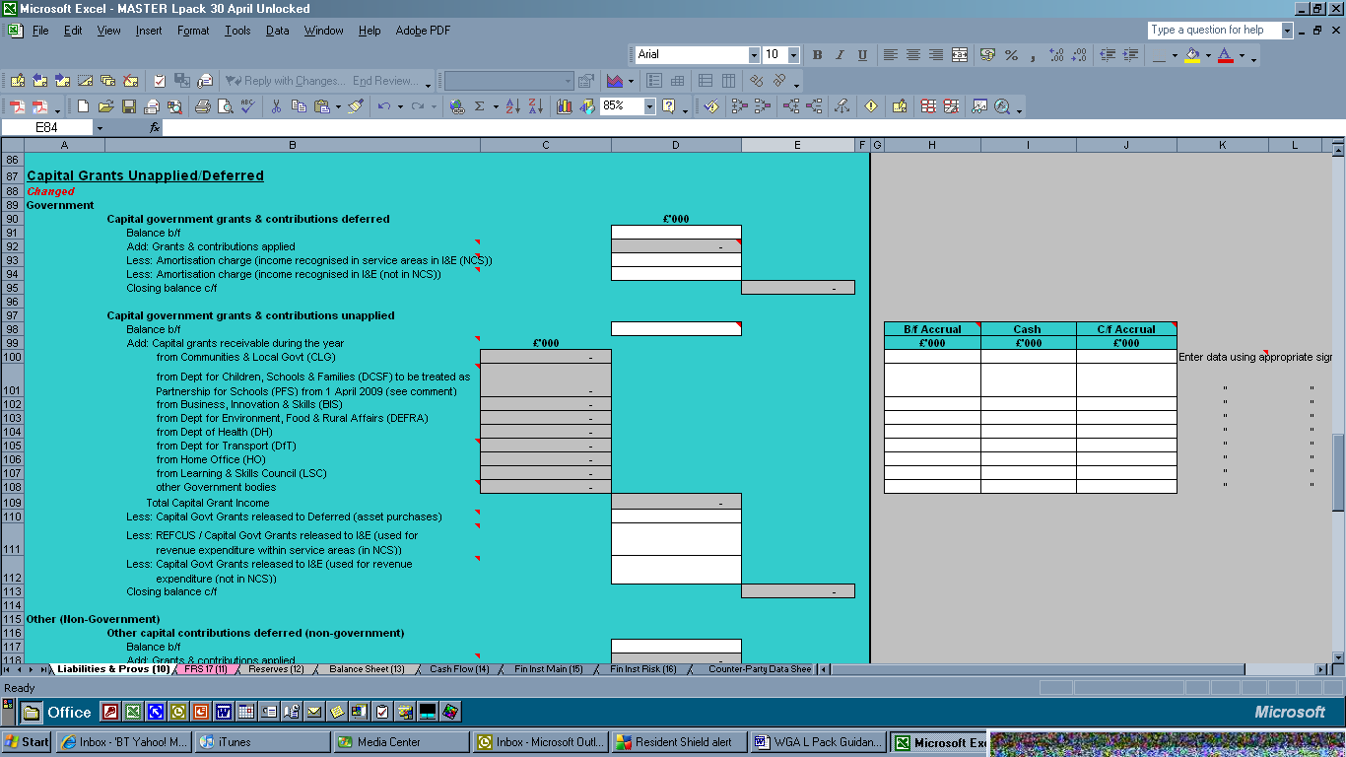

9.10.9. In WGA terms we need to isolate the capital government grant income relating to 2009-10 to ensure that the counter-party information is correctly identified so as to ensure that these transactions are eliminated with central government grant expenditure. Hence the split as to government and non-government (otherwise referred to as other contributions).

9.10.10. In accordance with GAAP, the SORP requires that authorities recognise capital grant income as first and foremost unapplied. Once an asset is brought into use then the balance (government grant attributable to that asset) is moved to government grants or the other contributions deferred account. Any depreciation charges attributable to the asset are charged to the I&E and the income is recognised as amortisation charge (either in the NCS or outside the NCS) – this is auto-populated in the I&E.

9.10.11. The intention is to identify all capital grant income recognised from government (or within the WGA boundary) in year here, and so counter-party data and a breakdown by body needs only to be provided once in the L Pack. Therefore we are following the SORP guidance notes, i.e. all capital government income is recorded under capital grant unapplied first even if the body has accounted for the capital grant directly in deferred or the I&E. This includes REFCUS (per SORP guidance, module 5, section K, para K8(iii)). They can then be transferred to the relevant section using the 'Less' boxes below. We are aware that the SORP guidance states capital grants towards REFCUS are treated as revenue grants and go straight to the I&E, however this method will prevent the double counting and overstatement of counter-party data which occurred in the past.

9.10.12. The brought forward unapplied balance [B] is the balance of the unspent capital grants that were received in prior years. This is different to the b/f accrual in column H (which is only the accrual adjustment to the grant received in year). We do not require the breakdown to the brought forward unapplied balance that was requested in previous years, as it is not the amount that must eliminate (as it was eliminated in prior years). A central adjustment is done in WGA to reflect this.

9.10.13. The capital grants receivable from each of the main government departments is auto-populated from breakdown required in columns H, I and J. The breakdown is being sought on the face of the liabilities and provisions sheet to assist our understanding of the composition of the amount recorded in the capital grants section (including the accruals) so that we can compare this to central government data (they too will provide a similar analysis). This will allow us to make the necessary adjustments without (we hope) the need to seek further information from local government colleagues.

9.10.14. The brought forward accrual [C] in column H is only the accrual adjustment to the grant received in year. This is different to the unapplied capital grant balance brought forward, which is for capital grants received in prior years but not yet spent [B].

9.10.15. Column I is the cash received in year.

9.10.16. Column J is not the closing balance carried forward figure - this is where there is a settling up element that needs to be recognised to ensure the unapplied figure/in year grant addition figure is correct.

9.10.17. The idea is that the total end balance in the unapplied section of the Liabilities and Provisions sheet is the same as the amount recorded in the authorities own accounts as capital grants unapplied in year.

9.10.18. Any transfers to deferred (for assets purchased/brought into use) are required here [D]. This amount is then auto-populated as the additions to the capital grants deferred liability.

9.10.19. Finally there are two further cells for Revenue Expenditure Funded from capital Under Statute (REFCUS) or for capital grants released direct to the I&E. This could be within the Net Cost of Service (NCS) or outside the NCS. These cells are auto-linked to the I&E (4) in the NCS and I&E (5).

9.10.20. The closing balance is automatically calculated.

9.10.21. As well as a note in the Statement of Accounts requiring the capital grants unapplied there is a separate disclosure for the deferred capital grant income.

9.10.22. There is a brought forward element – this is effectively government grant income received that has resulted in the creation/purchase of a fixed asset which has been brought into use. The government grant income is recognised in the I&E over the estimated useful economic life of the asset and will offset the depreciation charge.

E.g. An asset that is fully funded by a government grant for £10 million, with a useful economic life of 10 years, will have an annual depreciation charge of £1m. The capital grant income of £1m is recognised in the I&E under the amortisation of government capital grants deferred section (Further information is available in SORP Guidance notes Module 5 para I43-I45.)

9.10.23. The amount transferred in from 'Capital grants & contributions unapplied' for asset purchases is an auto-populated cell from the unapplied section (and acts as a secondary validation check). Whilst some bodies do not have separate Unapplied and Deferred accounts, please reflect it this way in the L Pack. This reflects the SORP approach, and ensures that the counter-party breakdown is required only once, preventing double counting/overstating of counter-party data (which occurred in prior years).

Other Contributions/Non Government

9.10.24. The same approach has been adopted for the other contributions sections (where capital grants have been received from non government bodies for the development of major capital projects, e.g. a large supermarket chain making a contribution towards the development of a leisure centre).

9.10.25. As this is outside of the WGA boundary there is no counter-party information to be disclosed. Presentationally, the capital grant contributions will first be recorded in the unapplied and then transferred to the deferred account upon the purchase or creation (brought into use) asset. This is consistent with the approach for government capital grant income and adheres to the SORP in the way this should be accounted for.

9.10.26. The total capital grants and contributions deferred are auto-calculated from the information above (hence it is a greyed out /locked cell). This figure is automatically taken to the Balance Sheet.

9.10.27 The same is true for the total capital grants and contributions unapplied. Together these two replicate the note in the statement of accounts.

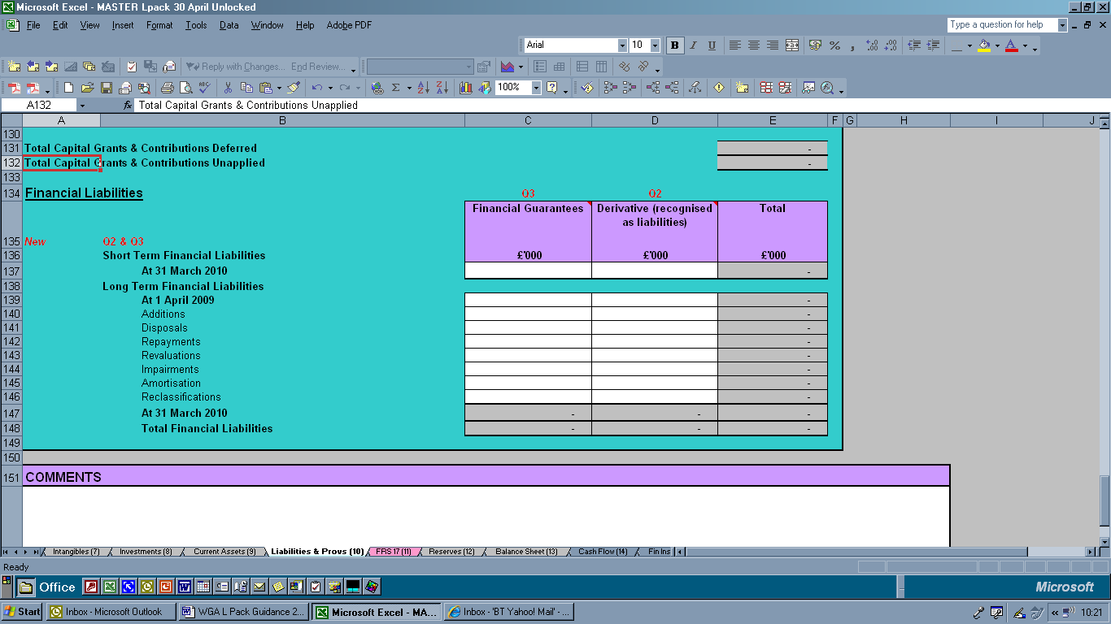

9.10.28. The final section on the Liabilities and Provisions sheet is the “new “ Financial Liabilities section. For WGA purposes we require this presentation.

9.10.29. If the local government body has derivative liabilities (Question 2 in the Essential checklist on the Overview sheet) as defined in the SORP guidance notes Module 6 Section F, the answer would be yes and this section would be unlocked for data input. Please complete the section as required.

9.10.30. If the local government body has any financial guarantees (Question 3 in the Essential checklist on the Overview sheet) as defined in the SORP guidance notes Module 6, the answer would be yes and this section would be unlocked for data input. Please complete the section as required.

(Extract from the Essential Checklist from the Overview sheet)

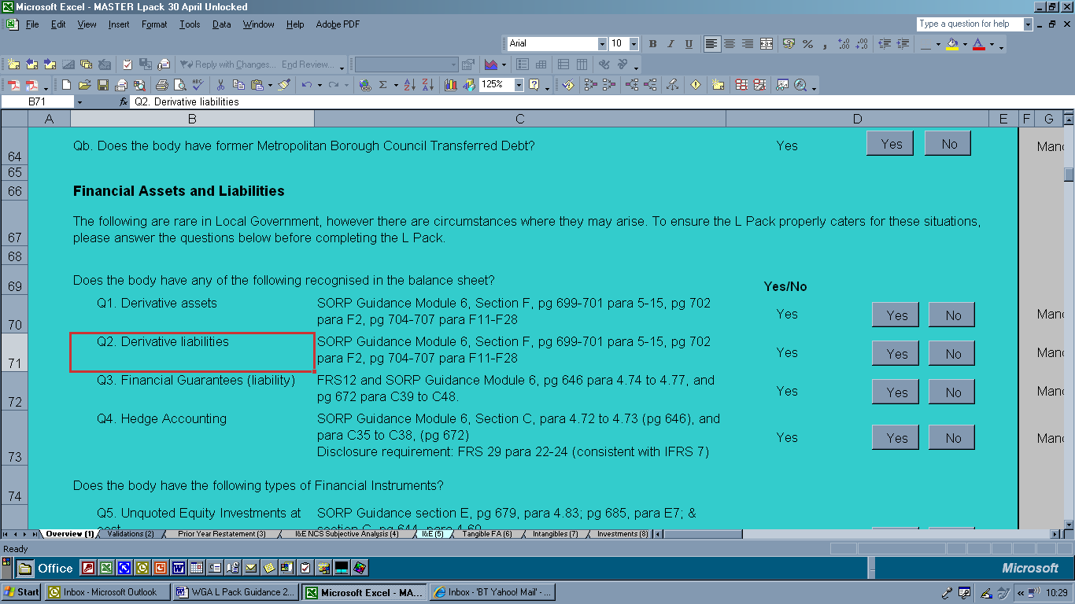
FRS 17 (sheet 11)

9.11.1 Public sector pensions have been of considerable public interest since the introduction of FRS 17. WGA reflects this, providing the fullest possible disclosures.

9.11.2 The analysis of movements in the FRS 17 liability is required for disclosure purposes and to allow the FRS 17 cost recognised in WGA to be properly analysed between the I&E and Statement of Total Recognised Gains and Losses. An analysis of FRS 17 costs and liabilities between unfunded and funded schemes is required for policy and disclosure purposes.

9.11.3 All schemes should be accounted for as required by the SORP. Therefore, the Teachers’ scheme should be accounted for on a “defined contribution” basis. The material unfunded schemes are the Police and Fire-fighters schemes, with the Local Government Pension Scheme as the main funded scheme. Any other schemes that are locally material should also be included.

9.11.4. The definition of all items on this sheet is in accordance with the SORP. The amounts included for each scheme should reflect the amounts included in the authority’s own accounts.

9.11.5 All FRS 17 liability / asset movements and disclosure items required for WGA can be drawn from the notes to the authority’s accounts.

Signage

9.11.6. A significant number of errors were noted in relation to incorrect signage of FRS 17 entries. The validation cells have been made more prominent, but for information, the expected signs are listed below:

9.11.7. Entries on the FRS 17 Note (Movements on the FRS 17 Liability/Asset):

- Current Service Cost: Negative (credit)
- Past Service Cost: Negative (credit)
- Gains/Losses on settlements and curtailments: Positive or Negative
- Interest Cost: Negative (credit)
- Payment of Pensions: Positive (debit)
- Expected Return on assets: Positive (debit)

9.11.8 Entries on the Income and Expenditure Account
- Pension Interest Cost: Positive (debit)
- Expected Return on Pensions Assets: Negative (credit)

Note

9.11.9. We have introduced the adjustment cell to the balance brought forward data – this amount is automatically carried into the Prior year restatement sheet (3).

9.11.10. Other changes include the introduction of two new cells

New | Contributions by scheme participants
New | Contributions by employer
This table now strictly follows the SORP presentation – combining the separate pension assets and liabilities tables (although the contributions by scheme participants will net off in the overall figures). This addresses feedback received in the 2008-09 WGA exercise.

9.11.11. Another comment that was frequently made in the previous year’s exercise was that the breakdown required to calculate the Actuarial Gains or losses was not provided by the Actuary. This is not correct. The SORP disclosure requirements have not changed and this table follows the SORP. Moreover it is difficult to understand how the actuary can provide their assessment of the gains or losses without completing this analysis. Please ensure that the correct requirements have been stipulated to the Actuary when requesting this information for the Statement of Accounts.

9.11.9. Additional information is required using the following format for rows 33-46: Input as a number without the percentage sign, to one decimal place.

9.11.10 If the rate is 2.5%, please record as 2.5; for 2.326%, record as 2.3; for 10% record as 10. Do not enter 2.5% as .025

9.11.11. Rows 39 to 41 will also follow this input format. However the input required is the proportion of the scheme invested in Equities, Bonds and Other. Therefore, the total of the 3 cells should add to 100. Again, these numbers should be entered without the percentage sign. E.g., 40%; 50%; 10% must be included as 40; 50; 10.

RESERVES (sheet 12)

9.12.1. Local authorities maintain a number of specialised reserves to meet accounting needs related to the capital and revenue control regimes. While these reserves are necessary adaptations to GAAP in a local authority context, they are generally not required at WGA level. We will therefore adjust local authority reserves to a GAAP basis, where possible, on consolidation.

General Guidance

9.12.2. Movements in reserves should be included in the most appropriate line. This is particularly important where the appropriation represents a movement that is an adaptation from GAAP. Transfers between reserves should be included in the relevant line of the reserves sheet, wherever possible. Any movements that cannot be separately identified, or for which a specific line has not been provided, may be included in Other Movements.

Main changes in the 2009-10 Reserves Sheet

9.12.3. The reserve sheet now includes a line for the “Difference between amounts credited to the I&E Account and amounts to be recognised under statutory provisions relating to Council Tax”. Please see the SORP guidance Ref Module 3 Section E para 5.28 (pg 99) and SORP module 4 section B para BB3 pg 454 for further details.

Brought Forward Balances

9.12.4. The balances brought forward from 2008-09 should be entered here. Note there is an additional row for any prior period adjustments as a result of the adoption of IFRIC 12/ or any other adjustments. The “adjusted” brought forward figures in the reserves sheet auto-populate the amounts in the prior year restatement sheet.

Statement of Movement on the General Fund Balance

9.12.5. Recognising that the Statement of Movement on the General Fund Balance reflects movements between the General Fund and other reserves, we have chosen to include this statement within this sheet.

9.12.6. This section takes the GAAP complaint I&E and adjusts for items (as allowed by regulation) so that these do not score against the reserves and to reflect the Council tax requirement. Therefore items such as depreciation and impairments are removed via the Capital Adjustment Account.

9.12.7. Invariably we start with a deficit from the I&E and end up with a Surplus to be taken to reserves as a result of these adjustments. (this is usually the case but as ever with local government there are always exceptions!)

9.12.8. Each line reflects the SORP guidance and should net to nil. This is highlighted in the validation checks. We have tried to ensure that the naming convention is aligned with the SORP guidance notes for practitioners with the exception of depreciation and impairments (which have been split)(pages 103-106).

Amortisation of intangible Fixed Assets, Depreciation of Fixed Assets and Impairment of Fixed Assets

9.12.9. All amounts of amortisation and depreciation charged to the I&E account should be reversed out here, with a corresponding entry in the capital adjustment account. Include all impairments, i.e. impairments due to a clear consumption of economic benefits and/or loss in market value. Note for this year there is a minor departure from the SORP in that the depreciation and impairments figures are required separately. This is so that additional data integrity checks could be added to the Pack.

Difference between HRA depreciation and Major Repairs Allowance

9.12.10 Include here the transfer between the HRA and the MRR required by the HRA Item 8 Determination, based on the difference between the MRA and the HRA depreciation charge. Note this is not a specific requirement per the SORP.

Government Grants Deferred Amortisation

9.12.11. No amount of GGD should be left as a credit against the General Fund balance. There should be a matching entry for this reversal in the capital adjustment account.

Revenue expenditure funded from capital under statute

9.12.12. Any amounts relating to the charging to the I&E of this category of expenditure will need to be reversed out under this heading where the expenditure is being financed from capital resources. Where the expenditure is to be financed from revenue, the charge is left to score against the bottom line and not reversed out here. Detailed guidance is provided in the SORP guidance notes Module 5 section K.

Net Gain/Loss on Disposal of Fixed Assets

9.12.13. The net of the adjustments to the revaluation reserve, usable capital receipts reserve, (and where applicable, the capital adjustment account); used to neutralise the effect of recognising gains/losses on the sale of fixed assets will be shown as a matching, reversing entry here.

Other income that cannot be credited to the General Fund

9.12.14. This was introduced following feedback from local government colleagues regarding where deferred capital receipts were being included in the Balance Sheet (below the line in taxpayers equity) resulting in the “balance being struck” being different to that in their own statement of accounts. The addition of this row will address this anomaly. However the SORP guidance noted did not specifically mention this and so this was not included in previous years.

Difference between Statutory debit/credit and amount recognised as income and expenditure in respect of financial instruments

9.12.15. Generally the General Fund Balance will reflect the interest expenses and income; impairment losses and gains/losses arising on de-recognition of financial instruments, in accordance with the debits and credits made to the Income and Expenditure Account. However specific statutory provisions apply to allow for the effects of some soft loans to be adjusted to contractual amounts payable and for premiums and discounts arising on the early repayment of debt to be spread over a number of financial years. Further guidance is included in the SORP guidance notes module 6.

Difference between amounts credited to the I&E Account and amounts to be recognised under statutory provisions relating to Council Tax

9.12.16. Following changes to the Accounting for Council Tax, this was added to the Statement on Movement in the General Fund Balance. SORP guidance Ref Module 3 Section E para 5.28 (pg 99) and SORP module 4 section B para BB3 pg 454 provides further details

Net Charges Made for Retirement Benefits in Accordance with FRS 17

9.12.17. This item will comprise the reversal of all amounts charged to the I&E for current service cost, past service cost, settlements and curtailments, interest cost and expected return on assets. The matching entry will be in the ‘FRS 17 reserve.’

Revenue provision for the repayment of debt for capital financing (MRP)

9.12.18. This includes all repayment of debt including the statutory provision for the repayment of debt, (as calculated under the relevant statutory provisions. This amount is not included in the I&E but is required to be included by statute when calculating the movement on the general fund balance for the year. The matching entry will be a credit to the capital adjustment account on the ‘MRP’ line) and the Voluntary Revenue Provision for Capital Financing. Any provision for repayment of debt over and above the MRP should be recorded here, with a matching entry to the capital adjustment account under ‘additional voluntary set aside.’

Capital Expenditure Charged In-Year to the General Fund Balance

9.12.19. There are a number of ways to describe capital expenditure financed from revenue, including Revenue Contribution to Capital Outlay (RCCO); Direct Revenue Financing (DRF); Capital Expenditure from a Revenue Account (CERA); Capital Expenditure Financed from Revenue (CEFR) or Capital expenditure Financed by Contributions from Revenue (CFCR).

9.12.20. This amount represents any contribution to capital expenditure charged to the general fund balance. This amount is not included in the I&E but is required to be included by statute when calculating the movement on the general fund balance for the year. The matching entry will be a credit to the capital adjustment account.

9.12.21. Our assumption is that this will reflect the use of revenue resources for capital financing in year. Revenue resources earmarked in reserves for future capital purposes remain legally revenue reserves and we expect that these will be included in Transfers to/from Earmarked Reserves.

Transfer from Usable Capital Receipts Reserve to meet payments to the
Housing Capital Receipts Pool
9.12.22. This applies to Housing Authorities only. Although debited to the I&E, this payment is financed from the UCR. There should therefore be a matching credit to the usable capital receipts reserve, in the line ‘Payment to the Housing Capital Receipts Pool’.

Employer’s contributions payable to the pension fund and retirement benefits paid directly to the pensioners

9.12.23. This will comprise the debit of employer’s contributions payable to the pension fund for the year, in relation to the defined benefit schemes to which the authority contributes and the retirement benefits paid direct. No counter-party data is required for these transactions.

Transfer of HRA Balance

9.12.24 Transfers are required to or from the HRA and the General Fund to ensure that the balance relating to council housing is removed. This is to ensure that the general fund reflects only the net cost to the local council tax payers.

Voluntary Revenue Provision for Capital Financing

9.12.25. Any provision for repayment of debt over and above the MRP should be recorded here, with a matching entry to the capital adjustment account under ‘additional voluntary set aside.’

Reversal of Financing of the Unequal Pay Back Provision

9.12.26 The balance sheet account, the Unequal Pay Back Pay Account was introduced for 2007-08 and is similar in concept to the pension reserve. Further details are available in LAAP bulletin 68 April 2007.

9.12.27. The provision will impact upon the I&E (4) account in cell F20, (contributions to employee related provisions) but will be reversed out in this line. The matching entry should be posted to the ‘other movements’ section of the capital adjustment account.

Net Transfer to or from Earmarked Reserves

9.12.30 Movements on reserves will be matched with entries on the reserves sheet.

Net Additional Amount to be credited to the General Fund Balance, Increase/Decrease in the General Fund Balance

9.12.31 This automatically generated amount should be the same as the amounts shown in the authority’s own accounts.

Revaluation Reserve

9.12.32 This records the unrealised revaluation gains arising (since 1st April 2007) from holding the fixed assets. However, for groups the balance brought forward should include the balances included in the group revaluation reserve for the previous year – these two have been amalgamated.

9.12.33. Note, further to the LAAP Bulletin 73 (point 49) local government bodies which operate an investment revaluation reserve for investment properties should include any movements in the revaluation reserve. This is in alignment with the accounting for investments in central government.

Capital Adjustment Account

9.12.34 The capital adjustment account is not a GAAP concept. The balance on this account represents timing differences between the amount of the historical cost of fixed assets that has been consumed and the amount that has been financed in accordance with statutory requirements.
- Revaluations/impairments: Debit the reversal out of the General Fund.
- Transfer to/from Other Reserves: Treat any appropriations from the I&E and the transfer of capital receipts applied from UCR as transfers from other reserves; these should net to zero.
- Other movements: All other movements should be included in line with the general guidance above.

Useable Capital Receipts

9.12.35. Please note:
- Capital expenditure financed from UCR: The reversal out of the Capital Adjustment Account should be debited here.
- Transfer to/from Other Reserves: Transfers of amounts applied, or set aside should be included in this line.
- Other movements: All other movements should be included in line with the general guidance above.

Housing Revenue Account Balance

9.12.36. The form is designed on the assumption that the Housing Revenue Account (HRA) Balance and the Housing Repairs Account (HRepA) Balance are similar in nature, and so are amalgamated into this column. Where an authority does not account for these together it will be acceptable for the reserves to appear in whichever group on this sheet is most appropriate.

9.12.37 The Major Repairs Reserve was separated out for 2007-08 because the Major Repairs Reserve is different in nature to the Housing Revenue Account (HRA) Balance and the Housing Repairs Account (HRepA) Balance.
- Net Surplus/Deficit for the year: The transfer from the SMGFB of the HRA balance should be included here.
- Transfer to/from Other Reserves: Transfers between the HRA and other reserves should be included here, and should thus net to zero
- Other movements: All other movements should be included in line with the general guidance above.

Major Repairs Reserve

9.12.38 This reserve records the amount of unspent balance of HRA subsidy paid to English housing authorities in the form of the Major Repairs Allowance.

9.12.39 The main credit to the Major Repairs Reserve will be an amount equivalent to the total depreciation charges for all HRA assets. This will have a matching entry to the Capital Adjustment Account. Where there is a difference between the HRA depreciation charges and the Major Repairs Allowance there is either a transfer to or from HRA to the Major Repairs. This entry is shown in the “difference between HRA depreciation and Major Repairs Allowance” line.

9.12.40 Where the MRR is used (for example to finance capital expenditure or repay debt) the amount will be debited to the MRR and credited to the CAA. These entries should be shown in the transfers to/from other reserves line.

Schools Balances

9.12.41. Please note:
- Transfer to/from Other Reserves: Transfers between the Schools Balances reserves and other reserves should be inserted here, and should net to zero.
- Other movements: All other movements should be included in line with the general guidance above.

Other Earmarked Reserves

9.12.42. This group is designed for those earmarked reserves (statutory or discretionary) that the authority discloses separately from the General Fund balance. They are not necessarily ring fenced reserves - their purpose can be amended and the funds utilised on other activities.

9.12.43. There is no requirement for this column to be completed if the authority does not separately account for such reserves in its own published accounts; it is purely for convenience in completing the WGA return. Amounts may be included in the General Fund column if that is more convenient.
- Transfer to/from Other Reserves: Transfers between Other Earmarked Reserves and Other Reserves should be inserted here, and should net to zero.
- Other movements: All other movements should be included in line with the general guidance above.

General, County or Police Fund

9.12.44 All residual transactions on the I&E should be reflected in this reserve. Any Transfer to/from Other Reserves or Other movements should be included in line with the general guidance above.

Collection Fund Adjustment Account
9.12.45. Income from Council Tax and NNDR is recognised in authorities’ accounts on an agency basis as a result of the SORP 2009 changes. Therefore this additional reserve was introduced to negate the impact on Council Tax via the SMGFB.

Available for Sales Financial Instruments Reserve and Financial Instruments Adjustment Account

9.12.46. This is similar to the requirements governing fixed assets. Financial assets are required to be carried at fair value (unless they have fixed or determinable payments but are not quoted in an active market). Note the outcome of proper accounting practices for the Income and Expenditure Account is different from that required for assessing the impact of local taxes.

The Financial Instruments Adjustment Account

9.12.47 This provides a balancing mechanism between the different rates at which the gains or losses (such as premiums on the early repayment of debt) are recognised under the SORP and are required by statute to be met from the General Fund.

Available for Sales Financial Instruments Reserve

9.12.48. This records the unrealised gains arising from holding available for sale investments, plus any unrealised losses that have not arisen from impairment of the assets.

FRS 17 Reserve

9.12.49. The pensions reserve is an adjustment that manages the effects of FRS 17 charges made to the Income and Expenditure Account against the statutory requirements for meeting the cost of retirement benefits from local taxes, as well as absorbing the impact of actuarial gains and losses. The movements in the FRS 17 reserve should mirror those in the authority’s own accounts.

Unequal Pay back Reserve

9.12.50. This was introduced as a separate column in the 2007-08 L Pack. The purpose of this reserve is to effectively remove the impact of the provision created by local government bodies by including a provision on the I&E and then removing this charge via the Statement of Movement in General Fund Balance.

9.12.51. As several authorities have started to make interim payments – these will need to be included in the I&E in the employees group subjective heading (under other employee costs Cell F15).

Group Accounts Only

Reserves of Group Entities
9.12.52 The movements in the reserve should mirror those in the authority’s own group accounts and should include the opening balance plus a total for any other movements.

Minority Interest
9.12.53 The balance of this account can be placed against the opening balance line in the sheet.

All of the above adjustments result in the net addition to reserves.

Statement of Total Recognised Gains or Losses

9.12.54. To complete the reserves analysis the STRGL is included. The only main addition this year is the inclusion of the Amounts recycled from the STRGL (Available For Sale financial instruments Reserve) to the I&E Account after impairment or derecognition. This amount feeds through from Fin Inst Main (15) gains/losses table.
Amount reversed out of STRGL (AFS Reserve) for transfer to I&E. SORP Guidance Module 6, section C, para C13, pg 656, para C21-C22 pg 665-667, & para C33 pg 671.

Data Validations

9.12.55. Several new validations have been added to the reserves sheet (many of these relating to the fixed assets depreciation and the impairment charges).

BALANCE SHEET (sheet 13)

9.13.1 This page requires no input; it is automatically completed from the Balance Sheet notes on the preceding sheets.

9.13.2 If the Balance Sheet is out of Balance the following warning appears:

Balance Sheet does not balance: do NOT submit

9.13.3 If the authority considers it has completed the return and the Balance Sheet is out of balance the return should be checked carefully against the audited accounts and corrected as required.

9.13.4 Authorities must not submit returns if the Balance Sheet is out of balance.
In previous years some authorities ignored this primary validation and submitted the Pack. The HMT COINS system cannot accept the data if the Balance Sheet does not balance. These were invariably sent back to local government bodies for further action and resolution. This was very time consuming for CLG. This year, a new check has been added, if there is a primary validation failure then the form cannot be sent to CLG.

9.13.5 Passing the balance sheet validation should not be taken as confirmation that the form has been correctly completed in other respects.

CASH FLOW (sheet 13)

9.14.1. Following considerable feedback from the cash flow that was introduced in the 2008-09 L Pack (not subject to audit review) the new cash flow has been developed.

9.14.2. The cash flow follows the SORP very closely and follows the indirect method. We appreciate that the SORP allows the option to follow the direct method and the indirect method, practitioners will appreciate that it is very difficult to develop a cash flow model so that this covers all possible scenarios in the direct method. Hence we have been pragmatic in the development of this sheet.

9.14.3. Note the first section of the cash flow titled “Non cash items in the Income and Expenditure Account” is required as a note if the direct method is followed. Hence we hope that this information is readily available.

9.14.4. The key thing to note is the cash flow does not have many automatically linked cells calculating the movement in cash. That is, there are a considerable number of white cells (cells available for data input). This was a conscious decision to adopt this approach to the cash flow. The cash flow would need to be expanded considerably to capture more detailed information including all the notes to the accounts (opening balances as well as closing balances) so that the movement in debtors, creditors etc could be derived automatically. Those authorities that have the CIPFA cash flow model will appreciate the significant number of additional data requirements.

The approach in the L Pack cash flow is to require these amounts included in authorities own statement of accounts to be input here. The workings behind the cash flow would be reviewed by your auditors when completing their audit review of the Statement of Accounts cash flow. Hence the L Pack cash flow would not need the same. The data required would be subject to audit review providing the necessary assurance to CLG, HMT and the NAO auditors.

9.14.5. All the headings and layout follow the SORP indirect method and we hope this will alleviate the issues raised in the 2008-09 cash flow. To assist the completion of this sheet many comment boxes have been added to clarify what is required. These are not reproduced here. For further information please refer to the comment boxes and these in turn refer to the detailed SORP guidance notes for further information.

FINANCIAL INSTRUMENTS (MAIN) (Sheet 15)

9.15.1. This sheet is a new addition to the 2009-10 L Pack. Although the SORP has required local government to follow the Financial Reporting Standards for Financial Instruments since the 2007-08 reporting year the L Pack is only now introducing the detailed disclosure notes relating to financial instruments.

9.15.2. Originally the WGA did not require the disclosures for financial instruments and so the L Pack did not require these as we do not ask for information that is not used.

9.15.3. Central government implemented the Financial Instruments FRSs in 2008-09. It was at this stage we realised that the L Pack should have been amended to collect this information. The band 1 bodies (top 60 by expenditure or net asset base) were considered to have the material Financial Instruments (over 70% of the total for local government). Hence these bodies were sent the additional disclosure requirements (based on the central government reporting requirements stated in the Financial Reporting Manual (FReM). Only 20 responses were received. These were used in the evaluation and development of the Financial Instruments disclosure requirements sheets (main 15 and risk 16).

9.15.4. The Financial Instruments disclosure requirements strictly adhere to the requirements in the SORP and the appropriate references have been included in the Pack (as comments) to clarify what is required. Previous feedback has indicated that many local government practitioners have found this to be very helpful.
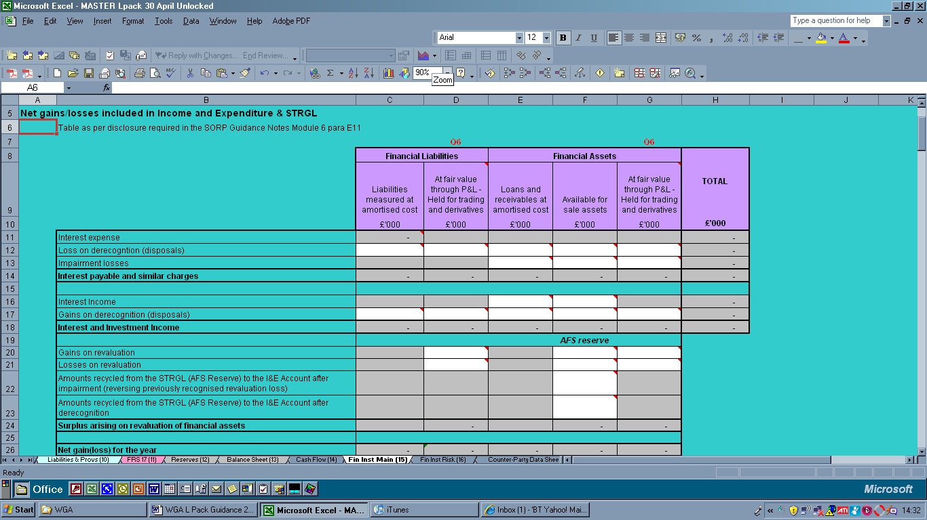
SORP Ref

9.15.5. At first sight the disclosure table may look daunting but this is the same as is required in the main statement of accounts. Note the SORP reference has been included. It may be that your local Treasury team complete this information for the main accounts – they will have the information to complete this section too.

9.15.6. Also note the number of greyed out cells – these are auto populated from other cells, or may not be relevant for data input (e.g. Financial liabilities will not have interest income). The auto-populated cells are referenced (see detailed comment boxes) and are derived from other information in the Pack, again acting as an additional data integrity check as well as saving time for the person completing the Pack.

9.15.7. This sheet is significantly less demanding that the version included in the illustrative draft on the CLG WGA webpage on 31 March 2010. To compensate for the reduction in the additional information requirements, a number of data integrity checks have been added (as can be seen at the bottom of the sheet).

These include:

- Financial liability creditors & borrowings should not exceed amount recorded on Liabilities & Provisions (10) sheet
- Financial asset debtors should not exceed amount recorded on Current Assets (9) sheet
- Financial Liabilities External to WGA i.e. The amount allocated to 'Less balances with other WGA bodies' should be greater than or equal to the amount allocated to Counterparties (CPIDs). It can be greater than the CPID allocations as these are only required for transactions/balances greater than £1million.
- Financial Assets External to WGA i.e. The amount allocated to 'Less balances with other WGA bodies' should be greater than or equal to the amount allocated to Counterparties (CPIDs). It can be greater than the CPID allocations as these are only required for transactions/balances greater than £1million.

These are all logical. Taking the first check – the financial liability creditors and borrowings should not be higher than the total stated for these in the Liabilities and Provision sheet. How can we have an analysis of financial liabilities for £15m when the total amount stated in the accounts is only £10m?

9.15.8. In addition to this, two additional “primary validations” have been added:

- WGA balances deducted from Financial Liabilities:
CPID data must not exceed WGA balances in Financial Liabilities table

- WGA balances deducted from Financial Assets:
CPID data must not exceed WGA balances in Financial Assets table

Again these are logical. The analysis provided in the counter-party information relating to the financial assets or liabilities (therefore within the WGA boundary) must not be greater than the value stated as being a financial asset or liability in the WGA boundary. This is checking for the same as the last two data integrity checks in 9.15.7, but as these relate to items within the WGA boundary it is imperative that the analysis is correct.

9.15.9. The last section in this sheet is only required to be completed where the local government body has other significant financial instrument scenarios – i.e. greater than £50 million. The disclosures required follow the Checklist of other significant (>£50 million) Financial Instrument scenarios [SORP Guidance Module 6, section E, para 4.84 to 4.89, pg 679 to 680]. Please refer to this for further information.

FINANCIAL INSTRUMENTS (Risk) (Sheet 16)

9.16.1. This sheet is a new addition to the 2009-10 L Pack. Although the SORP has required local government to follow the Financial Reporting Standards for Financial Instruments since 2007-08 reporting year the L Pack is only now introducing the detailed disclosure notes relating to financial instruments.

9.16.2. Originally the WGA did not require the disclosures for financial instruments and so the L Pack did not require these as we do not ask for information that is not used.

9.16.3. This sheet is significantly less demanding that the version included in the illustrative draft on the CLG WGA webpage on 31 March 2010, or the version sent to band 1 bodies in 2008-09. This is in part as we consider the full disclosures required to provide the most complete picture for the WGA balanced with the need for materially and that which local government are required to provide as part of the SORP disclosure notes.

9.16.4. This sheet requires information to be provided on the following:

- Credit Risk
SORP Guidance Module 6, section E, pg 682, para 4.98(c) requires 'information about the credit quality of financial assets that are neither past due nor impaired'. The SORP does not prescribe how the information should be presented, so the disclosures vary greatly between local government bodies. The information needs to be captured on a uniform basis for WGA, and it is probable that authorities will have this information available in this format for internal credit management. Geographical locations of financial assets should also be readily available. English local government bodies that completed the Financial Instrument return last year were able to complete this table. Presenting credit risk by credit rating is a disclosure suggestion on pg 695 of the SORP Guidance.

- Liquidity Risk
SORP Guidance Module 6, section E, page 682 para 4.101; page 692 para E21; and page 695 para E23.

- Market Risk
The SORP does not require this layout; however, the majority of local authority Financial Instrument returns received back last year were able to complete these tables. This includes a sensitivity analysis of a 1% base point movement and the impact on interest.
Counter-party Data Sheet (sheet 16)

Introduction

9.16.1. The counter-party data sheet facilitates the recording of counter-party identifier (CPID) information. It is an integral part of the form as it is the only way we can identify intra-group transactions and balances. This information is essential as it enables us to eliminate “internal” trading when consolidating all WGA designated bodies.

9.16.2. The amounts entered in the earlier worksheets against each of the description lines have been linked through to the Counter-party Data sheet in Column B. Users are required to split out any components of these totals which may relate to other public sector bodies. A complete list of public sector bodies included within the WGA can be found in sheet 23 of the L Pack.

Completing the form

9.16.3. Not all data lines in the WGA form will require CPID information. If the counter-party is outside of the government boundary, (e.g. local precepts, private firms), or is a “book” entry only (e.g. capital charges), then no counter-party information is required. Please leave the cell blank, do not enter a dash. For further detail on whether or not a transaction should be included on the counter-party sheet, please see further in this section, and read section 8.

9.16.4. Given the significance of this sheet, considerable effort has been devoted to the development and (hopefully) clarity in the completion of this sheet.
A
D
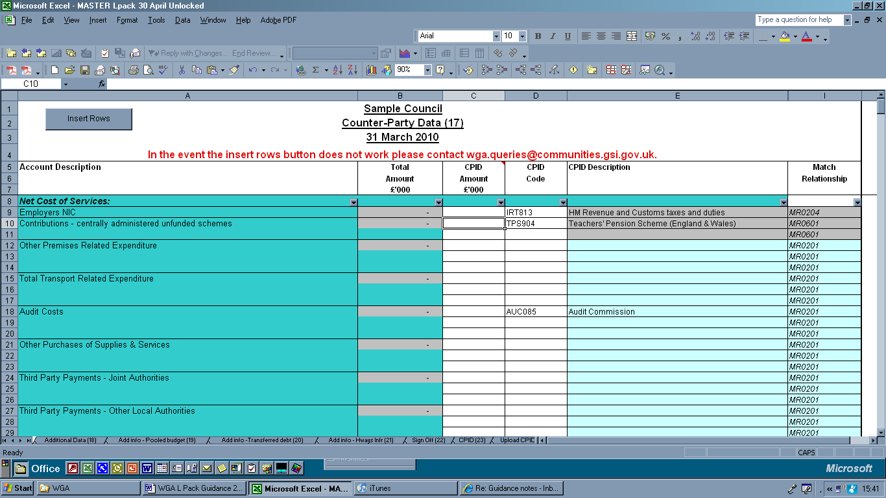
C
B

9.16.5. The counter-party information is drawn from information provided in the accounts. For example the Employers NIC [A] is taken from the information provided in the I&E (4)
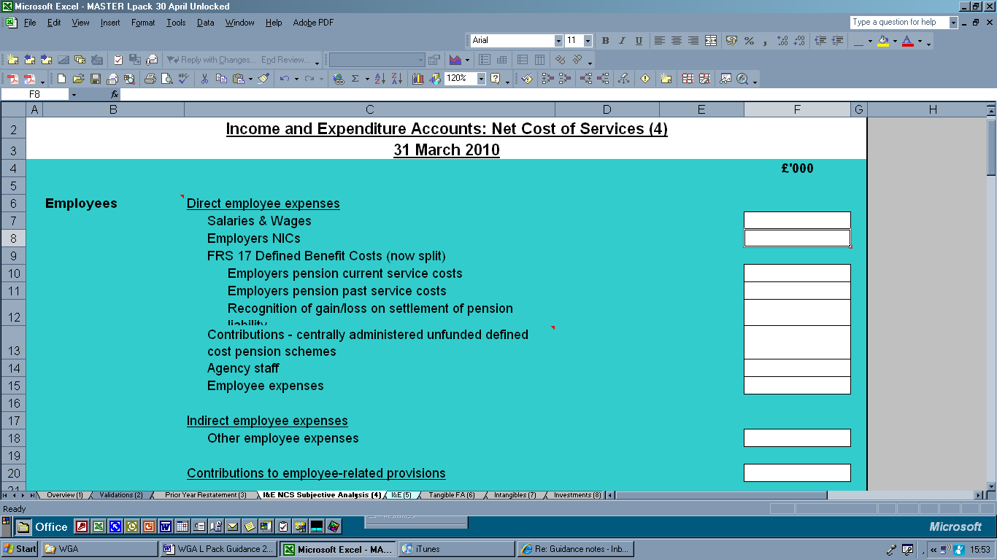

9.16.6. All Employers National Insurance Contributions are payable to HM Revenue and Customs counter-party identifier (CPID) code IRT813 [B]. Therefore this has been hard coded in this section. Selecting the counter-party identifier code will automatically populate the name of the body in the CPID description column. Hence IRT813 is HM Revenue and Customs Taxes and Duties.

9.16.7 This will act as an additional check to ensure that the correct WGA body has been selected where the authority has selected this from the CPID list on sheet 23.

9.16.8. A new feature of the counter-party sheet is to specify the match relationships on the face of the counter-party sheet [D]. COINS has been set up to automatically eliminate transactions in the same groups based on match relationships. For instance purchases of good and services will eliminate with sales of good and services (the match relationship for this is MR0201); Levies income paid will eliminate with levies income received (the match relationship for this is MR0202).

9.16.9. This is to assist the completer of the form to ensure that all the counter-party transactions relating to a particular local government body has been identified and recorded correctly on the counter-party sheet. When completing the counter-party information, note that we are only concerned with material transaction streams over £1 million per category. Items under £1m are not required as these are all automatically eliminated in COINS resulting in these amounts being posted to suspense overly inflating the suspense account balances!

This is best explained by an example.
A
I&E Extract
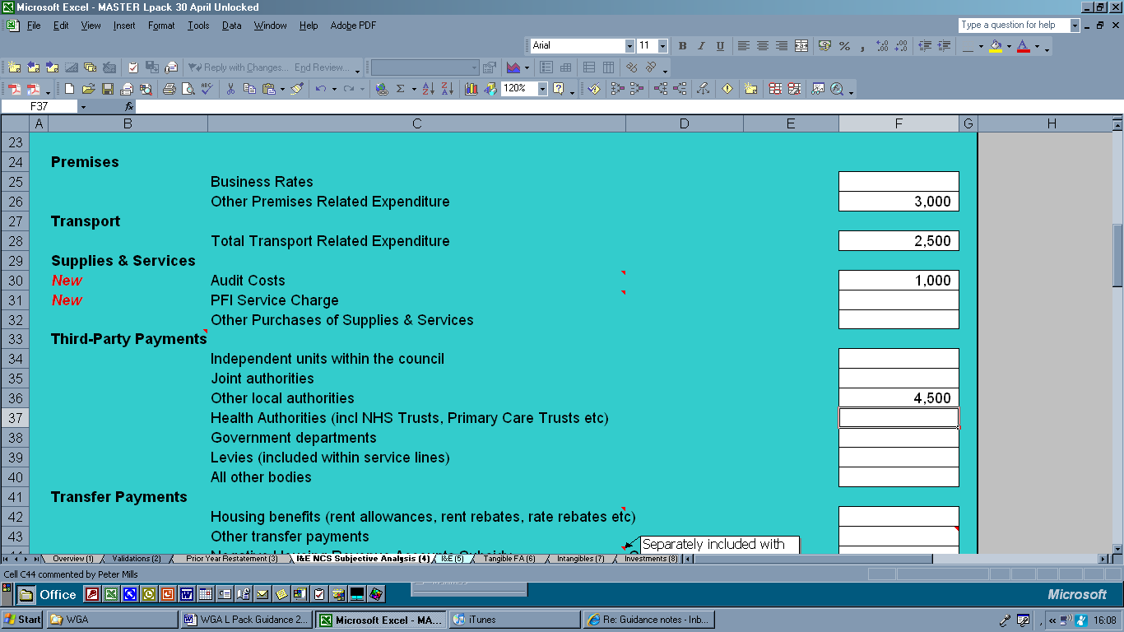
D
B

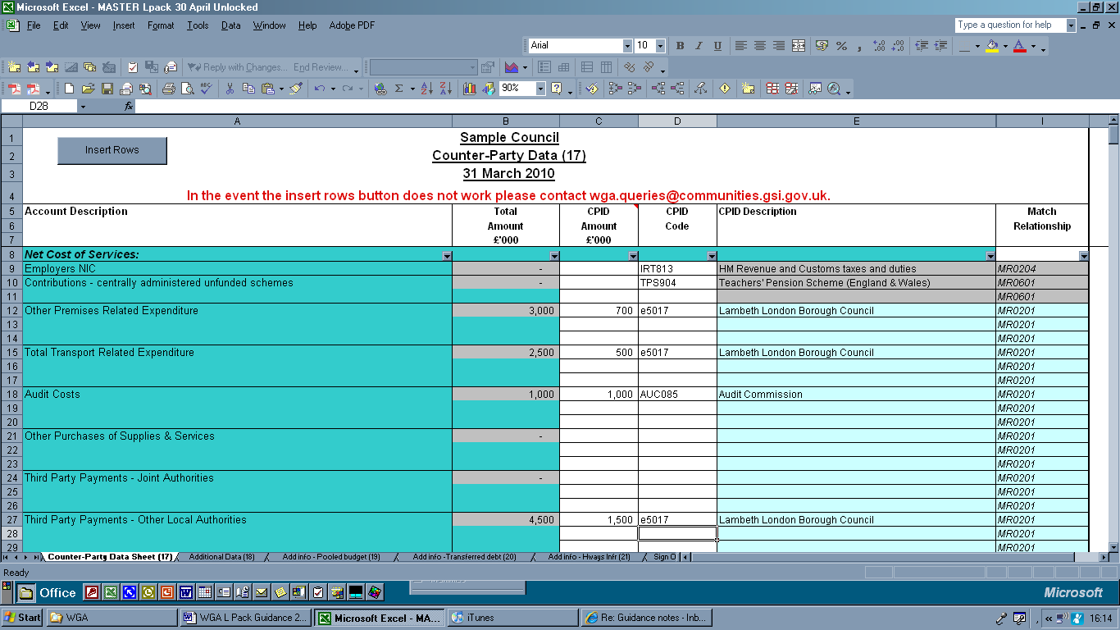
C

In the I&E subjective Analysis we have included the following information:

Other premises related expenditure £3,000*
Transport related expenditure £2,500
Audit Costs £1,000
Third party payments – other local authorities £4,500

* note these are all rounded to thousands – therefore the £3,000 represents £3 million.

These amounts have been copied into the counter-party sheet requiring further analysis (at A, B, C and D).

In this example we have identified that of the total expenditure by subjective analysis we have transactions with London Borough of Lambeth:

Of the:
Other premises related expenditure £3,000k £700k relates to LB Lambeth
Transport related expenditure £2,500k £500k relates to LB Lambeth
Third party payments(other local authorities) £4,500k - £1,500k relates to LB Lambeth

If we were adhering to the items over £1m then the first two items would not be included in the analysis. This would not be correct and we are understating the level of counter-party transactions with Lambeth.

Why?

These relate to the same match relationship MR0201 (colour coded). Therefore in the upload sheet all of the above are being mapped to the same account code in COINS 51403000. The total amount being mapped is £2,700k that is we have stated that we have counter-party transactions i.e. purchases with Lambeth totalling £2.7m during 2009-10
These are all added together when uploaded to COINS
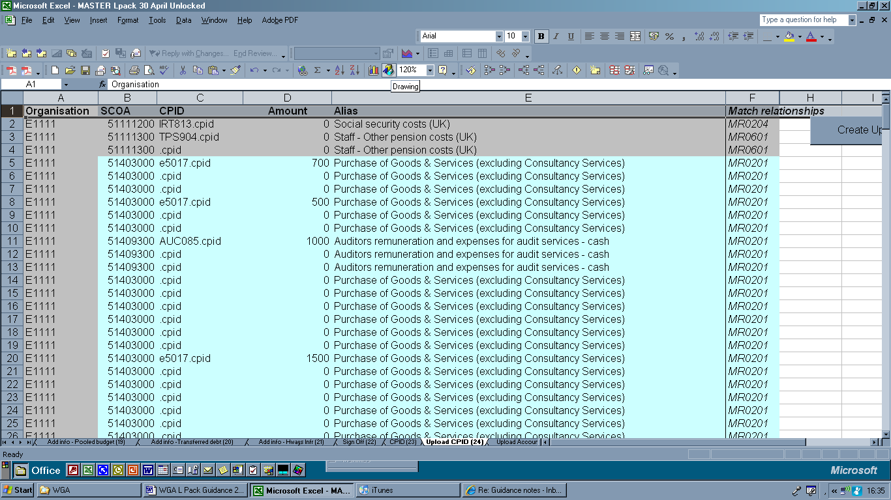

In the Lambeth counter-party sheet, Lambeth have identified that they have sales with Sample Authority (E1111) of £2,700k (of a total of £7 million.
I&E (4) extract:

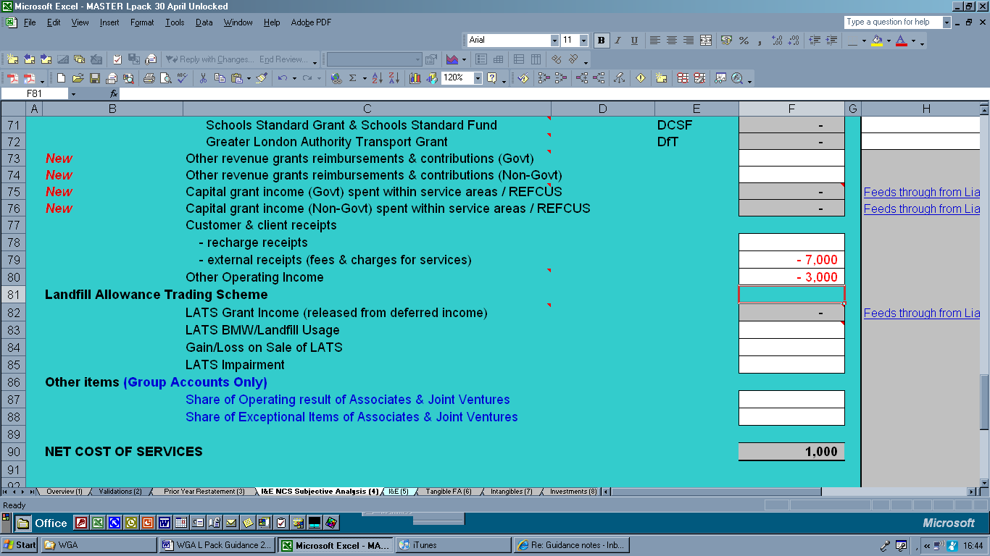

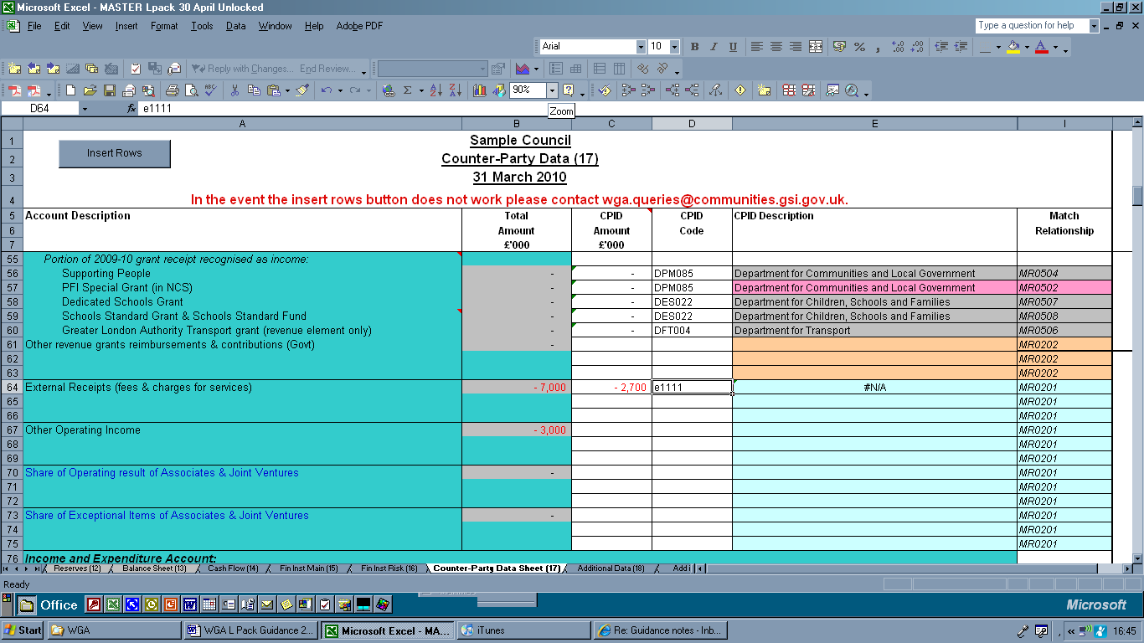

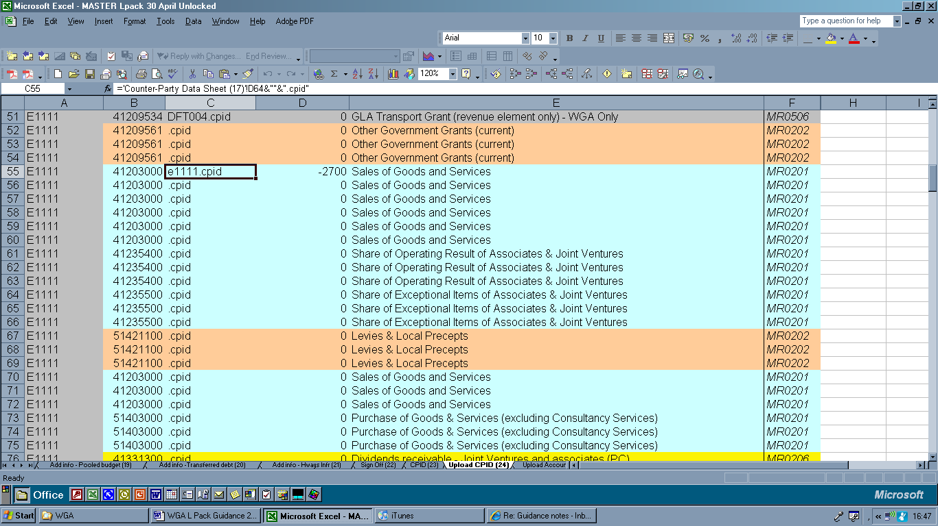

This is the same as that identified in the Sample Authority’s counter-party sheet and as these two are exactly the same amount and are in the same match relationship – this will eliminate completely – this is called a “Match Perfect”.

Sample Authority Purchases £2.7m with Sample Authority MR0201
Lambeth Sales £2.7m with Lambeth MR0201

However if Sample Authority exclude the amounts under £1million then there would be a mismatch:

Sample Authority Purchases £1.5m with Sample Authority MR0201
Lambeth Sales £2.7m with Lambeth MR0201

In this case COINS will not eliminate the two as there is a difference of £1.2m (the £700k and £500k are not included). Therefore, as can be seen from this example completeness and accuracy of the information included in the counter-party sheet is extremely important.
To complete this example there is an amount of £1,000k (identified as the audit costs). In this case the auditors are the Audit Commission auditors and the whole amount is allocated to the Audit Commission CPID.

9.16.10. If an invalid CPID is entered in column D then #NA will appear in column E. (you may have noted in the example above this was the case – as I used a fictitious local authority called Sample Authority with E code E1111 then #N/A appeared in the CPID description.

9.16.11. Do not submit your form with an invalid CPID. Please contact us if you are unsure of any codes, and we will locate the correct CPID. WGA.Queries@communities.gsi.gov.uk

9.16.12. Also on the HMT WGA webpage there is new detailed counter-party analysis showing the counter-party “family”. It is not always easy to determine whether a body is part of the WGA boundary (as it may be sub consolidated into another central government department.
This information is available at the following link:
http://www.hm-treasury.gov.uk/wga_guidance_index.htm

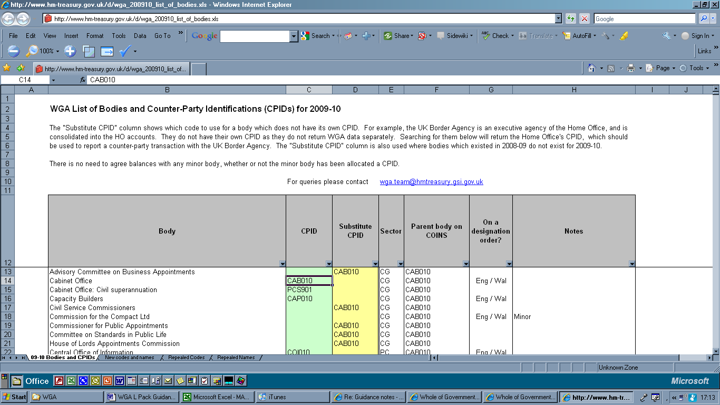

Key points to note
9.16.13 When completing the counter-party information, the following points are of particular note and require consideration:

- Consider all lines that may require input and ascertain if your entity holds any part of this balance or transaction stream with another government body.

- How do I know if the counter-party data is needed? We require you to note the counter-party for any transactions greater than £1 million with any other WGA body. We also require counter-party information for individual balances of less than £1m in several different lines when the following conditions are met:
  - They are of the same transaction type (income, expenditure, debtor, creditor, reserves)
  - They fall into one match relationship
  - They are greater than £1million when totalled.
We have colour coded each match relationship differently on sheet 17, so that it is possible to see which transaction descriptions fall into which match relationship. (In addition Annex C lists the match relationships and colour codes)

- It is no longer possible to input decimals, copy and paste any figures or link to other spreadsheets. We introduced a macro to stop their inclusion as they prevent the extraction of data and its upload onto COINS. This is important otherwise this causes many “referencing” errors causing the primary validations to fail, preventing the automatic upload of the information onto the HMT COINS system.

- The macro has been introduced that allows you to insert additional rows as needed into the counter-party sheet. Place your cursor into the relevant area in column A and click the “Insert Rows” button in the top left hand corner of the sheet. If this fails to work, please email us stating the number of additional lines required and where. We will add in the extra rows and return the form to you. WGA.Queries@communities.gsi.gov.uk

- In some cases, Columns C and D will automatically populate. This will only happen if the counter-party is responsible for the full amount. For example, PWLB Borrowing will always correspond to a counter-party of PWL888.cpid, (the Public Works Loan Board), and the full amount. Here, no action is required.

- Additionally, there are some instances where Column D will automatically populate, but not Column C. Here, we have suggested likely counterparties to be considered. E.g. interest payable is likely to have an amount attributable to PWLB, but there may be other entities you need to include as well. Always type in the amount attributable to the entity in Column C, and consider any other relevant bodies.

General Omissions

9.16.14. Many of the local government bodies simply did not include any counter-party information which resulted in numerous mismatches and significant remedial work was required to identify whether the original information was included in error, this was an omission from the recipient or the incorrect recipient had been included.

Match Relationships

9.16.15. All match relationships have been colour coded. Consider all transaction lines within each colour code and include any that total more than £1m with any counter-party. Note that each colour may be dispersed throughout the sheet, and may not appear all in one block. For example, total transport related expenditure; total purchases of supplies and services and other premises related expenditure are all included as one match relationship.

Signage

9.16.16 Amounts entered in column C should follow the same sign convention as the total in column B. E.g. if the Total Premises, Transport & Supplies expenditure in column B is a debit £100,000, then any CPID amounts recorded will also be debit. - They will be entered as positive numbers. The reverse will apply if the lines relate to credit balances, as these will be entered as negative.

CPID breakdown totals

9.16.17 Typically, the total of the CPID breakdown should not exceed the total in Column B. If the CPID breakdown total in Column C is greater than the line balance in Column B, then a validation error message will state ‘CPID breakdown incorrect’.

9.16.18 The total breakdown in Column C for each of the relevant lines does not need to equal the total amount in Column B, except in the following cases:

- Redistributed Non Domestic Rates
- PWLB Borrowing due within one year
- PWLB Borrowing due after one year
- Housing Revenue Accounts Subsidy
- Supporting People
- PFI special grant
- Council tax benefit – subsidy
- Rent allowance subsidy
- HRA Rent Rebates: subsidy
- Non-HRA Rent Rebates: subsidy
- Housing Benefit & Council Tax Benefit Admin Grant
- Dedicated Schools Grant
- Schools Standard Grant & Schools Standard Fund
- Sure Start Grants
- GLA Transport grant

Scope

9.16.19 As a general rule, bodies such as internal drainage boards, housing associations, charities, and town and parish councils fall outside the scope of WGA, and so do not require identifying on the counter-party sheet.

9.16.20 Some bodies are recorded against their central department and do not have their own counter-party identifier code. For example, Primary Care Trusts and Strategic Health Authorities are recorded as the Department of Health, and Government Offices for the Regions are recorded against CLG.

9.16.21 Greater London Authority functional bodies have separate CPID codes from the GLA. Please record counterparties against these organisations and not the GLA. (This includes TFL, Metropolitan Police, London Fire and Emergency Planning Authority).

Billing - Precepting Authorities

9.16.22 Following changes in the SORP 2009, all local government bodies are required to show their income from council tax regardless of the collection arrangements. As a result there could either be a debtor or creditor situation at year end. This debtor/creditor will need to be disclosed in the counter-party sheet. Previously all precepts paid over to police and fire authorities, county councils and the Greater London Authority were not reported within the counter-party sheet as these transactions did not pass through the income and expenditure account. This has now changed.

PTEs and ITAs (previously PTAs)

9.16.23 In the English local government sub consolidation, the Passenger Transport Executives are not included within this boundary. In 2008-09 we saw several instances where payments (including levies) for transport services were recorded against the wrong code and attributed to the Passenger Transport Executive, rather than the correct Passenger Transport Authority. The PTAs have since been renamed Integrated Transport Authorities. To avoid this confusion the Passenger Transport Executive codes have been removed from the counter-party list and are no longer available.

Joint Committees & Similar Joint Arrangements

9.16.24 Where a joint committee has been designated for inclusion in WGA (and so attributed a CPID code); transaction streams and balances should be treated in the same way as any other transactions in WGA. Where no CPID exists, it should be treated as outside of the public sector, and the counter-party not recorded.

Agency arrangements & delegated functions

9.16.25 If an authority is acting as agent of another public body, or is the principal in an agency agreement, it should report all income and expenditure in relation to the agency as recognised in its accounts. It should also record any relevant counter-party information between the two bodies.

Area Based Grants (ABG): replacing Local Area Agreements (LAA)

9.16.26 Transactions and balances arising under the ABG framework should be treated in the same way in WGA as they are in the authority’s accounts. CIPFA guidance should be followed, and so treatment should be in accordance with FRS 5.

9.16.27 Where the accountable body determines that it is the principal, it should record the relevant counter-party data in the counter-party sheet, including the lower and single tier, single purpose and NHS bodies to which grant is paid over. If it is acting as agent, the income and expenditure would not be recorded in its accounts and so should not appear in the counter-party sheet of the L Pack.

9.16.28 Lower tier and single purpose bodies do not need to determine whether the upper tier body is acting as agent or principal. The income should simply be recorded as counter-party income from whichever body the authority receives the grant from.

Line Guides

9.16.29 This section highlights key description lines where mistakes are commonly made or where additional information is useful.

Employer’s NIC

9.16.30 The amount must include all NI contributions made by employers, including for staff employed in trading operations and subsidiaries, accordingly we recognise the total counter-party amount could exceed the amount disclosed in the I&E.

Third Party Payments – NHS Trusts & Foundation Trusts

9.16.31 Health Authorities include NHS Trusts, Foundation Trusts, Primary Care Trusts and Strategic Health Authorities. NHS Trusts and Foundation Trusts have an individual counter-party identifier code. Primary Care Trusts and Strategic Health Authorities are agencies of the Department of Health and will therefore carry the CPID: DOH033.cpid.

Third Part Payments – Levies (within services lines)

9.16.32 Only enter levy payments which are included within the net cost of services analysis within the authority’s accounts, split out between amounts >£1 million paid over to levying authorities.

Government Grants Income

9.16.33 If there is confusion as to which government department is responsible for the funding, please do not hesitate to contact wga.queries@communities.gsi.gov.uk.

9.16.34 For the Schools Standard Grant & Schools Standard Fund total include - School Standards Grant (SSG) - paid by DCSF to Local Authorities. This is a formula driven grant paid via the Local Authority to all maintained schools. Schools are free to spend the grant on any purpose. Local Authorities request this funding in Table 1 of the Section 52 budget statement.
9.16.35 This line also includes the School Standards Fund (SSF). This is the umbrella term for a suite of grants paid by DCSF to Local Authorities for a variety of specific purposes including the raising of standards of teaching and learning in schools; extended services in schools; and the extension of the early years free entitlement. Largely devolved to schools, but some expenditure can be incurred at Local Authority level.
9.16.36 Further details can be found at: http://www.teachernet.gov.uk/docbank/index.cfm?id=12228 and http://www.teachernet.gov.uk/docbank/index.cfm?id=12227
Group Accounts

9.16.37 The following lines are open to group accounts only:
Share of Interest Payable of Associates & Joint Ventures
(Gains)/Loss on Re-purchase or Early Settlement of Borrowing
Share of Interest & Investment Income of Associates & Joint Ventures
Share of Pension Interest Cost & Expected returns of Associates & Joint Ventures
Taxation Payable of Group Entities
Share of Taxation Cost of Associates & Joint Ventures
Minority Interest Share of Profits or Losses of Subsidiaries

Transferred debt

9.16.38 Please see p.101 for guidance on the treatment of transferred debt.

9.16.39 Balances owed to pension funds should not be included within transferred debt counter-party data.

9.16.40 Note that transferred debt is not affected by the changes in the accounting for financial instruments.

Concessionary fares

9.16.41 A number of differences were noted during the 2008-09 WGA exercise due to the treatment of concessionary fares. We are currently working to clarify the situation and will issue guidance on the treatment of concessionary fares by email shortly.
ADDITIONAL DISCLOSURES SHEET (18)

9.18.1. This sheet is used to collect data for disclosure or adjustments that cannot be collected as part of the balanced WGA account.

Provisions: Expected timing of cash flows
9.18.2. This is a new disclosure requirement for the 2009-10 L Pack. This information is a standard data set requirement in the WGA. Please show as aggregate amounts - for example if the expected cash flow is £200 per year between 1 and 5 years, the amount to go in the cell is £200 x 4 = £800. Enter as positive.

Maturity Profile of Lease Commitments (not PFI)

9.18.4 This data is required to prepare the notes to the accounts.

PFI Additional Disclosures

9.18.5. Given the interest in the PFI there are a few additional data requirements for the number of PFI schemes to build schools and housing renovations; note this is not the number of PFI schools that are being requested but the number of PFI schemes to build the school. E.g. a local authority may have a PFI agreement to rebuild all the primary schools in their area. This should be recorded as one scheme.

9.18.6. The final disclosure is where there are PFI contracts over £500m (therefore material to WGA).

Other Financial Commitments

9.18.7. Here we require details of the total financial commitments at the balance sheet date (either capital commitments or non cancellable contracts). This will give us a true picture across WGA of committed public sector expenditure.

Contingent Assets/Liabilities

9.18.8 Please note that at the WGA level we are only interested in contingent liabilities greater than £500 million. Given the scale of WGA we do not anticipate local authorities having significant Contingent Liabilities. However these are areas of acute interest in public sector accounts. If it is necessary to include these items within WGA narrative disclosures we will contact the relevant authorities for further details.

Post Balance Sheet Events

9.18.9. Authorities need only disclose total balances for items over £1m. As a result, we do not anticipate local authorities having significant Post Balance Sheet Events. If it is necessary for these items to be included within WGA narrative disclosures we will contact the relevant authorities for further details.

Staff Numbers

9.18.20. The average staff numbers is a standard disclosure in the central government accounts and is require in the WGA. It is understood that local government are required to provide this information to ONS by the Quarterly Public Sector Employment Survey (QPSES ).

9.18.21. Please use the information provide in the staff survey for the number of staff employed by the local government body as at 31 March 2009 (opening) and 31 March 2010. The average number is automatically calculated as opening +closing divided by 2.

Adjustment Data

9.18.22 Following the introduction of the SORP 2009 changes the disclosure requirements for Income from Council Tax have been reduced to only the bad debts written off.

9.18.23. As the local government body must now account for NNDR on a agency basis we require information to be able to make the central adjustments so that that only the authority’s share from the pool is reflected in their accounts. Therefore any bad debts (or movement in the provision for bad debts), or business ratepayer’s income held, payments to the National Pool must be disclosed here to allow these central adjustments.

Additional Data Sheet – Pooled Budgets (sheet 19)

9.19.1. This sheet has been introduced to enable CLG and HMT to identify the number and value of pooled budget arrangements to ensure the L Pack reflects only the net expenditure to the authority, and is not ‘grossing up’ or recognising inappropriate counter-party data.

9.19.2. It is believed that there are over £3 billion counter-party differences caused by pooled budget arrangements. As a result a detailed sheet was developed in conjunction with input from local government as to the various scenarios that these arrangements can be.

9.19.3. Detailed guidance is included on the face of the sheet and so is not re-performed here. Please assess the scenario as it is applicable to your local arrangements and provide the necessary disclosure, and make the necessary adjustment to a net expenditure position within the L Pack, if required.

9.19.4. This sheet will only become available for data input if this option is selected in the Essential checklist on the Overview sheet(1).

Additional Data Sheet – Transferred debt (sheet 20)

9.20.1. This area caused several issues in the completion of the counter-party sheet for 2006-07 and 2007-08, and required considerable investigation to reach resolution.

9.20.2. A number of problems have arisen due to the varied treatment of transferred debt applied by authorities. Whilst some authorities record the deferred liability against the authority centrally administering the fund, some authorities do not. Some administering authorities record the full amount of transferred debt within their accounts and the amounts owed from each contributing authority, whilst others believe the debt sits outside of their accounts and should not be recorded for WGA.

9.20.3. In order to reduce the number of mismatches that result from transferred debt, a separate additional information sheet was introduced last year specifically to address inherited debt. Any authority with a deferred liability arising from the end of a former Metropolitan (or county) council should complete these page. This page is additional information to the accounts and so does not affect the consistent with opinion required from the auditors but is important for us to correctly identify the counter-party information and to do the eliminations.

9.20.4. For the authority centrally administering the transferred debt:
- Please disclose the amount of the debt held by the authority itself
- Please disclose the total amount of centrally administered debt
- The additional information required, detailing what was included in the L Pack.

9.20.5. For all other authorities holding transferred debt, please disclose the amount of debt held by the authority. We also require additional information outlining what has been included in the L Pack in order to highlight the differences between authorities.

9.20.6. This additional information is important to ensure that we can raise the appropriate journals centrally without the need to refer to the local authorities. This should be sufficient for the National Audit Office (NAO) when the audit of the sub consolidation is completed. It is hoped that this will reduce workloads for all parties.

Additional Information - Highways Infrastructure (21)

9.21.1. This is a new sheet introduced to assess progress on the journey to recording all Highways Infrastructure Assets on a Depreciated Replacement Cost Basis.

9.21.2. This sheet is not subject to audit review.

9.21..3. The information in the tangible fixed assets sheet in respect of highways infrastructure assets should be recorded on a historic cost basis.

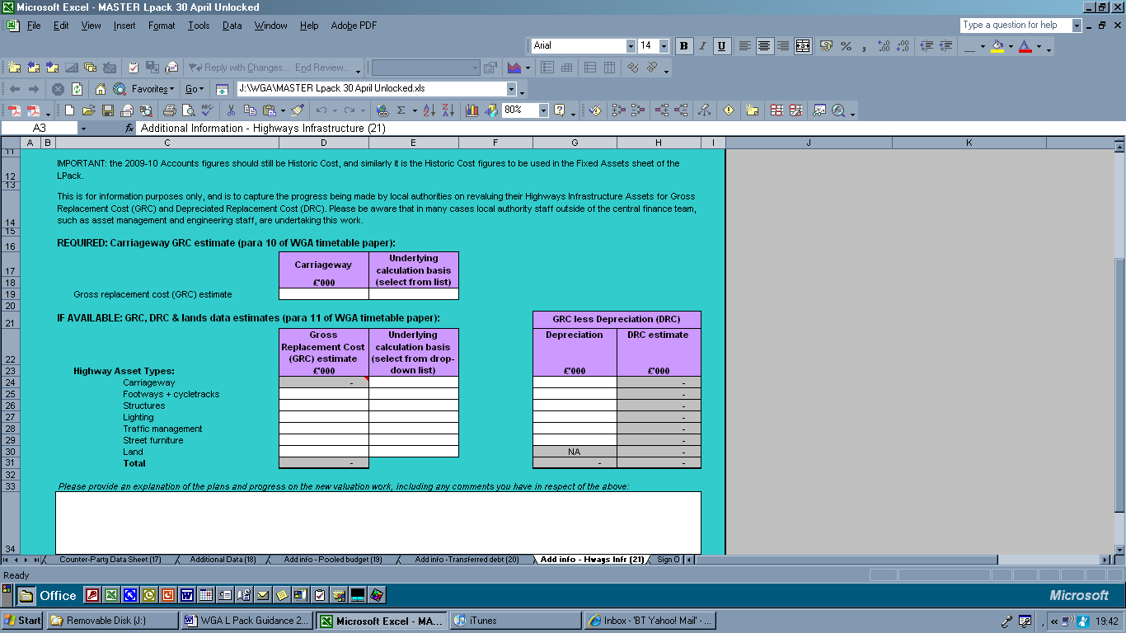

9.21.4. The papers referred to in the sheet is available from the CLG WGA webpage.

Sign Off (22)

9.22.1 Once the L Pack has been completed this sheet should be normally signed by the Senior Finance person, e.g. Director of Finance or Chief Accountant.

9.22.2. In previous years a hard copy signed version was required. In 2009-10 we do not require a hard copy of this sign off.

9.22.3. It may be noted that the audit sign off sheet (included in the illustrative pack) has been removed. The NAO have stated that auditors will instead be required to click the password protected Audit Confirmation button on the validations sheet, which will reflect on the Overview sheet that the Pack has been audited. Once the audited L Pack is sent electronically to CLG the NAO would like to receive all audit reports relating to the WGA directly. More instruction will follow nearer the time (and will be provided to the auditors in the auditor guidance on the WGA).

CPID (23)

9.23.1. This sheet lists all organisations that fall within the WGA boundary for 2009-10 and includes the counter-party ID (CPID) that should be used in the Counter-party Data Sheet (sheet 17).

Upload accounts (25) and Upload CPID (24)

9.24.1 These sheets are used by CLG to load the data onto the consolidation system. All information input in to COINS is included in these two sheets and forms the basis of the WGA.

SCOA (25)

9.25.1 The SCOA (Standard Chart of Accounts) code sheet has been included in the form for information. Each of the account codes match to these SCOA codes in COINS and are then uploaded into the HM Treasury WGA general ledger.

Post Audit Journal sheet and CPID Audit Journal sheet

9.26.1. These sheets will record the adjustments following the audit review of the L Pack. Once the draft pack is finished this should be locked and sent to CLG and your auditors for review.

9.26.2. To avoid duplication of effort the same pack is updated for changes – the effect of the changes can be seen here and a journal is prepared for CLG to upload onto the COINS system. This system was trialled for central government C packs and this worked hence it is being rolled out across all local government this year.

Track changes

9.27.1 We do not have any track changes yet as this is the first full draft. However if there are any changes this sheet records these. If there are any further amendments required following the issue of the form (hopefully there will be kept to a minimum!) this sheet will be updated with the change.

9.27.2 Note that the completers of the form will be notified separately by email of any such changes to ensure the latest/correct version of the L Pack is being used. If you have already begun to complete the form, we do not require you to start again on a revised version, but ask you to note the changes and ensure that any checks and balances would work if the error had been corrected.
Section 10

OTHER SOURCES OF GUIDANCE & CONTACTS

Other Sources of Guidance

10.0 For guidance on the accounting practices to be adopted in completing the returns authorities should refer to the 2009 SORP and BVACOP in the first instance. (Note the BVACOP version applicable covers 2008-09 and 2009-10.)

10.1 Authorities may also find the 2009 SORP Guidance Notes useful.

Contacts
10.2 If there are any queries about the timetable and/or completion of the form these should be addressed to Communities & Local Government:
E-Mail: wga.queries@communities.gsi.gov.uk

10.3 Upon completion of the form this should be forwarded to Communities and Local Government. Please observe the naming convention as outlined in section 2. E-Mail: wga.returns@communities.gsi.gov.uk

10.4 General queries about the WGA programme should be addressed to the WGA team at the address below:
WGA Team Inbox, HM Treasury
E-Mail: WGA.Team@HMTreasury.gsi.gov.uk

10.5 Authorities that subscribe to the CIPFA/IPF Finance Advisory Network may contact their Regional FAN advisor. CIPFA members may also contact the CIPFA Technical Enquiry Service for Guidance on the application of the SORP or BVACOP:
Phone: 0207 543 5888
E-Mail: technical.enquiry@cipfa.org
Section 11

FREQUENTLY ASKED QUESTIONS

1. Is this the final version of the L Pack?
The version of the L Pack issued on 30 April is intended to be the final version of the WGA return. Before issuing the L Pack it is sent for management review where we hope that any outstanding errors are picked up. Unfortunately, we cannot guarantee that all issues will have been identified and corrected. For this reason, it is possible that a later version may be uploaded onto CLGs website, if significant issues are found. If a revised version is issued, we will email the named WGA contact in each authority to ensure that they are aware of any changes. The latest version of the form will always be available on our website:

We strongly recommend that this is saved as a favourite and periodically reviewed. We hope to add in other information that may be of assistance to you in the completion of the form.

2. If I have started completing the L Pack and CLG make a change to the form do I have to complete the new form?
No. If there is a change to the form then CLG will accept the form that you have started to complete. Any changes that are made will be noted in the track changes sheet of the revised pack, and included in an email to all authorities. You may note that certain checks/validations fail on your version because of outstanding errors on the L Pack, amended in later versions. You should assure yourselves that the form would work without failing validation checks if the L Pack errors were not in place, and then proceed with audit and submission as normal. Please note in your email which version of the L Pack you have used and highlight any validation failures that remain as a result of the errors to the L Pack.

3. Why do CLG keep making changes to the form?
CLG will only make changes to the form where significant issues are identified that impact on the completion of the form. For instance, in 2007-08 the first change was made to correct an incorrect Counter-party identifier code. Left uncorrected this would have caused huge issues in completing the appropriate intra government eliminations. We give careful consideration for the need to make changes and weigh up the impact of leaving things unchanged. The aim is to make things as clear as possible to the completer of the returns (not always achieved!). Any changes made are highlighted in the track changes sheet of the L Pack together with the date the change was made. Note for 2009-10 we have tried to highlight all the changes that have been made to the form from the 2008-09 exercise: updating for SORP changes, issues identified by local government/ourselves in the completion for the form and other developments.

4. What is the deadline for the returns?
This year there are two deadlines:

Firstly we require the unaudited return to be submitted to us by 30 July 2010. The deadline for the submission of the audited return remains the same as previous years’ - 1 October 2010.
All completed returns should be sent to wga.returns@communities.gsi.gov.uk. Please follow the naming convention so that it is easier for us to process upon receipt. The subject field and file name should state:
E Code_ Local Government body name_Audit status_ WGA 2009-10.

5. Do I have to send in an unaudited return as well as an audited return?

Yes. The unaudited return is required to allow CLG and HMT the opportunity to review all the elimination differences. Presently local government is the last major data set to be added onto the HMT COINS system allowing very little time to complete the sub consolidation and review all the material elimination differences.

6. Am I required to fill in the Pack twice?

No. The functionality in the Pack has been included so that the unaudited pack that is submitted to CLG is simply updated for audit adjustments. The pack will automatically convert this information into two journals – one for the accounts and the other relating to any counter-party changes.

7. Can I send these in before the deadline?
Yes. Please send your return as soon as it is completed to CLG, following the guidance in Q4.

8. What should we do if the audit of the L Pack will not been completed by the deadline?
Please advise CLG immediately by emailing wga.queries@communities.gsi.gov.uk. Explain the reason for the delay and provide an indication as to when the audited return is likely to be completed. It is imperative that the draft L Pack is sent in by the deadline if the audit has not been finalised.

9. Are there any training events for the new L Pack?
Yes.
We are currently running a series of training events. These training events are not part of the CIPFA FAN network. We are extremely grateful to CIPFA FAN for arranging these in the past but some authorities have found the costs to be prohibitive/ or they have preferred to use the CIPFA allocation on other training events.. Hence we have arranged a series of regional events across the country to provide tailored training events.

The first of this series has commenced (late April/early May as requested) and a further series being required in early July 2010.

Annex A: Guidance notes accompanying the ONS quarterly public sector employees survey questionnaire

Guidance Notes for completing the Quarterly Public Sector Employees
Survey Questionnaire

Introduction
The Quarterly Public Sector Employees Survey is the main data source for measuring the number of employees in the public sector. The definitions used for this survey have been agreed by an interdepartmental committee to help bring greater consistency across different sources of public sector statistics.

Employees
Please report the number of employees with an employment contract who are being paid by the organisation, rather than the number of jobs/posts. There is a difference between counting employees (which is a measure of people) compared to jobs or posts (where one person may have more than one job). For example, where an individual works for a local authority run leisure centre they may work as a lifeguard and a fitness instructor. If an employee has more than one job within your organisation please categorise the employee based on the characteristics of the post in which the employee works the most hours i.e. permanent/casual, full-time/part-time

Include:
- Overseas workers, for example, those employees working in the Armed Forces, Diplomatic Service and the British Council serving abroad. However, exclude locally engaged staff as these are not considered UK residents
- Employees on secondment or loan only if your organisation is paying for the majority (more than 50 per cent) or all of their wages. If the costs are split equally, the sending rather than the receiving organisation should count the employee. Employees seconded in from the private sector should be included if your organisation is paying for the majority or all of their wages. However, please exclude employees seconded out to the private sector
- Workers who only work part of the year (e.g. those on casual or annualised hours contracts) if they are being paid at the reference point
- All those on paid maternity or paternity leave
- All those on paid sick leave (being paid either in full or part)
- All those on paid special leave
- Those employees on short-term unpaid leave (for example for bereavement, or parental leave) if they are absent
- On the reference date and they are on leave for a period less than their pay period.

Exclude:
- Workers who only work part of the year (e.g. those on casual or annualised hours contracts) if they are not being paid at the reference point
- Self-employed, contract workers and agency workers not paid directly from the payroll
- Those employees on unpaid leave if they are on leave for a period longer than their pay period
- All those on career breaks
- All those on unpaid leave.

Employee Status - Permanent, Temporary, Casual and Fixed Term
Include:
- Permanent employees, temporary employees, casual employees and employees with a fixed-term contract.
- Employees with fixed-term contracts of more than 12 months as permanent employees (regardless of the amount of time remaining on the contract)
- Employees with fixed-term contracts of 12 months or less as temporary employees, and report together with casual employees.

Part Time Employees
Part-time employees should be defined as those who work less than standard contracted hours, that is, your organisation’s normal weekly hours.

Full Time Equivalents (FTE)
Exclude:
- Full-time employees from your calculations.
- Paid and unpaid overtime from FTE calculations.
- Contracted hours are used for the basis to calculate FTE. The number of hours worked should be those that the employee is contracted to work for each week, so breaks should be excluded in the calculations.
- Contracted hours of those people on leave (e.g. maternity leave) should be those that they were working before they left.

You may find it useful to take a copy of the questionnaire for future reference or to answer any queries that may arise.
Annex B: Sample ONS questionnaire for the quarterly public sector employee survey

Quarterly public sector employee survey
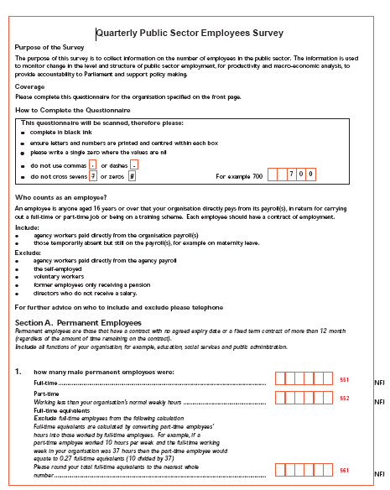

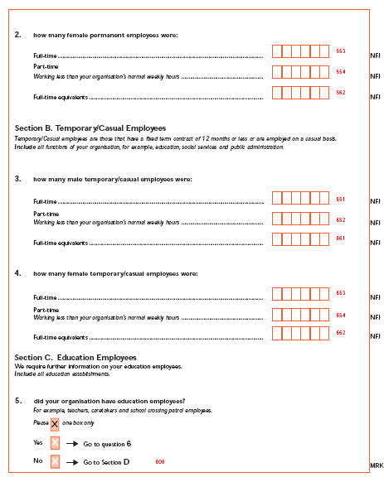

Annex C: Colour coding of match relationships in the Counter-party Sheet

The table below shows each of the match relationships that have more than 1 transaction description contributing to the overall eliminations for that relationship. If any transactions fall into a highlighted line, please consider if you have any other payments or receipts in fields of the same colour with the same organisation. Where a collection of figures in one colour code give a total balance of greater than £1 million, and the transactions are of the same nature (e.g. all income), the counter-party must be disclosed, even if the individual transactions are less than £1 million.

MR | Description | Colour
MR0101 | General Debtors and Creditors (including provisions) | Light Green
MR0102 | Financial Assets and Liabilities | Light Yellow
MR0103 | HMRC Taxes and Duties | Grey
MR0201 | Income and Expenditure (includes deferred income) | Pale Blue
MR0202 | Income and Expenditure (grant in aid, grants etc) | Tan
MR0203 | Group Accounts tax | Med Blue
MR0204 | NIC tax | Grey
MR0206 | Interest and dividends | Dark yellow
MR0501 | Revenue Support Grant | Grey
MR0502 | PFI Special Grant | Pink
MR0503 | GLA General Grant | Grey
MR0504 | Supporting People | Grey
MR0505 | Housing Benefit | Grey
MR0506 | GLA Transport Grant | Grey
MR0507 | Dedicated Support Grant | Grey
MR0508 | Schools Standard Grant & Schools Standard Fund | Grey
MR0509 | Sure Start Grants | Grey
MR0510 | Non HRA Rent Rates Subsidy | Grey
MR0511 | HRA Rent Rates Subsidy | Grey
MR0512 | Rent Allowance Subsidy | Grey
MR0513 | Council Tax benefit | Grey
MR0514 | Housing Revenue Account Subsidy | Grey
MR0515 | Distributed NNDR Pool | Grey
MR0516 | Area Based Grant | Grey
MR0601 | Contributions teachers pension scheme | Grey

